Creating Learning Materials for Open and Distance Learning:
Introducing the Commonwealth of Learning instructional design template
for OpenOffice.org 3.0
Sharon Roffey
Instructional Technology Consultant

Futuristic Ltd
Template Upgrade Consultant
For the Commonwealth of Learning
Copyright
The Commonwealth of Learning is an international organization established by Commonwealth Governments in September 1988, following the Heads of Government Meeting held in Vancouver in1987. It is headquartered in Vancouver and is the only Commonwealth intergovernmental organization located outside the United Kingdom. The purpose of the Commonwealth of Learning, as reflected in the Memorandum of Understanding, is to create and widen access to education and to improve its quality, utilizing distance education techniques and associated communications technologies to meet the particular requirements of member countries. The agency’s program mmes and activities aim to strengthen member countries’ capacities to develop the human resources required for their economic and social advancement. They are carried out in collaboration with Governments, relevant agencies, universities, colleges and other educational and training establishments, amongst whom it also seeks to promote cooperative endeavors.
The Chairman of the Board of Governors is Mr. Lewis Perinbam, O.C (Is it still so?).; the Commonwealth of Learning’s President and Chief Executive Officer is Sir John Daniel.
© Commonwealth of Learning, 2009
Any part of this document may be reproduced without permission but with acknowledgements to the Commonwealth of Learning. This work is licensed under a Creative Commons Attribution-ShareAlike 3.0 License. For additional information see http://creativecommons.org/licenses/by-sa/3.0/

ISBN PENDING
Due to continued development, the information, content and structure in this documentation may change regularly. If you experience any problems using the documentation or the templates for which it is written, please report them by email: info@col.org
<THIS MAY BE UPDATED IN THE FINAL VERSION>

Published by:
Commonwealth of Learning Telephone: 604 775 8200
1055 West Hastings Street Facsimile: 604 775 8210
Suite 1200 Email: info@col.org
Vancouver, BC V6E 2E9 Web: http://www.col.org
Canada

Forward
This template is for anyone who wants to write learning materials for open and distance learning (ODL). At COL we see ODL playing a critical role in development. This is because it is a methodology that enables the knowledge and creativity of a single teacher, or expert - or even a team of experts - to be taken to scale and made available to learners or fellow educators wherever they may be in the world. However, we also know at COL that the potential of ODL is lost if learning materials are not of high quality. For us this means giving careful attention to the special pedagogical features of ODL that contribute to excellence. Acquiring and applying these pedagogical skills often takes a long time and therefore hinders the adoption of ODL. By using this template COL hopes that any of you who may feel discouraged from developing ODL learning materials will feel empowered to begin to do so.

Many people across the Commonwealth have been involved in developing and testing this template. We are grateful to them all. However we also know that although we have tested it thoroughly weaknesses may remain. We are also sure that users will be able to improve it. So we hope that you will contact COL with feedback on how you have used the template and what improvements you have made.
Sir John Daniel
President and CEO
Commonwealth of Learning
Acknowledgements
We are grateful to the following individuals for their assistance during the development of the ODL OpenOffice.org 3 template and this user guide:
Template upgrade to Open Office:
The team from Futuristic Ltd including: Nicholas Kimolo - Quality Assurance and Review, Mickey Ombuna-Template Design and Editing, Joseph Mwanzia and Dennis Owino-Content Editing
Original template testing and user guide review:
Michelle Childs, Software Training Consultant, Information and Communication Technology Services, Manukau Institute of Technology, Manukau City, New Zealand
Helen Hall, owner, www.eteachers.com.au , Queensland, Australia
Oriel Kelly, Manager, Learning Technology Centre, Manukau Institute of Technology, Manukau City, New Zealand
Merilyn McAuslin, Senior Lecturer, Computing and Information Technology Department, Manukau Institute of Technology, Manukau City, New Zealand
Rona Taylor-Smith, Academic Group Leader, Computing, Business Applications Group, School of Business Diplomas & Certificates, Faculty of Business, Auckland University of Technology, Auckland, New Zealand
Solvig Norman, Instructional Development Coordinator, Open School BC, Victoria, Canada
Dr. Ng Wai-Kong, Director of Educational Technology, Wawasan Open University, Malaysia
Special thanks to:
Michael Alford, former Chief, Staff Development Section, Office of the United Nations High Commissioner for Refugees, Geneva, Switzerland, for his inspiration and collaboration with early versions of the template.
Maureen Cureton, consultant for her tireless and valuable input to the template content and the user guide.
Rosario Passos, consultant, for her active testing of the pilot template with students in Mozambique.
Steve Roffey for first stage editing.
Contents
Overview 1
Welcome to the Creating Learning Materials for Open and Distance Leaning: user guide 1
Template functionality 2
Who should read this guide? 2
How this user guide is structured 3
Need Help? 3
Saving the template on your computer 4
Where do I save the template? 4
Saving to a personal directory 4
Saving to the user template directory 4
A guided tour of the template 5
“Help!” prompts 5
Can’t see the “Help!” prompts? 5
The ODL Course Manual template toolbar 5
Can’t see the ODL Course Manual template toolbar? 5
About the ODL Course Manual template toolbar 6
How the template is structured 6
Template automation 7
Cover page 7
Form fields 7
Table of Contents 8
Page headers and footers 8
Design specifications 8
Page layout 8
Spot colour 9
Why spot colour? 9
Before you start 11
Check your document options 11
Show formating marks 11
Show field shading 12
Review the standard text 12
Review the page headers 13
Check Your AutoText 13
To Add an AutoText Directory to an OpenOffice.Installation 13
Using the ODL Course Manual template 14
Open a new ODL Course Manual document 14
From the user templates directory 14
From a personal directory 15
Save your new document 15
Print your new document 15
Why should I do this? 15
Switch on Show/Hide formatting marks 16
Why should I do this? 16
Complete the introductory pages 16
What to look out for! 17
Cover page 17
The [DOCUMENT TYPE] form field 17
Contents page 19
Course overview 19
Course units 20
Unit structure 21
Wait! Can I copy text from an existing document? 21
Writing the unit content 22
Removing a unit assignment 22
Removing a unit assessment 23
Adding a new unit 23
Removing a unit 24
Understanding Styles 25
What is a document style? 25
Think BACH! 25
Characters 26
What is my current style? 26
Changing an existing style? 27
Why would I want to do this? 27
Applying a new style 27
Using Graphics 28
Margin icons 28
Why margin icons? 28
Adding a margin icon 29
Changing the icon label 30
Adding borders to margin icon text 31
Changing the border colour and/or width 31
Illustrations 32
Adding the illustration place marker 33
Adding your illustration 33
Changing your picture position settings 35
Checklist graphic 35
Adding extra rows to the Checklist graphic 36
Full page insert 37
Table graphic 37
About the Table graphic 38
Inserting the Table graphic 38
Adding extra rows to the Table graphic 39
Removing rows from the Table graphic 39
Text Box graphic 39
Writing Space graphic 41
Adding additional lines to the Writing Space graphic 41
Printing your ODL course manual 43
Choosing a different paper size 43
Customizing the template 44
Adding your institute's watermark 44
Setting the watermark characteristics 44
Adding the watermark to your document 45
If you do not wish to include a customized watermark 47
Customizing the header 48
Adding your institute’s logo 48
Setting the logo size 48
Copying the logo to your ODL manual 49
Setting the logo position 50
If you do not wish to include a customized logo 50
And the COL logo? 50
Saving your customized template 51
Resources 52
Publications 52
Websites 52
Document styles list 54
Paragraph styles 54
Heading 1 55
Heading 2 55
Heading 3 55
Heading 4 55
List Bullet style 56
List Bullet 2 style 56
Margin Note style 56
Question style 56
List Number style 57
List Number Bullet style 57
List Continue style 57
List Alpha style 58
Note style 58
Note – Special Attention style 58
Quotation style 58
Character styles 59

Overview

Welcome to the Creating Learning Materials for Open and Distance Leaning: user guide
<HELLO PAUL-CAN YOU GIVE US REVISED WORDS FOR THIS SECTION? >
It was during the Commonwealth of Learning’s Institute on “Open and Distance Learning for Development” held in Vancouver in May 2005 that participants recommended that COL develop a template for instructional design. It was felt that such a template might aid the sustainable adoption of ODL methodologies. A template it was felt would guide new authors through the process of developing learning materials. So often it was argued enthusiasm for ODL developments floundered after initial attempts at writing failed to produce the kind of quality materials authors aspired to. This was identified as a major impediment to the adoption of ODL methodologies. When discussing this problem Michael Alford from the United Nations System Staff College (UNSSC) discussed a template he had been involved in developing when he had worked at the International Labour Office (ILO). He subsequently made a presentation on this template at the Canadian Association of Distance Education conference that took place immediately after the COL Institute.
Charged with taking forward the idea of a template COL approached Sharon Roffey the designer of the ILO template to undertake a similar development for COL. Her instructions were simple. The template had to be user friendly and simple. The template and this user guide are the result. Created in just over a year, and tested in many countries and institutions, with feedback provided by many instructional designers, COL wishes to take this opportunity to thank everyone in the ODL community who has been involved in this “work in progress”.
This is a work in progress in that we want to develop the template and improve it – incorporating your suggestions and ideas. Please contact us at info@col.org with ideas and suggestions for improvement.
The template is self-standing and can be used “as is” or may be customized to suit individual requirements. In essence, it is a user-friendly tool enabling you, as a content developer, to convert your own subject matter expertise into learning materials. Using the template will give you more control over the creative and development process which we hope will lead to higher levels of motivation and satisfaction. In effect the template collapses the previously separate roles of content specialist, writer and graphic designer into one
Helen Lentell Education Specialist
(Training and Materials Development)

Template functionality
Intuitive, easy to use and customizable, the template is suitable for everyone, regardless of Open Office processing skill level.
The step-by-step instructions in this user guide are applicable to Open Office.org 3.0.1. However, should you encounter any difficulty with functionality of the template of a technical nature please report them by email to info@col.org. Be sure to include the words “ODL Open Office template” in the subject line.

Who should read this guide?
This user guide is written as an accompaniment for anyone using the ODL OpenOffice.org 3.0 Course Manual template provided by the Commonwealth of Learning.
Developing open and distance learning materials is an integration of content development (planning and writing) and instructional design. This guide addresses the template’s specific design issues.
- It is an easy step-by-step practical tool.
- No assumptions have been made regarding the Open Office processing skills level of content developers.
See the section “Understanding Styles” on page 25
- The minimum requirement for using the template is a working knowledge of Open Office and an understanding of document Styles.
Although most of the functionality in the template has been automated, we urge you to read the sections “A guided tour of the template” on page 5 and “Before you start!” on page 11 before using the template for the first time—this will ensure that you understand what is going on “behind the scenes”.
A one-page “Quick Reference” job aid highlighting the major steps has also been provided to you to use as a working tool.

  Recommended reading | A recommended accompaniment to this user guide is the COL publication “Creating learning materials for open and distance learning: a handbook for authors and instructional designers” by Richard Freeman.  It is a “must read” for anyone who plans and writes learning materials for use in open and distance learning. You can download Richard’s handbook from COL’s website. Click on Resources > Publications> Startup Guides & Training Resources > Training handbooks.

  Note it | This user guide was written after the publication of Richard Freeman’s handbook. The ODL Course Manual template takes care of the course manual structure; therefore the section in his book 9.1.5 “Mechanics of drafting” does not apply to you.

How this user guide is structured
This user guide walks you through each element of the document creation process using the template you have downloaded from the COL website, or have on a CD created by COL and follows a logical order of events. Because each section is generally independent of the others it can be used at any stage of the course creation process. How you use this user guide will depend on your need and/or experience.

Technote | To the extent possible the instructions in this user guide have been kept to the minimum. However, there are times when a little further explanation may be necessary; such information will be indicated using a TechNote margin icon (see margin).  The TechNote sections can be skipped unless you require more detailed explanation on a particular feature..

Need Help?
We hope that any functional help that you might need will be answered in this user guide. Please check the Table of Contents carefully. If you cannot find the answer you might like to follow the suggestions below:
- Check with your institute’s technical support section.
- Visit the Open Office Support Groups website at support.openoffice.org/ Click on the Free Community Support
It’s a worldwide 24-hours-a-day, 7-days-a-week, 365-days-a-year resource. Questions are usually answered very quickly,
Be sure to give as much detail as possible, i.e. what you are trying to do, what steps you took, what problems you encountered, etc. You should also state which version of Open Office you are using.
- Send an email to info@col.org with the words “ODL OpenOffice.org 3.0 template help” in the subject line. We would appreciate hearing about any problems you encounter and solutions you have found—this will help us with later revisions of this user guide

Saving the template on your computer

Where do I save the template?
Saving the template in an easily accessible location—and one that is easy to remember—is crucial.
You have two choices:
- A personal directory on your computer.
- The user templates directory in Open Office
The most obvious choice is to save it in Open Office user templates directory. However, due to restrictions that may be present if your computer is part of a network, we suggest saving it to a personal directory (preferably your computer Desktop).

  Help | If you wish to save the template to your user templates directory please consult your institute’s technical support service for assistance

Saving to a personal directory
  Tip | Your computer Desktop is the best place to save the template:  - When you save a file to your Desktop an icon is automatically created; this icon will be visible at all times.  - Double-clicking the icon is all that is required to create a new document based on the template.

Saving to the user template directory
To save the template to the user templates directory,
- open your profile settings\Application Data\OpenOffice.org\3\user\template in your windows computer and save your template there (The same path is relative to your OpenOffice.org User Profile path in Linux)

A guided tour of the template

“Help!” prompts
The template has built-in “Help!” prompts. You will notice these as soon as you open a new document based on the template. These prompts are displayed as red text and appear at the place where help may be needed.

Can’t see the “Help!” prompts?
The “Help!” prompts are formatted as hidden text. If you do not see them when you open a new document based on the template you will need to display them by following the instructions in the section “Show formatting marks” on page 11.
This is a one-time only operation. You will need to repeat this process only if you work on another computer.
If you are an experienced Open Office user and do not need the help prompts— or you find them distracting on the screen—you may wish to switch off the hidden text display prompts by following the instructions in the section “Don’t want to see the Help! Prompts?” on page11

The ODL Course Manual template toolbar
All documents created using the ODL Course Manual template display an accompanying quick reference ODL Open Office Course Manual template toolbar (see “About the ODL Course Manual template toolbar”, on Page 6 below.
- This toolbar should automatically appear when you create a new document based on the ODL Open Office Course Manual template .
- It is a floating and you can move it around the screen by clicking in the title bar and holding the mouse key down while dragging it to the new location..

Can’t see the ODL Course Manual template toolbar?
- Click on View in the menu bar
- Click on ToolBars in the View menu
- Click on ODL Course Manual Template in the toolbar list to select it

About the ODL Course Manual template toolbar
The ODL Open Office Course Manual template toolbar is made up of two components:
Figure 1:
- Style List
- Add a Graphic/Table/New Unit Button

How the template is structured
The template contains the following elements:
- Cover page.
- Copyright page.
- Acknowledgements page.
- Table of Contents.
- About this [DOCUMENT TYPE]*.
- Course overview.
- Getting around this [DOCUMENT TYPE]*.
- Units 1-4.
* [DOCUMENT TYPE] will be replaced by the text you added on the cover page

Template automation
The ODL Open Office Course Manual template contains “behind the scenes” automation i.e. activities that occur without any user intervention. A brief description follows.

Cover page
The cover page is the source of the document’s automation: it is comprised of double click-and-type form fields (see “Form fields” below).
- The text you type in these form fields will filter through the entire document.
- Any future changes to the content of the form fields will also be automatically reflected throughout the document.

Form fields
Throughout the template you will encounter form fields. They are easily identified by their grey shading, the most obvious of which will be on the front cover.
- There are two types of form fields used in this template.
The first type of field requires one click on the form field and a dialogue input box appears. This enables one to update its value and click ok to update the field. These are fields like the Unit introductory text.(See Figure 5: on page 17)
The other types of fields requires one to double click on the form field and update the value of that field. This are fields like the Document Type.(See Figure 5: on page 17)

What is a form field?
- A form field is a place marker to indicate the place where text should be added—this is done either by you or is auto-generated by the template.
Be careful—there is a difference!
If you click once on a form field and it is selected (darker grey shading) you may replace the text that was initially on the input form field within the edit input field dialogue box
If you click once on a form field and you don't get its edit dialogue box, you need to double click the input field and change its variable value.
- A form field is pre-formatted with a font style, size, and sometimes colour for the type of text to be entered.

Table of Contents
The heading levels you use in your document are used to create a hierarchical layout in the Table of Contents.

Tip | Regenerate your Table of Contents regularly to check your document’s structure.  - Right-Click inside the Contents list and choose Update Index/Table option  Regular updating of the Table of Contents is particularly useful if you are unsure of which heading level to use where—your Table of Contents will often give you the answer.

Page headers and footers
The odd and even page headers and footers have been designed for dual sided printing.
- The template includes a place marker for your institute’s logo in the header on odd numbered pages and the Commonwealth of Learning logo in the header on even numbered pages.
See “Customizing the header” on page48 for instructions on adding or removing either of the logos.

Note it! | The text entries in the headers are fully automated—changing one may affect the entire document. Unless you are familiar with document automation they should not be touched.  The headers contain the name of the course on the odd-numbered pages and the section title/unit # and title on the even-numbered pages.  - This information is picked up from what you typed in the form fields on the cover page.

Design specifications

Page layout
The page layout uses the “generous layout” principle favoured by writers on ODL instructional design and ensures the best use of “white space”. This is achieved by setting 2.69 inches (equivalent to 7cm) left margin. The wide left margin is used for margin icons and margin notes. The major headings (Headings 1-3) also “creep” into the margin for added emphasis

Reading | See Richard Freeman’s handbook, section 1.3: How do ODL materials differ from other educational materials? (particularly Table 3: Comparison of ODL materials and textbooks) for more detailed information on design issues for ODL materials

Spot colour
The major heading levels, graphics and other illustrations in the template have been formatted with dark blue font. Such heading levels include:
- Cover page.
- Copyright page
- this page also includes your institute’s name.
- Acknowledgements page.
- Contents page.
- Heading 1 level
- Heading 1 indicates the start of a new section.
- Margin icons.
- Tables: borders and column headings.

Why spot colour?
The subtle use of spot colour enhances the attractiveness of your course material; this is especially true where course material is used electronically, for example in PDF format. It does not add to printing costs as there is a built-in option in Open Office to ignore colour when printed on a non-colour printer (see the Tip box below).

Did you know that …?
Blue is considered a colour of peace as it represents the colour of the sky above and the sea below.
White is also cited as a symbol of peace—it conceals nothing and so is seen as a symbol of purity, innocence and truth.

Tip | Set your Open Office to ensure that documents containing colour print correctly on non-colour printers, as follows;  - Select Tools from the Open Office menu bar  - Select Options from the Tools menu  - Expand the OpenOffice.org Writer and select the Print in the options dialogue box  - Click the check box next to Print Black to select it  - Click Ok

Before you start

Check your document options
- Click on Tools in the Open Office menu bar.
This is a one-time only operation—it need not be repeated unless you move to a different computer
- Click on Options in the Tools menu.
- Expand the OpenOffice.org Writer option on the dialogue box

Show formating marks
You will only need to do this if you do not see the red on-screen “Help!” prompts.
- Select the Formatting Aid option
- Click in each of the formatting marks you want to be displayed under the Display of category ( see Figure 2: below) to add a check mark.
- Click Ok
- Click on View in the Open Office menu bar
- Select on the NonPrinting Character in the View menu

Don’t want to see the Help! Prompts?
- Click on View in the Open Office menu bar
- Select on the NonPrinting Character in the View menu to remove the check mark
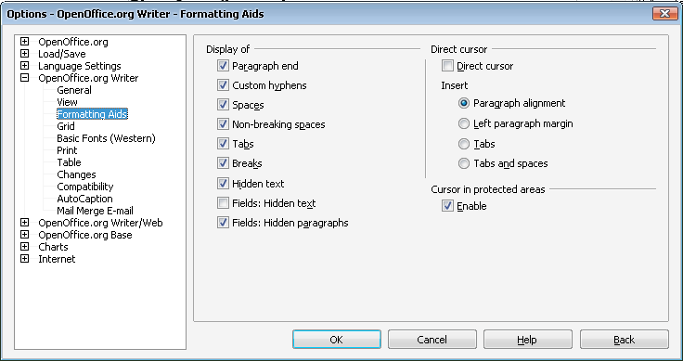Figure 2:

Show field shading
This is a pure precaution – if the fields are shaded it will eliminate the risk of you altering or deleting them inadvertently
- Click on View in the Open Office menu bar
- Select on the Field Shadings in the View menu to add the check mark (make sure it is not already selected).
- Other selections may vary from what you see in the Figure 2: and need not necessarily be changed.

Review the standard text
The template contains standard pre-written text throughout. This text will be included in all documentation based on the template. Please review this carefully to ensure that it meets with your institute’s approval.
Make any changes required and then review the cover page watermark (see “Review the cover page watermark” below and “Review the page headers” on page 13).
If you make any changes you will need to save a new version of the template. Instructions for doing this are given in the section “Saving your customized template” on page 51
A “Your logo here” watermark place marker is included in the template. It appears on the cover page, the copyright page and the acknowledgements page.
If you wish to include your institute’s logo as a watermark please follow the instructions in the section “Adding your institute’s watermark”on page 44.
If you make any changes you will need to save a new version of the template. Instructions for doing this are given in the section “Saving your customized template”on page 51

Review the page headers
A “Your logo here” place marker is included in the odd-numbered page headers in the template.
If you wish to include your institute’s logo in the odd-numbered page headers in the template please follow the instructions in the section “Adding your institute’s logo” on page 48
If you make any changes you will need to save a new version of the template. Instructions for doing these are given in the section “Saving your customized template” on page 51

Check Your AutoText
OpenOffice saves AutoText entries to categories in files with a *.bau extension.You can make custom AutoText files available to all users or to individual users of a network installation of OpenOffice.

To Add an AutoText Directory to an OpenOffice.Installation
- Click on Tools in the Open Office menu
- Select Options from the Tools menu
- In the list of default paths, select AutoText, and then click Edit.
- In the Edit Paths dialog box, click Add.
- Locate the directory that contains the ODL Course Manual Template.bau files that you want to add and click the Select button.
- In the Edit Paths dialog box, click OK.
- In the Options - OpenOffice. - Paths dialog box, click OK.
- If you click on Edit in the OpenOffice Menu. Select the AutoText opton from the Edit menu, you will be able to see the ODL Course Manual Template category listed among the Categories within your OpenOffice Application.

Using the ODL Course Manual template

Open a new ODL Course Manual document
Open a new document based on the ODL Course Manual template following the instructions below—either “From the user templates directory” or “From a personal directory” depending on where you saved the template.

From the user templates directory
If you have saved the template in your user templates directory you can call upon it each time you wish to create a new document based on the template:
- Open Open Office.
- Click on File in the Open Office menu bar
- On the New File Menu, Click on the Templates and Documents option.
- A New Templates and Documents pane will open. (see Figure 3: below):
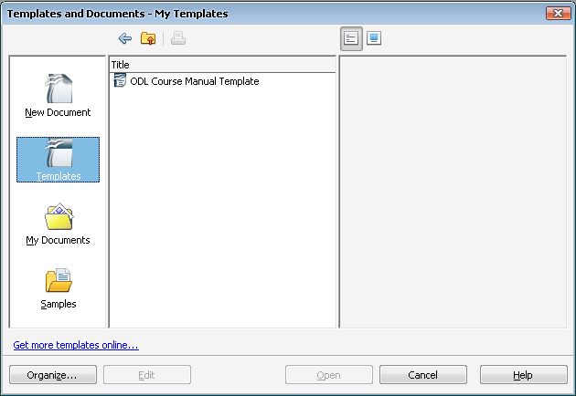Figure 3:
- Click on the Templates option (as shown in Figure 3: above)
- The Titles option will be populated
- Double-Click on the My templates and select ODL Course Manual template from the list of your templates.
- Click on OK
- A new document based on the template will be opened.

From a personal directory
- Go to the directory in which you saved the template.
- Double-click the ODL Open Office Course manual template.ott file
- If you saved the template on your Desktop all you need to do is double-click the icon.
- A new document based on the template will be opened.

Save your new document
Although you have not made any changes to this new document, now is a good time to save it:
- Choose a unique name appropriate for your new course manual.
- Save it in your usual directory.

Print your new document

Why should I do this?
A printed copy of a new ODL Course Manual will serve as a handy reference tool while you are working on the content of your own course manual.
If you follow the instructions below, the new document will print with all the on-screen Help boxes.
- Click on File in the Open Office menu bar
- Click on Print from the File menu.
- Click on the Options button in the Print dialogue box
- Click inside the Hidden Text check box in the Print dialogue box to select it (See Figure 4: below)
- Other selections may vary from what you see below and need not necessarily be changed.
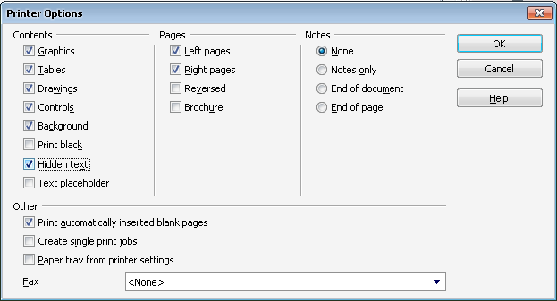Figure 4:
- Click Ok

Switch on Show/Hide formatting marks

Why should I do this?
The entire structure of the template is built using document styles (see “Understanding Styles”on page 25 for more information on document styles). Any inadvertent deletion of an end-of-paragraph marker (¶) during the creation/editing process can have catastrophic results.
During the document creation process it is good practice to work with the Show/Hide formatting marks switched on (see margin graphic):
- The Show/Hide button in the Standard toolbar is a toggle switch: a single click alternates between off or on.

Complete the introductory pages
The introductory pages include the cover page to the “Getting around this [document type] ” section.
Follow the on-screen “Help!” prompts—or a printed version of your new document if you choose to switch off the help prompts—to complete the introductory pages

What to look out for!

Cover page

The [DOCUMENT TYPE] form field
- Double -click inside the [DOCUMENT TYPE] form field and replace the text in the value field without pressing the caps key—even for the first letter. (see Figure 5: below)
.
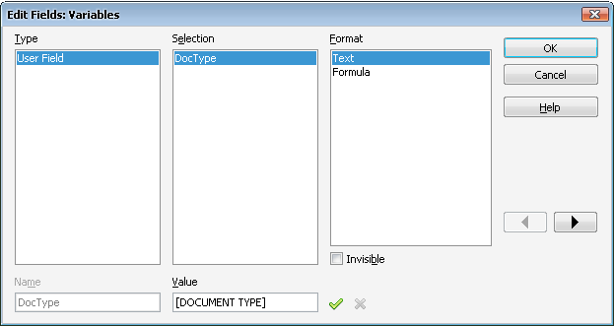Figure 5:
(See TechNote below if more explanation is required).

TechNote | The [DOCUMENT TYPE] form field has been formatted using ALL CAPS and should not be changed.  Why?  The formatting in the form field is nothing more than a mask: a way of formatting the text in a style consistent with the front cover while— behind the scenes—reproducing the content in lower case throughout the document.
If you wish to override this setting you may do so as follows:
- Click the [DOCUMENT TYPE] form field to select it.
- Click on Format in the Open Office menu.
- Click on Character option .. in the Format menu.
- Select the Font Effects Tab on the character dialogue box
- Change the Capital option to (Without) option on the Effects heading
- Click on the OK button.

Remember! Without the ALL CAPS formatting the text you type in this form field will be exactly how it appears in the document. If you have changed it following the steps above and do not like the result you can repeat the steps above selecting Capitals once again and then …
… <CTRL>+<A>, then <F9> to effect the changes everywhere

The [Add course title here] form field
If your course title is very long and splits on to two lines there are two options to consider:
- Select the course title you have typed and reduce the font
- Currently the font size is 28pt. Try 26, then 24, then 22, etc. until your course title fits neatly on one line
- Try splitting the title into two parts and use the [Course sub-title] field
- See the cover of this user guide as an example.

Note it! | The course sub-title field is not included in the odd-numbered page headers!  If you use this form field as part of your course title you should check that what you have typed in the [Course title] form field will be suitable in the header.

The [Your logo here] watermark
This is a place marker for your institute’s watermark. Please refer to the section “Adding your institute’s watermark”on page 44 for instructions on adding your own watermark or removing the place marker.

Contents page

The [Your logo here] header logo
The first page of the Contents contains a place marker for your institute’s logo. Please refer to the section “Adding your institute’s logo” on page 48
This is a one-time operation—adding your logo here will also place it on all odd-numbered pages throughout your document.

Course overview

Course outcomes
We have made provision for six course outcomes. If you require more— or you have less—please follow the instructions below for adding or deleting outcomes.

Adding an outcome:
- Place your cursor at the end of the last outcome, replace the ending full stop with a semi-colon and press <ENTER>.
- Type the outcome text—remember to start with a taxonomy verb
- See Richard Freeman’s handbook, section 3.3.3: Bloom’s taxonomy, section 3.3.4: Other taxonomies, and section 3.3.5 Learning objectives and learning outcomes.
- Select the verb and click on Custom Italics from the ODL Course Manual template mini toolbar styles list.
- Repeat as many times as necessary until your outcomes list is complete
- Remember to end the list with a full stop.

Deleting unused outcome fields
- Select the entire outcome: i.e. both form fields and the paragraph marker (¶) and press the <DELETE> key.

Course units
Now that you have completed the introductory pages you are ready to write the course content.
A course is typically broken down into units; often (but not always) a unit will correspond to a week’s work.

Recommended reading | At this point you may wish to refer to Richard Freeman’s handbook, paragraph 4.1.3, “Components that form the three-part structure”, in particular “Stage 2: Conduct the session”  Note: “Stage 1: Explain what the session will be about” and “Stage 3: Remind learners what the session was about and check they have learnt it” are taken care of by the template. See “Unit structure” below.

Tip | Unit 1 contains on-screen “Help!” fields. If you haven’t already printed your document you may wish to print Unit 1 now to help you during the completion of additional units.  You may wish to review the section “Print your new document” on page 15.

Unit structure
As soon as you have completed the unit introduction, the unit outcomes and any new terminology, you will write the unit content.
The template contains four units ready for completion: each unit comprises either form fields or pre-written text.

Help | Until now you have been using pre-set styles determined either by the click and type form fields, or the pre-written standard text.  Now that you have started on your course content you will need to make some decisions on your own. If you are not familiar with the basic principles of styles we highly recommend that you read the section “Understanding Styles” on page 25.

A complete set of styles – and how they relate to each other – is shown in the” Document style list” annex 54

Wait! Can I copy text from an existing document?
Absolutely! There are a few precautions you must take though when you copy from your old document to your new one:
Both keys must be held down at the same time!

Why is it important to do this?
Any formatting to the existing text may have undesirable results when pasted into your new ODL template document.
- Select the text you wish to copy
- With the text still selected, press <CTRL>+<C> to copy the text to the clipboard.
- Return to your new document
- make sure the cursor is in the correct position.
Both keys must be held down at the same time!
- Click on Edit in the Open Office menu
- Select the paste Special option on the Edit menu
- Click on the Unformatted Text option on the Paste Special Option dialog box.

Writing the unit content
- Complete the [First topic heading] and [Add topic text here] form fields.
- Complete the topic content.
- This will be a mixture of Text Body, bullet lists, numbered lists, etc. plus any number of activities (margin icons).
- You might like to read the section “Adding a margin icon” on page 29
- Repeat the above for each topic within the unit
Remember! A unit summary and any assignments or assessments required for the unit are already included for you in each unit structure.
- Complete the unit summary, assignment and assessment content.
- If you do not require either an assignment or an assessment for a particular unit please refer to the sections “Removing a unit assignment” (below) and “Removing a unit assessment” (below) for instructions on removing them.

Removing a unit assignment
If a particular unit does not have an assignment you may remove the section as follows:
- Save your document now!
- Make sure that you have Show / Hide switched on.
If you can see “¶” symbols they are switched on.
- Place your cursor directly in front of the Assignment heading.
- Select the entire text as far as—and including—the paragraph marker directly under the assignment box.
- Press the <DELETE> key.

Removing a unit assessment
If a particular unit does not have an assessment you may remove the section as follows:
- Save your document now!
If you can see “¶” symbols they are switched on.
- Make sure that you have Show / Hide switched on.
- Place your cursor directly in front of the Assessment heading.
- Select the entire text as far as—and including—the paragraph marker directly under the assessment box.
- Press the <DELETE> key.

Adding a new unit
- Make sure that you have Show / Hide switched on.
- Click on the last paragraph marker (¶) at the end of the previous unit.
If you can see “¶” symbols they are switched on.
- Click on the Add Autotext tool on the ODL Course Manual Template toolbar.
Figure 6:

- Do you have the ODL Course Manual Template in the Categories listed?. Double click on the ODL Course Manual Template option list all the Auto Text categorised within the template.
This filters the AutoText entries to display only those applicable to this
Open Office will remember this selection so you only need to do this once per editing session.
- Scroll down the list to display the New Unit Auto Text entry
- Click on the New Unit to select it
- Click on the Insert button
- A new unit will be added to you course manual
- The New Unit Auto Text spans two pages.
- Scroll up to the [Add Unit # here] heading and complete the unit as usual.

Removing a unit
If you do not require four units you may delete a unit follows:
If you can see “¶” symbols they are switched on.
- Save your document now!
- Make sure that you have Show / Hide switched on.
- Place your cursor directly in front of the Unit # heading.
- Select the entire text as far as—and including—the last paragraph marker directly under the assessment box at the end of the unit.
- Press the <DELETE> key

Understanding Styles
The template—and any document you create based on the template-contains styles that determine how your document is structured.
All the styles used in the template are included in the Style list in the ODL Course Manual template toolbar.
- The toolbar is automatically launched when you create a document based on the template. See the section “The ODL Course Manual template toolbar” on page 5.

What is a document style?
Simply put, a style determines the “look” and behaviour of a piece of text. A style can apply to a single character (character style) or a block of text (paragraph style).
A style has been applied to every element of the template—all you need is a basic understanding of these styles—the “what” and “why”—and how to choose or apply them—the “how”. This section addresses those issues briefly.

Think BACH!
There are many styles in the template but they are basically broken down into four major components:

Body Text
Body Text is the default paragraph style.
What does this mean? In text processing “default” equates to “normal”; it is the basis of all other styles and is how text appears unless you apply other styles. Other styles such as List Bullet, List Number, etc. are enhancements of the underlying “default” Body Text.

AutoText
Although not strictly a style, Auto Text is included here as it is used heavily throughout the template. In the context of the ODL Course Manual template Auto Text refers to pre-formatted elements you will add to the basic template structure to enhance and personalize your document.
- Auto Text ensures the correct positioning and formatting of text associated with graphics, illustrations, tables, text boxes, etc.
- The Auto Text entries are contained in the Auto Text button on the ODL Course Manual template toolbar.

Characters
Tip
Tip | Avoid using the Bold and Italics buttons on the Formatting toolbar. Instead use Custom Bold and Custom Italics on the Styles and Formatting menu see the comparison below:  This is regular bold This is Custom Bold  This is regular italics This is Custom Italics

A character style is one that you apply to a single character or groups of characters within an existing paragraph. Look at the example below:
“The quick brown fox jumps over the lazy white dog.”
- The entire sentence is formatted with the paragraph style Quote
- The words “quick” and “lazy” are formatted individually with the character style Custom Italics.
- The words “fox” and “dog” are formatted with the character style Custom Bold.

Headings
A Heading style is what you use to give your document structure. The Heading level you choose will determine the hierarchical structure of your document’s Table of Contents.

What is my current style?
Any text that you type will automatically have a style applied to it.
Determining which style is applied to existing text is easy:
- Click anywhere inside the text and check the Style list (see Figure 7: below).
Figure 7:

Changing an existing style?

Why would I want to do this?
You may wish to choose a different heading level, or you may wish to apply bullets to a list.

How do I choose a style?
- Scroll through the introductory pages of your new document.
Check the “Document styles list” annex on page 57.
- Click on a heading or a piece of text that you think will fit.
- Check the Style in the Style list in the ODL Course Manual template toolbar(see Figure 8: below)

Applying a new style
- Save your document now!
If you can see “¶” symbols they are switched on
- Make sure that you have Show / Hide switched on.
- Select the entire text as far as—and including—the paragraph marker at the end of the text
- Click on the down arrow in the Style list in the ODL Course Manual template toolbar
- Scroll to the top of the list and click on Clear Formatting (see margin)
- This is a precaution—any existing formatting could interfere with the formatting of a new style.
- Click on the down arrow in the Style list in the ODL Course Manual template toolbar(See Figure 8: below).
Figure 8:
- Scroll through the list—or type the first letter of the style name if you know it—and click on the style name.

Using Graphics

Margin icons
A complete set of margin icons has been included within the template. Each icon represents a particular theme, e.g. activity, assignment, case study, etc.

TechNote | The graphics included in the ODL Course Manual toolbar have been defined as AutoText entries.(see Figure 9: below)  The AutoText entry controls the precise size and positioning of the graphics.

Why margin icons?
These icons serve to “signpost” a particular piece of text, a new task or a change in activity.

Reading | See Richard Freeman’s handbook, section 4.4: Illustrative devices for more information concerning the use of graphics in ODL materials.
The icon set contained in the template is shown below.

 |  |  | 
Activity | Assessment | Assignment | Case study
 | 
Discussion | Group activity | Help | Note it!
 |  |  | 
Outcomes | Reading | Reflection | Summary
 | 
Terminology | Time | Tip

Adding a margin icon
You have already seen examples of margin icons in this user guide (e.g. Recommended reading, TechNote, Tip, Help).
To add a margin icon:
If you can see “¶” symbols they are switched on.
- Make sure that you have Show / Hide switched on.
- If your cursor is at the end of a line with existing text press <ENTER> to go to a new line.
- With the cursor on the new line, choose Body Text from the Style list
- This is just a precaution—whatever style is applied to the empty” line is the style that will follow the margin icon.
- Click on the AutoText button on the ODL Course Manual template toolbar.(see Figure 9: on page28)
You only need to do this once per session … the next time you want to add a Graphic/Table/New Unit this selection will be remembered
- Do you have the ODL Course Manual template category? If not See the section “Check Your AutoText “on page 13
- This filters the Auto Text entries to display those applicable to the ODL Course Manual template.
- The margin icon Auto Text entries appear among the top entries of the list, scroll down to select the one you require.(see Figure 10: below)
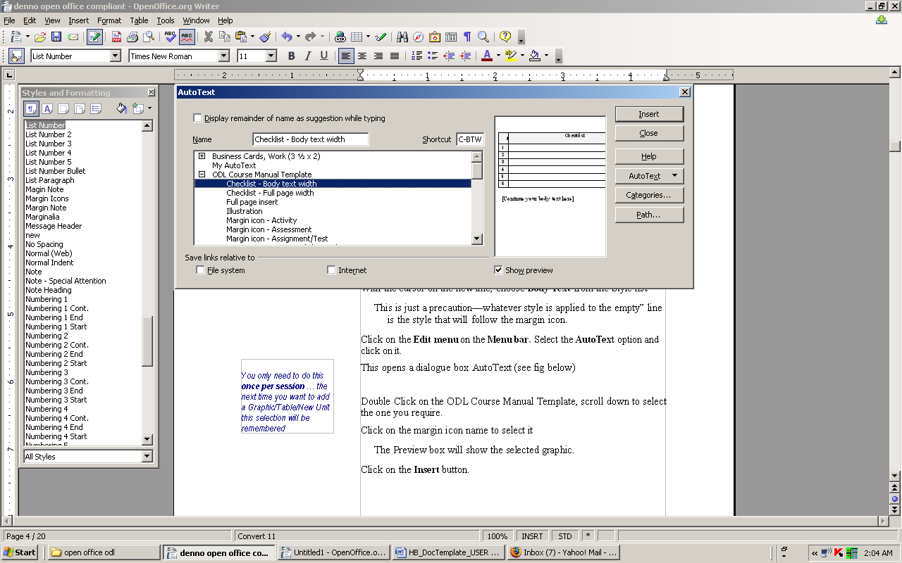Figure 10:
- Click on the margin icon name to select it
- The preview will show the selected graphic. (if not Click on the Show Preview check box )
- Click on the Insert button.

Changing the icon label
Margin icons are inserted with an optional descriptive label, e.g. Assessment, Case Study, Reflection, Reading, etc.
The icon label can be modified or deleted, as required.
- Select the label text.
- An Input Field dialogue box will appear
- Type the new text and click OK
TechNote | The Margin icon AutoText entry is actually a one-row, two-column table formatted with the “No border” option.  The borders are not visible either when previewed on-screen, converted into PDF format or printed on paper.
Formatting the AutoText entry as a table has two distinct advantages:
- It relieves you of the task of aligning a conventional text box with the margin icon
- Conventional text boxes are prone to “roaming” … during document editing there is no guarantee that a text box will stay put!
- With the click of a button you can add borders to an activity without having to draw a conventional text box.

Adding borders to margin icon text
Due to its design as a table, adding borders to a margin icon text is a quick and easy process:
This should be done only where absolutely necessary so that you do not lose consistency within your document.
- Click inside the text area (the column on the right).
- In the Table Menu click on Table Properties.
- Select the Borders Tab`(see Figure 11: below)
- Click on Set Outer Border Only option under Line arrangement heading
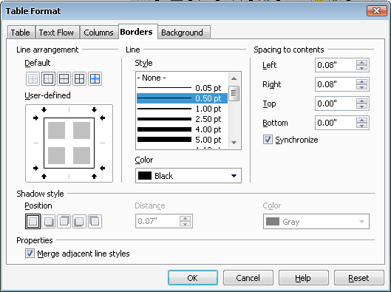Figure 11:

Changing the border colour and/or width
- Select the line style, colour and width under the Line Heading (see Figure 11: above)
- Scroll the Style list and click on a line style to select it
- Click on the arrow in the Colour to select a colour
- Click on OK.

Illustrations
The template also includes an AutoText entry to help you with the placement and formatting of additional illustrations, for example photographs, cartoons, charts, etc.
Adding an illustration is a two-part process: first you will add the illustration place marker, then you will add your illustration.

Adding the illustration place marker
- Make sure that you have Show / Hide switched on.
If you can see “¶” symbols they are switched on
- If your cursor is at the end of a line with existing text press <ENTER> to go to a new line.
- With the cursor on the new line, choose Text Body from the Style list
- This is just a precaution—whatever style is applied to the “empty” line is the style that will follow the new illustration.
- Click on the AutoText button on the ODL Course Manual template toolbar.
- Do you have the ODL Course Manual template category? See the section “Check Your AutoText “on page 13
- This filters the Auto Text entries to display those applicable to the ODL Course Manual template.
- Click on the Illustration entry to select it
You only need to do this once per session … the next time you want to add a Graphic/Table/New Unit this selection will be remembered
- Th preview will show only two red paragraph markers- this is perfectly correct
- Click on the Insert Button.
- The Illustration Auto Text comprises two red paragraph markers and a Figure # caption holder
- If this is the first illustration in your document you will see Figure 1. Otherwise the number displayed will be automatically adjusted. For example, if you already have six illustrations, this will appear as Figure 7.

Adding your illustration

Method 1: If your illustration already exists elsewhere
This method will apply to photographs, cartoons, etc.
- Copy your illustration to the clipboard.
- Click on the second of the two red paragraph markers you added in the steps above.

- Click on the Paste icon in the Standard toolbar
- or select Edit from the menu bar then Paste from the Edit menu
Tip | Depending on how your options are set, the illustration you insert may not appear in the place where you positioned your cursor. This can be easily corrected as follows:  Click on the illustration to select it  - Click on Format in the Open Office menu.  - Click on Picture in the Format menu.  - Click on Wrap tab in the Format Picture dialogue box  - Click on the None Graphics option (see Figure 12: below).  - Click OK
If you wish to make this setting permanent please follow the instructions in the TechNote entry under “Changing your picture position settings” on page Error: Reference source not found
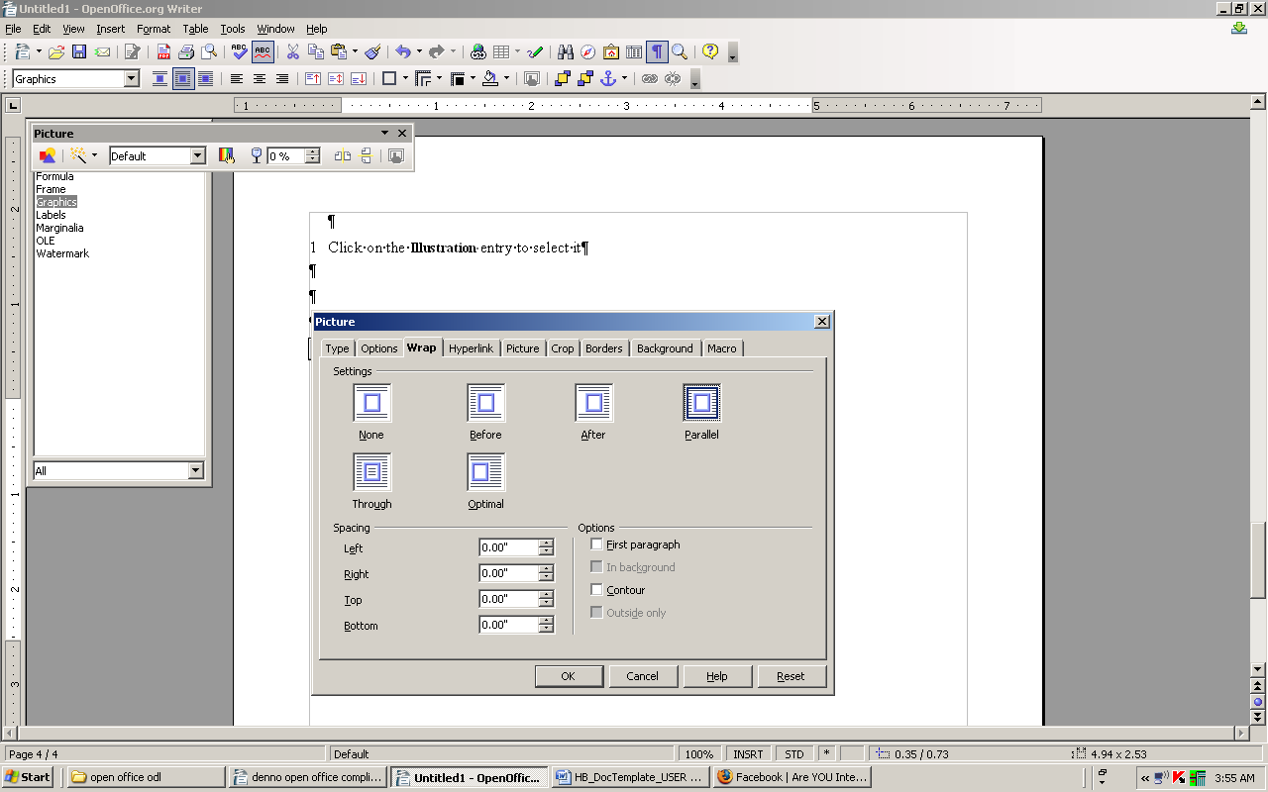Figure 12:

Method 2: If you are going to create your illustration
This method will apply to diagrams, charts, etc.
- Click on the second of the two red paragraph markers you added in the steps above.
- Create or add your illustration as applicable.

Technote | Changing your picture position settings  - Click on the illustration to select it.  - Click on Format in the Open Office menu.  - Click on Picture in the Format menu.  - Click on Type tab in the Format Picture dialogue box  - From the Position section select the position where you want to position your picture using the combo boxes (see Figure 13: below)  - Click OK

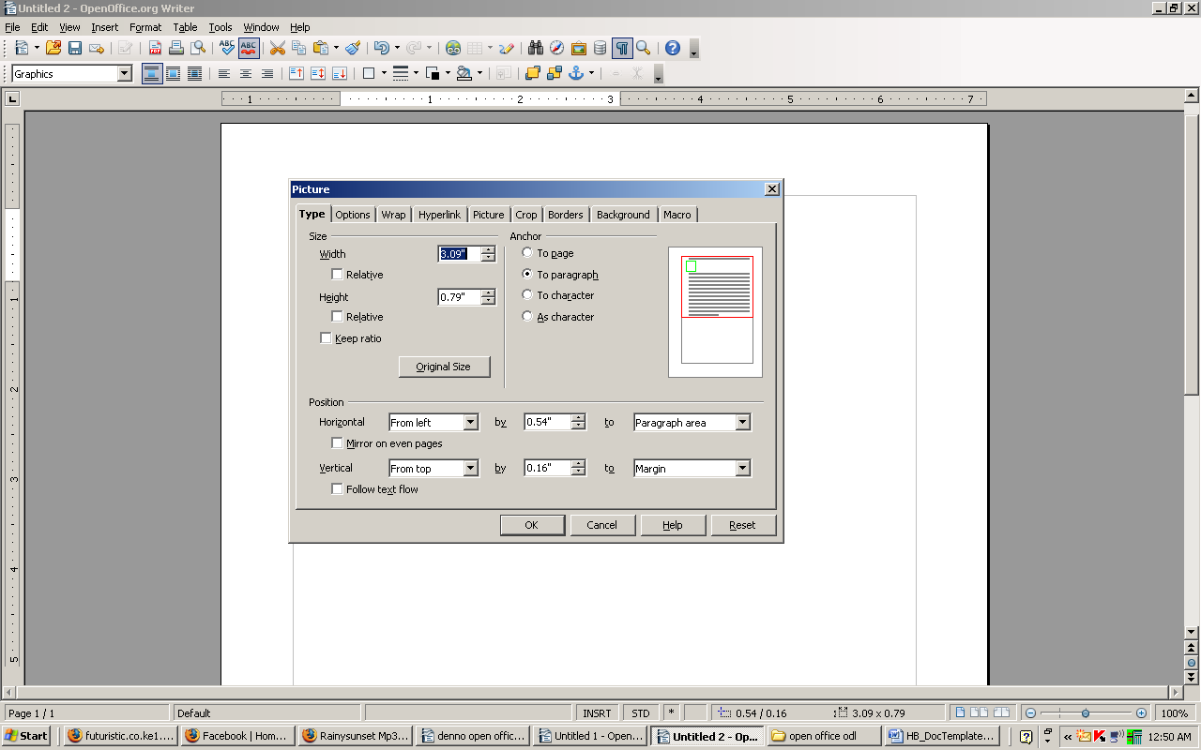Figure 13:

Checklist graphic
Use this graphic as part of a reader exercise, or perhaps where you want to emphasize—or recap—a particular activity ( see Figure 14: below)
If you can see “¶” symbols they are switched on.
# | Checklist | ☑
1 |  | ❑
2 |  | ❑
3 |  | ❑
4 |  | ❑
5 |  | ❑
6 |  | ❑
Figure 14:
- Make sure that you have Show / Hide switched on.
- If your cursor is at the end of a line with existing text press <ENTER> to go to a new line.
You only need to do this once per session … the next time you want to add a Graphic/Table/New Unit this selection will be remembered.
- With the cursor on the new line, choose Body Text from the Style list
- This is just a precaution—whatever style is applied to the “empty” line is the style that will follow the new illustration.
- Click on the AutoText button on the ODL Course Manual template toolbar.
- Do you have the ODL Course Manual template category? See the section “Check Your AutoText “on page 13.
- This filters the Auto Text entries to display those applicable to the ODL Course Manual template..
- Click on the Illustration entry to select it
You only need to do this once per session … the next time you want to add a Graphic/Table/New Unit this selection will be remembered
- Th preview will show only two red paragraph markers- this is perfectly correct
- Click on the Insert Button.

Adding extra rows to the Checklist graphic
- Click in the last column of the last row and press the <TAB> key
- A new row will appear; the numbering will continue automatically.
- Repeat as many times as necessary

Full page insert
If for any reason you need to include a page where the 7cm left margin would not work, you may switch temporarily to a full page width using the Full page insert AutoText
- Make sure that you have Show / Hide switched on.
If you can see “¶” symbol they are switched on.
- If your cursor is at the end of a line with existing text press <ENTER> to go to a new line.
- With the cursor on the new line, choose Body Text from the Style list
- This is just a precaution—whatever style is applied to the “empty” line is the style that will follow the Full page insert.
- Click on the AutoText button on the ODL Course Manual template toolbar.
- Do you have the ODL Course Manual template category? See the section “Check Your AutoText “on page 13
- This filters the Auto Text entries to display those applicable to the ODL Course Manual template.
- Click on the Full Page Insert entry to select it
- The Full page insert Auto Text entry spans two pages.
- Scroll up to go to the beginning of the new page you have just inserted
- The new page insert starts with a Heading 2 form field. If you do not require a Heading 2 level select the entire text including the end paragraph marker and apply a new heading style.

Table graphic
The Table AutoText entry is available in four formats:
- Table (Body Text width) - 2 cols (see example in Figure 15: below below)
- Table (Full page width) - 2 cols
- Table (Full page width) - 3 cols
- Table (Full page width) - 4 col
Column header | Column header
Figure 15:

About the Table graphic
TechNote | - The table header row is shaded with a light grey background and is pre-formatted so that text typed into each of the column header rows is automatically formatted with Custom Bold character formatting (see ).  - For added impact the text and borders are formatted as dark blue.  - If the table splits over on to another page the header row is automatically repeated.  - Tables automatically carry a “Figure #” caption. If this is the first graphic in your document you will see Figure 1, otherwise the number will be automatically adjusted

Inserting the Table graphic
- Make Sure that you have Show/Hide switched on.
If you can see “¶” symbols they are switched on.
- If your cursor is at the end of a line with existing text press <ENTER> to go to a new line.
- With the cursor on the new line, choose Body Text from the Style list
- This is just a precaution—whatever style is applied to the “empty” line is the style that will follow the new illustration.
- Click on the AutoText button on the ODL Course Manual template toolbar.
- Do you have the ODL Course Manual template category? See the section “Check Your AutoText “on page 13
- This filters the Auto Text entries to display those applicable to the ODL Course Manual template.
- Click on the required Table AutoText entry to select it
- The Preview box will show only the first row of the table for the Body Width table or a Section Break for the Full page width table—this is perfectly correct.
- Click on the Insert button.

Adding extra rows to the Table graphic
- Click in the last column of the last row and press the <TAB> key
- Repeat as many times as necessary.

Removing rows from the Table graphic
- Click in the first column of the first row to be deleted.
- Hold down the mouse key and select all the rows to be deleted
- The selected rows will be highlighted in black.
- Select Table from the Open Office menu bar.
- Select Delete from the Table menu.
- Select Rows from the Delete pop-up menu.

Text Box graphic
The Text Box graphic is available in two formats: Body Text width and Full page width.
The Text Box graphic has a double-line dark blue border for emphasis. To complement this any text that you type will also be blue.
If you are going to print your document on a non-colour printer, please review the Tip in the section Spot colour on page 9.
- Text Box – Body Text width
The Body Width text box is the exact width of the document body text.
- Text Box – Full page width
The Full page width text box follows the Page Setup, i.e. 2.5 cm left and right margins.
If you can see “¶” symbols they are switched on
This is a Text Box – Body Text width
The Text Box format has been defined as an AutoShape. As you enter text the Text Box will resize itself to accommodate the text.
You can include any of the formatting styles in a Text Box:
- You can include the List Bullet style in a Text Box.
- You can include the List Number style in a Text Box.
Figure 16:
- Make sure that you have Show / Hide switched on.
- If your cursor is at the end of a line with existing text press <ENTER> to go to a new line.
- With the cursor on the new line, choose Body Text from the Style list
- This is just a precaution—whatever style is applied to the “empty” line is the style that will follow the text box.
- Click on the AutoText button on the ODL Course Manual template toolbar.
- Do you have the ODL Course Manual template category? See the section “Check Your AutoText “on page 13
- This filters the Auto Text entries to display those applicable to the ODL Course Manual template.
- Scroll down the list and click on the required Text box AutoText entry to select it
- The Preview box will show the blue text box border.
- Click on the Insert button.
- Click on the form field inside the Text Box An Edit dialogue box appears. Ttype your text and press OK.
- Click on the form field below the Text Box and continue as normal.

Writing Space graphic
Figure 17:
The Writing Space graphic is used to indicate where the reader is required to write information.
Make sure that you have Show / Hide switched on.
If you can see “¶” symbols they are switched on.
- If your cursor is at the end of a line with existing text press <ENTER> to go to a new line.
- With the cursor on the new line, choose Body Text from the Style list
- This is just a precaution—whatever style is applied to the “empty” line is the style that will follow the text box.
- Click on the AutoText button on the ODL Course Manual template toolbar.
- Do you have the ODL Course Manual template category? See the section “Check Your AutoText “on page 13
- This filters the Auto Text entries to display those applicable to the ODL Course Manual template.
- Scroll to the end of the list and click on the Writing Space AutoText entry to select it
- The Preview box will show the first two lines of the writing space.
- Click on the Insert button.
- Click on the form field below the Writing Space graphic and continue as normal.

Adding additional lines to the Writing Space graphic
The Writing Space graphic is actually just a one-column, 6-row table with a line on the bottom of each row.
Additional rows can be added as required:
- Click in the last row of the graphic.
- Press the <TAB> key.
- Repeat as many times as necessary
- Each press of the <TAB> key gives you a new line.

Printing your ODL course manual
When you print (or preview) your course manual you will undoubtedly see a number of blank pages.

Note it! | Do not remove these blank pages from the printed copy: they are required for the correct placement of the odd and even page headers in duplex (“recto verso”) printing.  Removing them will have undesirable results in the final publication.

Choosing a different paper size
Note it!
Note it! | The ODL course manual template has been designed to print in A4 format. You will only need to do this if your printer uses a paper size other than A4, for example Letter size paper.  The instructions below will change the print format without affecting the physical layout of the document.

- Select File from the Open Office menu bar.
- Select Print from the menu.
- Click on properties on the print dialogue box .
- Select the new paper size in Scale to paper size under the (See Figure 18: below).
This procedure scales the document for the current printing session only. You will need to repeat for each print request.
- Click OK
Figure 18:

Customizing the template

Adding your institute's watermark
A “Your logo here” watermark place marker is included in the template. It appears on the cover page, the copyright page and the acknowledgements page.
You will only need to perform this operation once!
The instructions below will guide you step by step on how to replace this with your own logo.

Note it! | Before you start this process, make sure that you have a copy of your institute’s logo installed on your computer and that you know how to insert it into an Open Office document.

- Open the directory that contains your logo. While placing your cursor over the logo, right click and select copy option
- Open a new Open Office, click on Edit menu and select paste to insert a copy of your institute's logo.
- .Click on the logo to select it
- Click on Format in the Open Office menu
- Click on Picture in the Format menu
- The Format Picture dialog box will be displayed. From here you will fix the size and position of the logo

Setting the watermark characteristics
- Click on the Type tab in the Picture dialog box (seeFigure 19: below).
- Check that the Keep Ratio is ticked (this ensures that the height/ width ratio will be maintained).
- Change the Height to 15 cm (5.91 “)
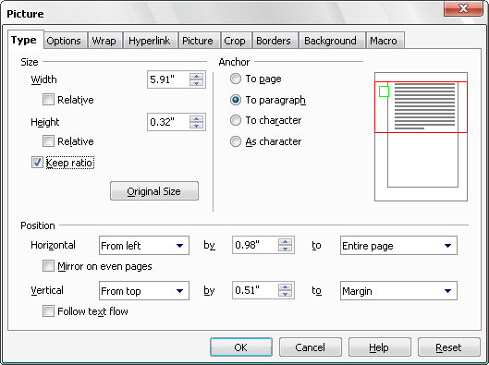Figure 19:
- Click Ok
- Right Click on the image and Select Save Graphics option
- Give your image a name and save it on the Desktop or any other folder within your computer

Adding the watermark to your document
- Go to the first page of your document (press <CTRL>+<Home> if you are elsewhere in the document).
Note: this is a one-time operation. The template automation will ensure that when you have added your watermark to the front page of your document it will also appear on the copyright and acknowledgement pages
- Select Styles and Formatting from Format menu bar.
- On the Styles and Formatting window, select the Page Style Category
- Right Click on the First Page Style and select Modify (see Figure 20: below)
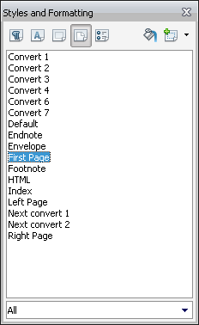Figure 20:

- Click on the Background Tab
- Select As option as Graphic
- Click Browse and navigate to where you saved your watermark image then click open.
- Under position, click on the center radio button (see Figure 21: below)
- Click OK

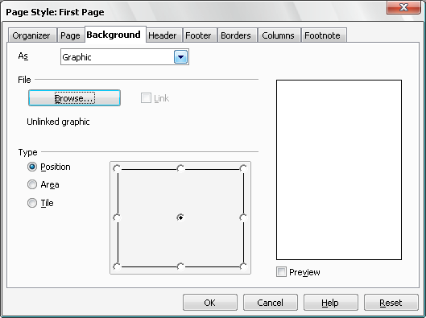Figure 21:

If you do not wish to include a customized watermark
- Go to the first page of your document (press <CTRL>+<Home> if you are elsewhere in the document)
Note: this is a one-time operation. The template automation will ensure that when you have removed the place marker on the front page of your document it will also remove from the copyright and acknowledgement pages.
- Select Styles and Formatting from Format menu bar.
- On the Styles and Formatting window, select the Page Style Category
- Right Click on the First Page Style and select Modify (see Figure 20: above)
- Click on the Background Tab
- Select As option as Colour
- Under Background Colour, Select No fill
Click OK

Customizing the header

Adding your institute’s logo
A “Your logo here” place marker is included in the odd-numbered page headers in the template.
The instructions below will guide you step by step on how to replace this with your own logo.

Note it! / | Before you start this process, make sure that you have a copy of your institute’s logo installed on your computer and that you know how to insert it into an Open Office document.

- Open a new Open Office document and insert a copy of your institute's logo.
- Click on the logo to select it
- Click on Format in the Open Office menu bar
- Click on Picture in the Format menu
- The Format Picture dialog will be displayed. From here you will fix the size and position of the logo

Setting the logo size
- Click on the Type tab in the Picture dialog box (see Figure 22: below).
- Check that the Keep Ratiois ticked (this ensures that the height/ width ratio will be maintained).
- Change the Height to 1.2 cm
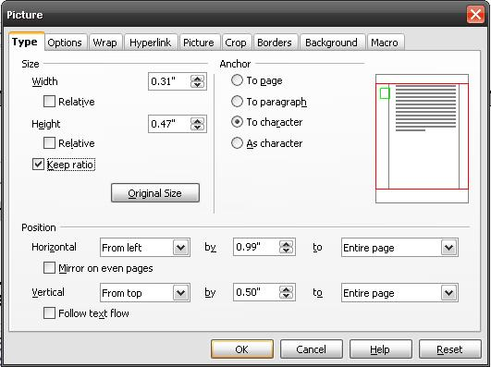Figure 22:

Copying the logo to your ODL manual
With the resized logo selected:
- Click on the Copy icon in the standard toolbar
- or press the <CTRL>+<C> keys.
- Go to the first page of your document (“About this [DOCUMENT TYPE])”.
Note: this is a one-time operation. The template automation will ensure that when you have added your logo to the first page of the Contents it will appear throughout the document.
- Click on the sample “Your logo here” icon to select it.
- Press <Delete> to remove the sample icon.
- Make sure your cursor is positioned where the initial sample logo was and click on the Paste icon in the standard toolbar
- or press the <CTRL>+<V> keys.

Setting the logo position
With the logo selected
REMEMBER! This is a one-time operation!
- Click on Format in the Open Office menu bar.
- Click on Picture in the Format menu
- The Picture dialog box will be displayed here you will fix the position of the log.
- Click on the Type tab in the Format Picture dialogue box
- Set Horizontal from left to 0.99” to entire page
- Set Vertical from top to 0.50”to entire Page (see Figure 22: above).
- Click on OK.

If you do not wish to include a customized logo

- Go to the first page of the Contents.
Note: this is a one-time operation. The template automation will ensure that when you remove your logo to the first page of the Contents it will also remove throughout the document.
- Click on the sample “Your logo here” icon to select it.
- Press <Delete> to remove the sample icon.

And the COL logo?
If you are not including your institute’s logo in the header then you will probably not want to include the existing COL logo. Follow the steps below to remove it.
Go to the second page of the Contents.
Repeat steps 2-3 above.

Saving your customized template
Any changes that you make to a document based on the template will affect only the current document and not the template.
If you wish to make changes that are applicable to all future documents you can make these changes permanent by saving your document as a template. Instructions are given below.
We strongly recommend that you contact your institute’s technical support service before doing this.
- Choose File from the Open Office menu bar.
- Choose Save As from the File menu.
From the Save As dialog box:
- Click on the arrow on the right of the Save in: box and select the same folder as the one containing the ODL Course Manual template you downloaded from the COL website.
- Type an appropriate name for the new template in the File name: box, e.g. ODL Template-[your institute name].
- Click on the arrow on the right of the Save as type: box and choose ODF Text Document Template (.ott) from the list.
- Click on Save
- Save your new template in the same location as the original ODL Course Manual template
You may wish to review the section “Saving the template on your computer” starting on page 4 before you do this.

Resources

Publications
Creating learning materials for Open and Distance Learning: A Handbook for Authors & Instructional
Designers, Richard Freeman, Commonwealth of Learning, 2005

Websites
- http://www.how-to-study.com/
A study skills resource site
- http://www.ucc.vt.edu/stdysk/stdyhlp.html
Website of the Virginia Tech, Division of Student Affairs.
- http://www.howtostudy.org/resources.php
The Chemeketa Community College website.

Annex
Document Styles List
ODL Course Manual template

Document styles list

Paragraph styles
In this annex you will discover the most frequently used styles in the ODL Course Manual template.
Styles are broken down into two categories—paragraph styles and character styles.
Paragraph styles control all aspects of a paragraph’s appearance, such as text alignment, tab stops, line spacing, and borders.
Character formatting styles are described in “Characters” on page 26.
The examples that follow are the five Heading styles as well as the most commonly used paragraph styles.
Body Text has been inserted throughout to demonstrate how the different styles relate to Body Text

Heading 1
Heading 1 is formatted in dark blue font. Heading Level 1 always starts on a new page.
When you press <ENTER> after Heading 1 it is automatically followed by Heading 2.

Heading 2
Heading Level 2 has a distinctive top border. Heading Level 2 is automatically followed by the Body Text style.
Sample Text. Sample Text. Sample Text. Sample Text. Sample Text. Sample Text. Sample Text. Sample Text. Sample Text. Sample Text. Sample Text. Sample Text. Sample Text. Sample Text.

Heading 3
Heading Level 3 is automatically followed by the Body Text style.
Sample Text. Sample Text. Sample Text. Sample Text. Sample Text. Sample Text. Sample Text. Sample Text. Sample Text. Sample Text. Sample Text. Sample Text. Sample Text. Sample Text.

Heading 4
Heading Level 4 is automatically followed by the Body Text style.
Sample Text. Sample Text. Sample Text. Sample Text. Sample Text. Sample Text. Sample Text. Sample Text. Sample Text. Sample Text. Sample Text. Sample Text. Sample Text. Sample Text.

Heading 5
Heading Level 5 is automatically followed by the Body Text style
Sample Text. Sample Text. Sample Text. Sample Text. Sample Text. Sample Text. Sample Text. Sample Text. Sample Text. Sample Text. Sample Text. Sample Text. Sample Text. Sample Text.

Body Text style
Body Text style is the standard paragraph style used throughout your document.
Sample Text. Sample Text. Sample Text. Sample Text. Sample Text. Sample Text. Sample Text. Sample Text. Sample Text. Sample Text. Sample Text. Sample Text. Sample Text. Sample Text.

List Bullet style
- This is List Bullet style.
- When you press <ENTER> you automatically get another List Bullet style.
- To revert to Body Text simply select the bullet—including the end
- paragraph marker—and choose Body Text from the Style list.
Sample Text. Sample Text. Sample Text. Sample Text. Sample Text. Sample Text. Sample Text. Sample Text. Sample Text. Sample Text. Sample Text. Sample Text. Sample Text. Sample Text.

List Bullet 2 style
- This is List Bullet 2 style.
- You would only normally use this style after List Bullet style to create a sub-list.
- When you press <ENTER> you automatically get another List Bullet 2 style.
- To revert to Body Text simply select the bullet—including the end paragraph marker—and choose Body Text from the Style list.

Margin Note style
Use Margin Note style to add brief explanatory text.
To create a Margin Note just type your text in the body, select it and choose Margin Note from the Style list. It will automatically be formatted correctly and placed in the margin.
This is a Margin Note. This is a Margin Note. This is a Margin Note.
Sample Text. Sample Text. Sample Text. Sample Text. Sample Text. Sample Text. Sample Text. Sample Text. Sample Text. Sample Text. Sample Text. Sample Text. Sample Text. Sample Text.

Question style
Use Question style to ask your reader a question.
Question style. Question style. Question style. Question style. Question style. Question style.
Sample Text. Sample Text. Sample Text. Sample Text. Sample Text. Sample Text. Sample Text. Sample Text. Sample Text. Sample Text. Sample Text. Sample Text. Sample Text. Sample Text.

List Number style
- This is List Number style.
- When you press <ENTER> you automatically get the next chronological number.
- To revert to Body Text simply select the list number—including the end paragraph marker—and click on the Bullets Off/On on the format tool bar.

Tip | Whenever you create a new list using List Number style Open Office will assume you want to continue the numbering from the last list in the document.
To correct this:
- Right click on the items list and choose restart numbering from the drop down(You can also Click Restart numbering in the Bullets and Numbering dialog box).

List Number Bullet style
Use List Number Bullet style to follow List Number style.
- List Number style. List Number style. List Number style. List Number style. List Number style. List Number style
- This is List Number Bullet style. Use this style to follow a list number with a bulleted list.
Sample Text. Sample Text. Sample Text. Sample Text. Sample Text. Sample Text. Sample Text. Sample Text. Sample Text. Sample Text. Sample Text. Sample Text. Sample Text. Sample Text.

List Continue style
Use List Continue style to add extra paragraphs after List Number style if you do not want the text to have either a number or a bullet.
- This is List Number style. List Number style. List Number style. List Number style. List Number style. List Number style.
This is List Continue style. List Continue style. List Continue style.List Continue style. List Continue style. List Continue style.
Sample Text. Sample Text. Sample Text. Sample Text. Sample Text. Sample Text. Sample Text. Sample Text. Sample Text. Sample Text. Sample Text. Sample Text. Sample Text. Sample Text.

List Alpha style
- This is List Alpha style.
- This is List Alpha style.
Sample Text. Sample Text. Sample Text. Sample Text. Sample Text. Sample Text. Sample Text. Sample Text. Sample Text. Sample Text. Sample Text. Sample Text. Sample Text. Sample Text.

Note style
Use Note style to draw attention to a particular point.
This is Note style. Note. Note. Note. Note. Note. Note. Note. Note. Note. Note. Note. Note. Note. Note. Note. Note. Note. Note. Note. Note. Note. Note. Note. Note. Note. Note. Note.
Sample Text. Sample Text. Sample Text. Sample Text. Sample Text. Sample Text. Sample Text. Sample Text. Sample Text. Sample Text. Sample Text. Sample Text. Sample Text. Sample Text.

Note – Special Attention style
Use Note – Special Attention style to draw attention to an important point.
This is Note – Special Attention style. Note - Special attention. Note – Special Attention style. Note - Special attention.

Quotation style
Use Quotation style when you use a verbatim quote. Quotation Style is automatically followed by Quotation Source style.
This is Quotation style. Quotation style. Quotation style. Quotation Style. Quotation style. Quotation style. Quotation style. Quotation style. Quotation style. Quotation style. Quotation style.
Quotation source
Sample Text. Sample Text. Sample Text. Sample Text. Sample Text. Sample Text. Sample Text. Sample Text. Sample Text. Sample Text. Sample Text. Sample Text. Sample Text. Sample Text.

Character styles
Character formatting is that which you apply to selected text within a paragraph – it may be a single character, a single word, or a group of words. A typical example of character formatting would be a change of font, e.g. bold or italics.

Custom Bold
Use the Custom Bold character formatting to draw the attention of the reader to important points.
Text formatted with Custom Bold uses the Arial Narrow font to make it more noticeable than the regular bold typeface on the Formatting toolbar.
- Look at the two examples in the paragraph above to see the difference.
Custom Italics
Use the Custom Italics character formatting to refer to another part of your module, or for references to other publications.
Text formatted with Custom Italics uses the Arial Narrow font to make it more noticeable than the regular italic typeface on the Formatting toolbar.
- Look at the two examples in the paragraph above to see the difference.

