Course Material for OPEN DISTANCE LEARNING
Critical Thinking & Social Media Technology

GRAPHIC ERA HILL UNIVERSITY
DEPARTMENT OF COMPUTER APPLICATIONS

Copyright
The Commonwealth of Learning (COL) is an intergovernmental organisation created by Commonwealth Heads of Government to promote the development and sharing of open learning and distance education knowledge, resources and technologies.

Commonwealth of Learning 2016
©2016 by the Commonwealth of Learning. Except where otherwise noted, Critical Thinking & Social Media Technology is made available under a Creative Commons Attribution 4.0 International (CC BY 4.0) License: https://creativecommons.org/licenses/by/4.0. By using the content of this publication, the users accept to be bound by the terms of use of the Commonwealth of Learning’s Open Access repository (http://oasis.col.org).
Disclaimer: The ideas and opinions expressed in this publication are those of the author; they are not necessarily those of Commonwealth of Learning and do not commit the organization.
Caveat: This course material was published to support the learning of students registered with Graphic Era Hill University, Dehradun, India. Neither Graphic Era Hill University, Dehradun, India nor the Commonwealth of Learning grants any degree, certification or credits based solely on your completion of this course material.
Acknowledgement: The development of this course material was supported by the Commonwealth of Learning, Burnaby, Canada as part of the Grant #2015-2585 generously made by The William and Flora Hewlett Foundation, USA.

GRAPHIC ERA HILL UNIVERSITY
DEPARTMENT OF COMPUTER APPLICATIONS
Society Area, Clement Town
Dehradun
Uttarakhand
India

Phone: +91-8439000729
E-mail: vcgehu@gmail.com
Website: www.gehu.ac.in

Acknowledgements
Graphic Era Hill University, Dehradun, India wishes to thank those below for their contribution to this Course Material:
Prof. (Dr.) Sanjay Jasola | Advisor  Vice Chancellor,  Graphic Era Hill University, Dehradun, India
Ishteyaaq Ahmad | Course Coordinator & Subject Specialist  Assistant Professor,  Department of Computer Applications,  Graphic Era Hill University, Dehradun, India
Aditya Harbola | Subject Specialist  Assistant Professor,  Department of Computer Applications,  Graphic Era Hill University, Dehradun, India
Nidhi Mehra  Dr. Ramesh Sharma | Subject Specialist  Assistant Professor,  Department of Computer Applications,  Graphic Era Hill University, Dehradun, India  External Reviewer  Former Director  Commonwealth Educational Media Centre for Asia (CEMCA), New Delhi, India

Contents

About this Course Material for OPEN DISTANCE LEARNING 1
How this Course Material for OPEN DISTANCE LEARNINGis structured 1
Course overview 3
Welcome to Critical Thinking & Social Media Technology 3
Critical Thinking & Social Media Technology—is this course for you? 3
Course outcomes 4
Timeframe 4
Study skills 4
Video Resources 6
Need help? 7
Assignments 8
Assessments 8
Getting around this Course Material for OPEN DISTANCE LEARNING 9
Margin icons 9
Unit 1 11
Critical Thinking 11
1.1 Introduction 11
1.2 Meaning 12
1.3 Definitions 13
1.4 Features of Critical Thinking 13
1.5 Techniques of Critical Thinking 15
1.6 Art of questioning 15
1.7 Interpretation 17
1.8 Analysis 18
1.9 Evaluation 20
1.10 Inference 21
1.11 Explanation 21
1.12 Self-regulation 22
1.13 Hurdles to Critical Thinking 23
1.14 Need & Importance 24
Unit summary 25
Assignment 25
Assessment 26
Unit 2 27
Social Media Technology 27
2.1 Introduction 27
2.2 Social Network 28
2.3 History of Social Networking 29
2.4 Network and Graph Theory 32
2.5 Classification of Social Network 34
2.6 Social Network Analysis 35
2.7 Advantages of Social Media 36
2.8 Recent Trends and Issues 37
2.9 Categories of Social Networking Sites 37
2.10 Hands on with popular Social Networking Sites 38
2.10.1 Blogging 38
2.10.2 Micro-blogging 40
2.10.2.1 Twitter 41
2.10.2.2 Facebook 43
2.10.2.3 Linkedin 45
2.10.3 Content Sharing Social Network 47
2.10.3.1 Instagram 47
2.10.3.2 Flickr 49
2.10.3.3Pinterest 51
2.10.3.4 YouTube 52
Unit summary 55
Assignment 55
Assessment 58
Unit 3 61
Critical Analysis of Social Media 61
3.1 Introduction 61
3.2 Information Overloads 62
3.3 Dubious Claims 63
3.4 Hoax 64
3.5 Fact-Checking Sites 64
3.6 Personal Privacy 65
3.7 Social Isolation 66
3.8 Cyber Infidelity 66
3.9 Virtual Life 67
3.10 Cyber Criminals 67
3.11 Addiction 68
3.12 Health Issues 69
Unit summary 70
Assignment 70
Assessment 71
Unit 4 72
Social Media Analytics 72
4.1 Introduction 72
4.2 Need and challenges 73
4.2.1 Why Social media data analytics needed? 74
4.2.2 Key challenges in social media data analytics 75
4.3 How social networking sites make money 76
4.4 Structured and unstructured data 78
4.5 Key performance indicators 80
4.6 Popular tools for analytics 81
4.6.1Google analytics: 81
4.6.2Twitter Analytics: 83
4.6.4 Facebook content analytics: 84
4.6.5 Vine: 85
4.6.3Klout: 85
4.6.7Gephi: 87
4.7 Social media analytics with R tool: 88
4.7.1 R installation: 88
4.7.2 R packages: 89
4.7.3 Creation of Twitter application 90
Unit summary 93
Assignment 93
Assessment 93
Unit 5 95
Ethical issues and social media cyber laws 95
Introduction 95
5.1 Defining Ethical and Influence Factors 96
5.2 Connection between Ethics and Social Media 97
5.3 Ethical Issues 98
5.4 Social Media Laws and Regulations 100
5.5 Financial Industry Regulatory Authority 101
5.6 Health Insurance Portability and Authority Act 102
5.7 Children Online Privacy Protection Act 102
5.8 United States Copyright Act 103
Unit summary 105
Assignment 105
Assessment 106
Feed Back Form 107

About this Course Material for OPEN DISTANCE LEARNING
Welcome to the course on “Critical Thinking & Social Media Technology”.
The course material titled “Critical Thinking & Social Media Technology” has been produced by GRAPHIC ERA HILL UNIVERSITY, Dehradun, India as a part of the OER for Skills Development initiative of Commonwealth of Learning. (COL). All the study material produced by Commonwealth of Learning is structured in the same way, as outlined below.

How this Course Material for OPEN DISTANCE LEARNINGis structured
The course overview
The course overview gives you a general introduction to the course. Information contained in the course overview will help you determine:
- If the course is suitable for you.
- What you will already need to know.
- What you can expect from the course.
- How much time you will need to invest to complete the course.
The overview also provides guidance on:
- Study skills.
- Where to get help.
- Course assignments and assessments.
- Activity icons.
- Units.
We strongly recommend that you read the overview carefully before starting your study.
The course content
The course is broken down into units. Each unit comprises:
- An introduction to the unit content.
- Unit outcomes.
- New terminology.
- Core content of the unit with a variety of learning activities.
- A unit summary.
- Assignments and/or assessments, as applicable.
Resources
For those interested in learning more on this subject, we provide you with a list of additional resources at the end of this Course Material for OPEN DISTANCE LEARNING; these will be primarily books or websites that the student may refer to as a part of the learning.
Your comments
After completing the course on “Critical Thinking & Social Media Technology” we would appreciate it if you would take a few moments to give us your feedback on any aspect of this course. Your feedback might include comments on:
- Course content and structure.
- Course reading materials and resources.
- Course assignments.
- Course assessments.
- Course duration.
- Course support (assigned tutors, technical help, etc.)
Your constructive feedback will help us to improve and enhance this course.

Course overview

Welcome to Critical Thinking & Social Media Technology

The two burning issues of the present century are 'Critical Thinking’ & ‘Social Media Technology’.
It is said that critical thinking finds its home in a creative mind. Here, one may argue- 'but a creative mind is God-gifted!' Yes, exceptions are always there but critical thinking skills can be acquired and allowed to bloom; given an environment of tranquillity.
Social media are computer-mediated tools that allow people or companies to generate, share, or exchange information, career inputs, ideas, and pictures/videos in virtual communities and networks. Recently there has been an increase in number of social networking sites and their users. This course is designed to help us understand the A-Z of Social Media and its current trends.
One must always supply what is demanded and today's creative society demands confident, analytical minds and critical thinkers who know how to use social media technology. So, let us grab this opportunity and rescue our genius minds from the grip of death.

Critical Thinking & Social Media Technology—is this course for you?
This course is intended for people who aspire to know all about how to think smart, get logical, and improve decision making skills and use social networking efficiently.
By taking this course, you will be able to uncover the truth of the messages / posts appearing on social media. You will be able to know what is hoax and dubious claims, which are most prevalent these days on social media.
The student needs to have the basic knowledge of computers and Internet for course.

Course outcomes

Upon completion of Critical Thinking & Social Media Technologyyou will be able to:
  Outcomes | - Identify relevant information presented in the case or problem.  - Analyse the case or problem.  - Identify alternative solutions to the problem or case.  - Derive best solution(s) to the problem or case.  - Explain conclusions that follow from the solution(s).

Timeframe
  How long? | - The course is intended to be completed in 90 working days.  - The expected formal study time for an instructor driven programme is 42 hours and can be broadly divided as follows:  Unit 1: 10 hours  Unit 2: 10 hours  Unit 3: 8 hours  Unit 4: 8 hours  Unit 5: 6 hours  - The expected self study time will be 1 to 2 hours per day.  However, if you are doing the course on a distance learning mode where the primary learning is based on self study, you can expect to successfully learn and master the concepts in around 60-70 hours.

Study skills
 | As an adult learner your approach to learning will be different to that from your school days: you will choose what you want to study, you will have professional and/or personal motivation for doing so and you will most likely be fitting your study activities around other professional or domestic responsibilities.  Essentially you will be taking control of your learning environment. As a consequence, you will need to consider performance issues related to time management, goal setting, stress management, etc. Perhaps you will also need to reacquaint yourself in areas such as essay planning, coping with exams and using the web as a learning resource.  Your most significant considerations will be time and space i.e. the time you dedicate to your learning and the environment in which you engage in that learning.  We recommend that you take time now—before starting your self-study—to familiarize yourself with these issues. There are a number of excellent resources on the web. A few suggested links are:  - http://www.how-to-study.com/  The “How to study” web site is dedicated to study skills resources. You will find links to study preparation (a list of nine essentials for a good study place), taking notes, strategies for reading text books, using reference sources, test anxiety.  - http://www.ucc.vt.edu/stdysk/stdyhlp.html  This is the web site of the Virginia Tech, Division of Student Affairs. You will find links to time scheduling (including a “where does time go?” link), a study skill checklist, basic concentration techniques, control of the study environment, note taking, how to read essays for analysis, memory skills (“remembering”).  - http://www.howtostudy.org/resources.php  Another “How to study” web site with useful links to time management, efficient reading, questioning/listening/observing skills, getting the most out of doing (“hands-on” learning), memory building, tips for staying motivated, developing a learning plan.  The above links are our suggestions to start you on your way. At the time of writing these web links were active. If you want to look for more go to www.google.com and type “self-study basics”, “self-study tips”, “self-study skills” or similar.

Video Resources

This study material comes with additional online resources in the form of videos. As videos puts in human element to e-learning at the same time demonstrating the concepts visually also improves the overall learning experience.
Each video clip used in this study material has a corresponding QR code which has been custom generated. You can use the Print2Screen Android app to view these videos on your Android powered mobile device. The Print2Screen (Beta version) app is available for download on Google play.  You can learn how to create Print2Screen compatible QR codes for your teaching and learning materials at http://colprint2screen.blogspot.ca/2016/07/how-do-i-create-qr-codes.html or through the info menu inside the app. |   MF181: Figure 5.47 by Rosenfeld Media used under a CC BY 2.0 License (https://www.flickr.com/photos/rosenfeldmedia/7171786116/in/photolist-aNdRFX-5q5RiK-bbKjnP-iWWQsB-bVKh9L)

Need help?

  Help | Course Instructors:  1. Ishteyaaq Ahmad (Unit I & III)  Working hours: 9 am to 5 pm (India time)  Address:  Assistant Professor  Department of Computer Applications  Graphic Era Hill University  Dehradun  e-Mail : ishteyaaq@gmail.com  2. Aditya Harbola (Unit IV & V)  Working hours: 9 am to 5 pm (India time)  Address:  Assistant Professor  Department of Computer Applications  Graphic Era Hill University  Dehradun  e-Mail : adityaharbola@gmail.com  3. Nidhi Mehra (Unit II)  Working hours: 9 am to 5 pm (India time)  Address:  Assistant Professor  Department of Computer Applications  Graphic Era Hill University  Dehradun  e-Mail :nidhigehu@gmail.com

Assignments

  Assignments | There are five units in the course and each unit has an assignment at the end of the unit. You must first complete the study of the unit and then attempt the assignment. It is suggested that the assignment be attempted by the student in the classroom and the doubts can be cleared by the course instructor before moving ahead with the next unit.  The assignments can be done in the same order in which the units have been presented.

Assessments

  Assessments | There are five units in the course and each unit has an assessment at the end of the unit.  You must first complete the assignment in the classroom, look at the answers and the explanations wherever required, get the doubts cleared by your instructor and then attempt the assessment.  The assessment is the final evaluation of your understanding of the lesson learnt and will be assessed and marked by the course instructor. It is suggested that the assessment for a particular unit be carried out at the end of the unit and in the same order in which the units appear in the course material.

Getting around this Course Material for OPEN DISTANCE LEARNING

Margin icons
While working through this Course Material for OPEN DISTANCE LEARNING you will notice the frequent use of margin icons. These icons serve to “signpost” a particular piece of text, a new task or change in activity; they have been included to help you to find your way around this Course Material for OPEN DISTANCE LEARNING.
A complete icon set is shown below. We suggest that you familiarize yourself with the icons and their meaning before starting your study.

 |  |  | 
Activity | Assessment | Assignment | Case study
 |  |  | 
Discussion | Group activity | Help | Note it!
 |  | 
Outcomes | Reading | Reflection | Study skills
 |  |  | 
Summary | Terminology | Time | Tip

Unit 1

Critical Thinking

1.1 Introduction
Ever heard of the ‘five monkeys in a cage’ experiment?
If no, just read on. If yes, did you learn any lesson?
This is a famous fable on Internet based on a related experiment published in a 1966 paper titled “Cultural Acquisition Of A Specific Learned Response Among Rhesus Monkeys” by a researcher called G.R. Stephenson. The story goes as follows:
Five monkeys were put in a cage. There was a banana hanging from the ceiling of the cage with a ladder just below it. On seeing the banana, one of the monkeys rushed toward the ladder. As he started to climb, cold water was sprayed in the cage. Along with the monkey climbing the ladder, all the other monkeys also got wet.
After a short while another monkey tried to climb the ladder and the same thing happened. On seeing this, none of the other three monkeys dared to climb up the ladder. After sometime, the shower of cold water was shut down and one of the monkeys in the cage was replaced. Unaware of what was going on in the cage, the new monkey ran towards the ladder to grab the banana. But as soon as he started to climb, he was dragged down and was beaten up by the other four monkeys.
The poor monkey had no idea why he was beaten up but realized that he should not climb the ladder.
Next, another of the original monkeys was replaced with a new monkey. The same situation followed. All the three original monkeys started beating up the second newcomer as soon as he started to climb the ladder. Interestingly the first newcomer also joined the group! The second newcomer also learned his lesson.
This process was repeated till all the original monkeys were replaced by new monkeys. When the fifth newcomer tried to climb the ladder, all the other four newcomers, who actually had no idea why they were beaten up, started to beat him.
If you were in the place of the new monkeys, who had no idea of the situation, you would definitely have asked, “Why are you beating me?”
Did this experiment knock your mind? If no, here is something for you to reflect on.
Human beings are social animals considered superior to any other animal. What distinguishes man from animal is the quality of thinking.
The next section will introduce you to aconcept called critical thinking. This is not a new concept butit has been recently considered as one of the many skills that can help you to take reasonable and sensible decisions.
Upon completion of this unit you will be able to:
Outcomes | - Understand critical thinking.  - Identify different sub-skills to acquire the skill of critical thinking.  - Distinguish various skills of critical thinking.  - Remove hurdles to critical thinking.  - Solve problems using critical thinking.

Terminology | Thinking: | The action of using our mind to produce ideas, decisions, memories, etc.
 | Critical Thinking: | Ability to think distinctly and rationally.
 | Interpretation: | Action of explaining the meaning of something
 | Analysis: | Detailed examination of the elements or structure of something.
 | Evaluation: | Systematic and objective assessment of a project/programme/policy
 | Inference: | Conclusion drawn based on evidence and reasoning
 | Explanation: | Thoughts in proper order so that it clearly justifies the conclusions drawn

1.2 Meaning
The mind has an incredible capacity to generate millions of ‘thoughts’ beyond imagination. These ‘thoughts’ are the product of a mental process called ‘thinking’. Everything is in the mind and your thoughts guide you in shaping your mind. Hence it is of utmost importance to carefully frame your mental upbringing.
Thinking is not just a mental process but an acquired skill that assists man in the decision making processes of everyday life. It is an institution for learning and understanding that helps make sense of, interpret, represent or learn from experience and forecast in similar or not so similar situations of the world.
Broadly speaking, thinking may be categorised as follows:
- Positive and Negative
- Conscious and Unconscious
- Divergent and Convergent.
The first two types are beyond the scope of the current discussion. This study material would therefore concentrate on Divergent and Convergent thinking. Divergent means ‘different’ and convergent means ‘coming close’. While convergent thinking evaluates the validity and worth of something existing, divergent thinking produces a totally new idea. Critical thinking is a type of convergent thinking while creative thinking is a type of divergent thinking.
While thinking comes to us naturally, critical thinking is an acquired skill. It requires lot of effort to train the mind to think critically. Actions respond to the thoughts. Being smart or intelligent is not a result of qualification or education but it depends on how we think! Once you master this art of thinking, youcan explicitly widen your horizon of knowledgeand learning.

1.3 Definitions

Critical thinking is a process of making judgements after evaluating the validity of any existing situation, event or an idea by absorbing significant available information. Such a thinking process helps us to reason out and take rational decisions in our personal as well as professional life. In other words, to think critically is to manipulate the mind instead of tracing out what we hear from others. It has been defined by different people and organisations in different ways.
The National Council for Excellence in Critical Thinking defines critical thinking as the intellectually disciplined process of actively and skilfully conceptualizing, applying, analyzing, synthesizing, and/or evaluating information gathered from, or generated by, observation, experience, reflection, reasoning, or communication, as a guide to belief and action.
Following the report by World Economic Forum, a more refined form of definition for critical thinking can be given as follows:
Critical thinking is a scientific process of manipulating the mind to make judgements on any existing issue with the available information in taking rational decisions.
In other words, Critical thinking can also be defined as a skill that challenges the theories of others and arrive at distinct and rational conclusions through investigation.

1.4 Features of Critical Thinking
There are some important features of critical thinking that are described as follows:-
- Knowledge: This is the first and most important feature of critical thinking. The theoretical and practical understanding of any subject matter clubbed with awareness and alertness of the surrounding environment is essential to think critically.

- Balanced: Generally the word ‘critical’ is synonymously used with ‘criticism’. Criticism again is mistaken for finding fault about any issue, event or situation. Itis necessary to realize the balanced nature of critical thinking that involves measuring simultaneously the pros and cons, positive and negative and the good as well as the bad.
- Rational: Critical thinking is based on reason or logic. To think rationally or logically implies, not to blindly accept anything we hear or read. It involves a systematic and scientific way of expression of thought.
- Unbiased: Another important feature of critical thinking is to remain impartial without any prejudice.
- Valid sources: Critical thinking is a process of thinking based on available data of any existing idea or situation. The data must be accurate and collected from valid sources.

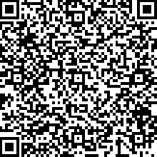  Video | This Video introduces the concept of critical thinking and its importance. What does it mean to you?  https://www.youtube.com/watch?v=dTyO4N0tbdE&index=1&list=PLXN-JCVb8z8DS1umCwF2cvJoIgxSDRP4j

Reflection 1.1 | Test your understanding of the concept of critical thinking by solving the following puzzle.  Puzzle:  Here is a village man, waiting on the banks of a river scratching his head. He has to deliver a tiger, a goat and some grass to one of his friends who live in a nearby village on the other side of the river. He has a boat to help him cross the river. The boat is so small that he can carry only one thing at a time. The tiger is domestic and will not attack him. Can you help this poor man cross the river safely along with his three belongings?  __________________________________________________________  __________________________________________________________  __________________________________________________________  __________________________________________________________  Solution:  The man first takes the goat to the other side of the river leaving behind the tiger and the grass. Reason? From basic knowledge, it is clear that if the man takes the tiger first, the goat will eat the grass or, if he takes the grass first, the tiger will attack the goat! Next, he comes back and takes the grass and drops the grass on the other side and brings back the goat. This time he leaves the goat behind and takes the tiger to the other side (remember that the tiger is domestic and will not attack the man). He comes back and takes the goat with him, thus bringing all three safely to the other side of the river!

1.5 Techniques of Critical Thinking
Once youhave understood the basic concept of critical thinking, you will now be interested to know how to acquire and develop this skill to help you in taking rational decisions in your personal as well as professional life.
To acquire the skill of critical thinking, you must first develop a craze to learn. Below are some simple but efficient sub-skills that will guide you in acquiring this skill. The following sections introduce you to the different sub-skills of critical thinking.

1.6 Art of questioning
Critical thinking has been defined as a scientific process of thinking. The most important and easy way of learning to think critically is to learn the art of questioning.
Have you ever wondered how art is different from science? ‘Art’ is concerned with aesthetics and ‘Science’ is concerned with the truth. Now, how can you know the truth? It is simple! You investigate, you ask questions.
Life is a learning process. You stop asking questions and your mind stops working. And this in turn slows down learning. Why does a child ask so many questions? It is because he has a craze to learn. Questions act as food for the mind, which consequently facilitates to think, understand and learn logically.
It is important to learn to cultivate a mind that can ask questions without fear and hunt for fundamentally alternative solutions for any problem. A person who thinks critically is driven by curiosity, doubt, surprise, disbelief, puzzlement, etc. and seeks to find answers by questioning.
Activity 1.2 | Read the following paragraph.  A superhero is a type of cartoon character possessing extraordinary talents, supernatural phenomena, or superhuman powers. They have been assigned the duty of protecting the public from evil sources. Some well known superheroes are Superman, Batman, Spider-Man, Wonder Woman, Captain America, Wolverine, Green Lantern, The Flash, Hulk, Thor and Iron Man.  How many questions came to your mind after reading the paragraph?  1._________________________________________________________  2._________________________________________________________  3._________________________________________________________  4__________________________________________________________  5._________________________________________________________  Note: If you have read the paragraph without reflecting on what is said, you have simply accepted what is said and will pass on the same information as it is said. This can be as dangerous as a virus that can affect the environment in a negative way. On the other hand, if your mind is flooded with questions after reading the paragraph, you are half way up the ladder of acquiring the skill of critical thinking.  Some of the questions that may have crossed your mind are:  - Is the above paragraph true?  - Is a superhero a fiction or have they really lived on this earth?  - Is wonder woman also called a superhero despite being a woman?  - Who assigns them the duties to protect the earth?  - Do all Superheroes wear an undergarment outside the dress?  - Who designed the dresses for the superheroes?

1.7 Interpretation
Another important sub-skill of critical thinking is Interpretation. In layman language, interpretation is the action of explaining the meaning of something. For example, an act of translating what the speaker says or an author writes without verification is interpretation.
Is there any difference in meaning between the following two sentences?
A woman without her man is nothing.
A woman: without her, man is nothing.
Both the sentences can be interpreted in different ways depending upon the use of punctuation mark. Therefore, you must keep your sense of seeing and your sense of listening alert to correctly interpret what is said.
In the context of critical thinking, interpretation is not used merely as an action to explain something, but to explain something based onobservation and perception. Perception is the ability to see, hear, understand and interpret. In order to interpret something correctly, you must keep yourself alert and up-to-date and armoured with clear perception and use valid available information so that you can draw some meaningful conclusions.

Activity 1.3 | Test your interpretation skills  Observe the following pie-chart carefully. It shows the percentage distribution of the expenses incurred in carrying out a project:  By what percent is Cost of Contingency less than Cost of Transportation?  Four options are given to you. Which is the correct answer according to you?  - 5% (b) 25 % (c) 10 % (d) 15%
Answer: Option B
Was your answer 5%? Find out why it is wrong.
The answer to the above problem is given below:
Percentage is a proportion or share in relation to a whole. 20% transportation cost means that if the cost of project (C.P) is 100, the share of transportation out of the total cost of project is 20. Similarly, contingency of the project is 15 out of a total of 100.
Now, to calculate percentage decrease: First work out the difference (decrease) between the two numbers you are comparing. Then divide the decrease by the original number and multiply the answer by 100. If your answer is a negative number then this is a percentage increase.
Thus,
Transportation Cost of Project = 20% of C.P.
Contingency of the Project= 15% of C.P.
Difference = (20% of C.P.) - (15% of C.P) = 5% of C.P.
- Percentage difference = $\left(\frac{Difference}{Transportation Cost} ×100\right) \%$
=$\left(\frac{5\% of C.P}{Transportation Cost} ×100\right) \%$ = 25%

1.8 Analysis
Analysis is amore detailed and scientific route to acquiring the skill of critical thinking.
Analysis means detailed examination of the elements or structure of something. In this technique, a complex topic or information is broken down into smaller parts in order to gain a better understanding of it and discover their interrelationships.
Analysis of a thought or an idea discusses the problems involved in it rather than finding solutions. This further gives rise to new questions that enhances the clarity of the content under review.
This technique of critical thinking is used for solving particularly complex problems. Analysis concentrates on ‘why’ rather than ‘how’ and it is based on facts rather than opinion.
This technique can be qualitative or quantitative. While qualitative analysis deals with theoretical concepts, quantitative analysis deals with specific numbers and data.

Activity 1.4 | Qualitative Analysis:  12 Angry Men (1957) is the Golden Bear winning, American motion picture, which was directed by Sidney Lumet. It’s remake “Ek Ruka Hua Faisla” is a 1986 Hindi film, directed by Basu Chatterjee.  Here is the plot of the film:  The story begins in a courtroom where a teenage boy from a city slum is on trial for stabbing his father to death. Final closing arguments have been presented, and the judge then instructs the jury to decide whether the boy is guilty of murder. A twelve-man jury retires to a private room to discuss the crime scene. It is immediately apparent that the jurors have already decided that the boy is guilty, and that they plan to return their verdict quickly, without taking time for discussion. But there is this Juror, a sole exception who has the only "not guilty" vote in a preliminary tally. He explains that there is too much at stake for him to go along with the verdict without at least talking about it first. As the film proceeds. The sole Juror tries to convince the rest of the jury to change their votes to “not guilty”.  Was the Juror successful in his attempt?  To understand critical thinking through the technique of qualitative analysis, the course taker is instructed to watch this film and comprehend the importance of qualitative critical thinking that can help analyse a particular problem effectively.
Activity 1.5 | Quantitative analysis:  Sudoku is a famous mathematical puzzle played worldwide. The long and interesting history of the Sudoku is quite a puzzle in itself. The name Sudoku comes from Japan and consists of the Japanese characters Su (meaning 'number') and Doku (meaning 'single') but it was not invented in Japan.  Here is a brief explanation of what the puzzle is all about.  Place a number in the empty boxes in such a way that each row across, each column down and each 9-box square (3x3 grids) contains all of the number from one to nine. Make sure the numbers in a line horizontally, vertically or in a box is not repeated.  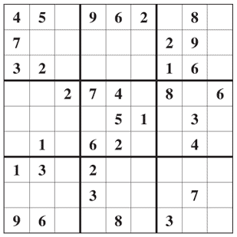  Solution  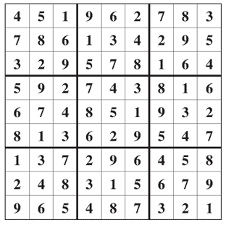  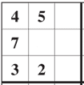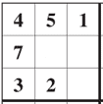Hint:  Let’s start with say top left square. The numbers missing from this square are 1, 6, 8 and 9. In which square will you enter 1? The number 1 cannot be accommodated in the square immediately right of 7 and to the right of 2. Therefore 1 can be accommodated either in the square to the right of 5 or in the distant square right of 7. Now, thetop right box already has 1. Therefore the only place where we can enter 1 in top left square is the square to the right of 5.

1.9 Evaluation
Evaluation is another interesting but tricky sub-skill. Evaluation means making judgement or forming an opinion about any existing information. The main purpose of evaluation is to provide ‘useful feedback’ that can assist in decision making.
The technique of evaluation involves assessment of your reasoning. Before framing any judgement about any information or issue or situation and giving feedback; it is important to test the clarity and accuracy of your thoughts. It is a learning tool that gives an opportunity to have insight and expand our knowledge base thereby enhancing your skill of critical thinking.
Reading | We recommend going through the website of Independent Evaluation Unit of United Nations Drug Control Programme @  https://www.unodc.org/unodc/en/evaluation/index.html  On this website you will find evaluation reports, evaluation briefs, norms and standards on evaluation as well as related guidelines, templates and the Evaluation Handbook. In addition to this it also has a self-test on evaluation.
Tip | In order to create evaluation form of your own, just check out some of the evaluation forms available online. For e.g.  For Evaluation of a Teacher  https://www.iitg.ernet.in/acad/forms/Forms/Common/NewFormA.pdf  Faculty Advisor Evaluation Form  http://iim.ust.hk/download/5_IIM_advisor.pdf
Activity 1.6 | Evaluate your favourite Website; look for: Purpose, Sponsor/Owner, Organization of page and Content, Biasness, Date of Uploading / Modification, Effectiveness, Efficiency, Authority/author, Audience, Coverage, Security, etc. Your report should have three aspects of the website Positive points, Weak points and Improvements which can be done.

1.10 Inference
Given any subject matter, how would you draw your own conclusions? The skill of inference plays an important role here.
Now, what is inference?
Any conclusion drawn, that is based on evidence and reasoning is called inference. It has the following characteristics:
- Open mind: The mind works effectively only when it is open. This means you allow your thoughts to flow freely and fearlessly. This helps the mind to think logically.
- Focus: It is necessary to focus on the subject matter. All the evidences and date must converge to a common conclusion. (This point is explained in more detail in the next section under the heading of self regulation)
In the context of critical thinking, it is important to distinguish between inference based on observation and inference based on logical expression. Critical thinking draws conclusion not based on observation but on reasoning.
The following examples will make this distinction clear.
Example 1: Inference based on observation
Statement: The Human Development Index of India was 135 in 2014 and
130 in 2015
Inference: The Human Development Index of India improved in 2015
Example 2: Inference based on reasoning
Statement: The woman does not travel by airplane.
Inference: The woman does not travel by airplane because she fears the
plane will crash.

1.11 Explanation

A simple yet crucial skill is explanation. Once you wish to express your views on any issue, your main motive is to put your thoughts in proper order so that it clearly justifies the conclusions you have drawn. This process is known as explanation. It is the aptitude to reaffirm the existing information and add precision and your viewpoint in a meaningful way.
The following points must be kept in mind while explaining what you want to say:
- Explanation will differ depending upon the age group and the level of intelligence. Hence it is important to decide the group of readers you want to share our views with.
- Language is an important tool to present our thoughts and expressions. Sentences must be framed carefully so that the content is crystal clear. Special care must be taken while translating any piece of work.
- The explanation must be concise. The ability to express your thoughts briefly but comprehensibly can be inculcated with practice.
- Your explanation must include relevant data, examples and diagrams (if necessary) to bring out clarity of thought.

Activity 1.7 | Test your explanation skill  How does the Internet work? Explain this question to a kid from middle school to a student of undergraduate course.  Explanation to kid from middle school:  ____________________________________________________  ____________________________________________________  ____________________________________________________  ____________________________________________________  ____________________________________________________  Explanation to a student of undergraduate course:  ____________________________________________________  ____________________________________________________  ____________________________________________________  ____________________________________________________  ____________________________________________________  ____________________________________________________

1.12 Self-regulation

Self-regulation is the backbone of critical thinking. It is the ability to focus, remain calm and control your thoughts. This ability helps in respecting the views of others, listen to and understand what they are trying to say. It enhances self-improvement leaving behind biasness and personal interest.
You can work onyour self-regulation ability by self examination, check for any errors or correction required and make necessary changes.

1.13 Hurdles to Critical Thinking
Obstacles or hurdles in critical thinking imprison the thought process. It hinders you from learning how to improve your problem solving skills. However if you are aware of your weakness and try to identify them, and take efforts to overcome them, these hurdles can make you smarter!
Some of the hurdles in critical thinking are portrayed in the figure 1.1 below
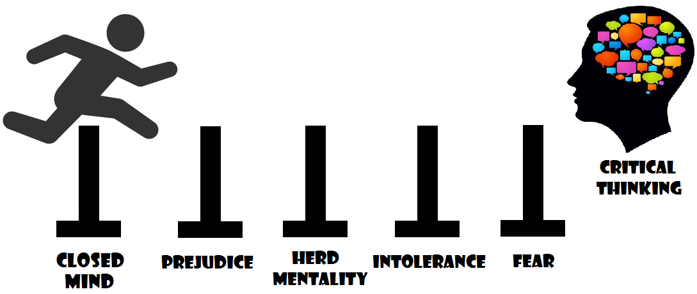
Figure 1.1: Hurdles to Critical Thinking
(CC BY 4.0, Graphic Era Hill University, Dehradun, India. 2016)
- Closed Mind – It is said that we listen what we want to hear. This makes you deaf to the thoughts and feelings of others. As a consequence you think with a closed mind that impedes the mind to think critically.
- Prejudice–Being prejudiced is to flood your mind with preconceived opinion that obstructs you from making judgements based on reasoning and overlooks necessary information.
- Herd Mentality–In other words, believing something without verification. If you follow the crowd you will go to places where the crowd goes. If Columbus would not have moved away, America would never have been discovered.
- Intolerance - Helen Keller said “The highest result of education is tolerance”. One the factor that leads to intolerance is arrogance; i.e., the sense of one’s own importance and ability. Intolerance hinders acceptance and importance of the thoughts and ideas of others.
- Fear – The basic and most important hurdle. Fear of taking risks, fear of facing problems, fear of committing mistakes, fear of criticism, fear of disapproval or rejection and fear of personality crisis are some of the notable fears that can hinder a person to think different and critically.

1.14 Need & Importance
The twenty first century is witnessing the growth of competition in every sphere of life. Everyone is in a race towards achieving success. The World Economic Forum in a recent study emphasised the important job skills for the future employees. ‘Critical thinking’, one of the important job skills, rated fourth important for 2015, has been rated second important for 2020. This report is based on a discussion of chief human resources and strategy officers from leading global employers.
(Source: https://www.weforum.org/agenda/2016/01/the-10-skills-you-need-to-thrive-in-the-fourth-industrial-revolution/)
There has never been so much information bombarding ever, as of now. These days round the clock 24 X 7 information of all kind are distributed, and to go through the content to find accurate, genuine and valuable material is no small task. In this regard, critical thinking has never been more significant or more demanding than in today’s time.
Employers nowadays look for critical thinkers, who could adopt rational approach, select from the vast existing information, figure out relevant information, understand the theories and arguments behind it, and then communicate and give good reason for the point of view.
Hence critical thinking is need of the hour that can help you to take reasonable and sensible decisions in your life.

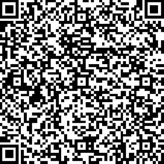  Video | This Video explains how to acquire and develop techniques of Critical Thinking and what are the obstacles or hurdles in critical thinking.  https://www.youtube.com/watch?v=xyub1qIbha8&index=2&list=PLXN-JCVb8z8DS1umCwF2cvJoIgxSDRP4j

Unit summary

Summary | In this unit you learned that critical thinking involves thinking with full consciousness, awareness, alertness and open-mindedness. At the same time it also involves thinking without bias, prejudice, and discrimination.In order to evaluate your thoughts you need touse relevant data, proofs and evidence, which will ultimately become aid to your decisive factor. The correctness of the data, proofs and evidence is hence important.  Critical thinking skills can be acquired. The following techniques helps  - Art of questioning  - Interpretation  - Analysis  - Inference  - Evaluation  - Explanation  - Self-regulation

Assignment

Assignment | - It is often said that a picture is worth a thousand words. Look at the following picture (Figure 1.2) and write about it.  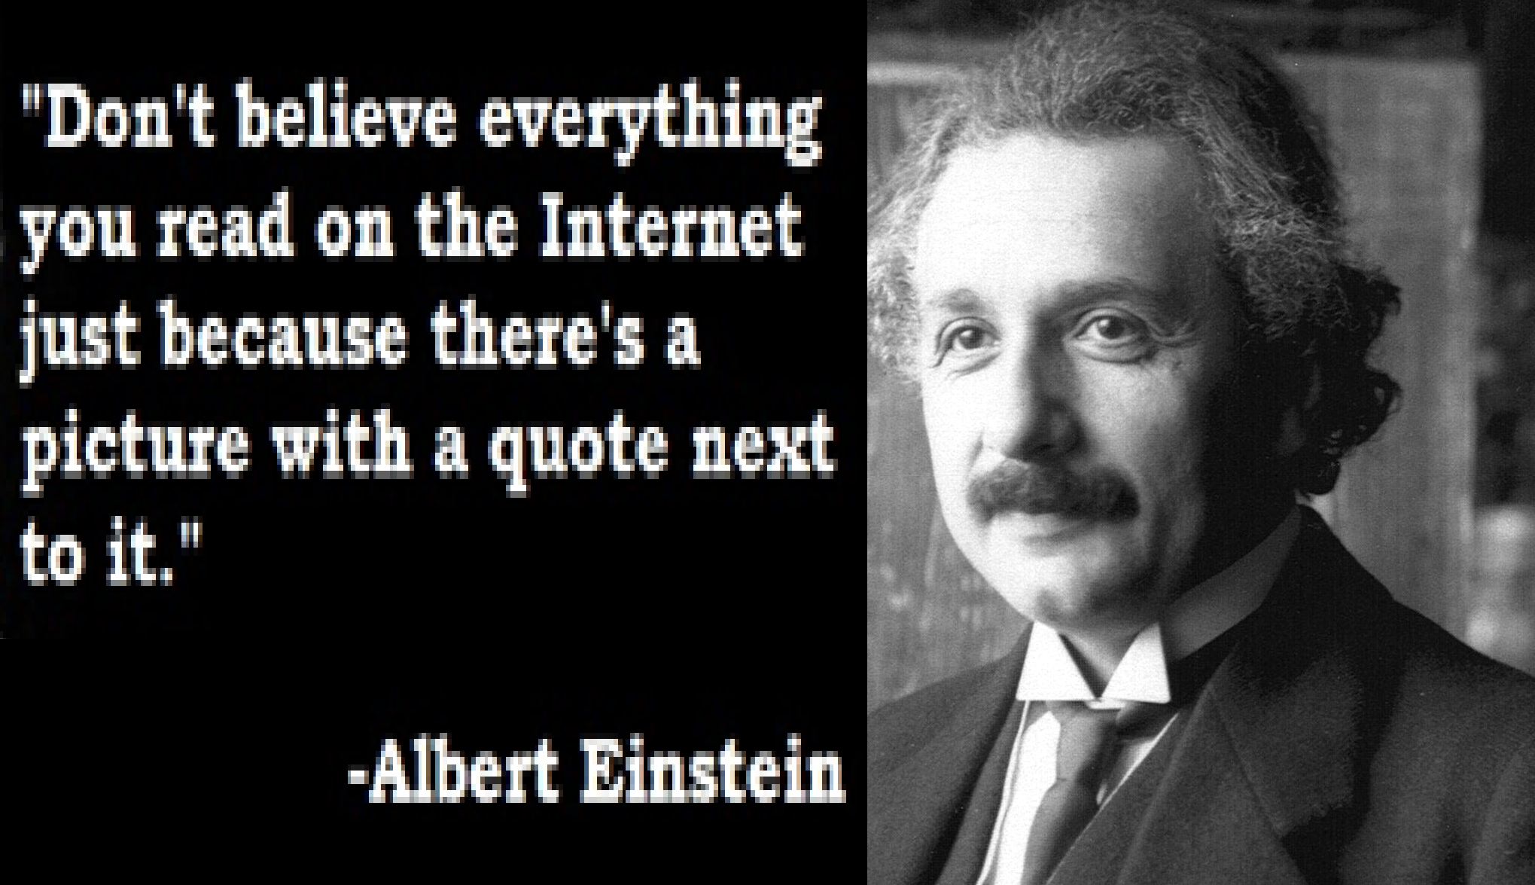  Figure 1.2: Internet Truths  (CC BY 4.0, Graphic Era Hill University, Dehradun, India. 2016, Einstein Photo source: https://upload.wikimedia.org/wikipedia/commons/3/3f/Albert_Einstein_1921_by_F_Schmutzer.jpg)

______________________________________________________
______________________________________________________
______________________________________________________

Answer: A critical thinker would do question the authenticity of the quote, a little use of critical thinking technique would lead us to the fact that Albert Einstein died in Princeton, New Jersey, in 1955, way before Internet came into existence. Thus the image is a hoax.
- Before Mount Everest was discovered, what was the highest mountain in the world?
____________________________________________________
____________________________________________________
Answer: Mount Everest was still the highest even though it had not been discovered.

Assessment

Assessment | - Everyone has made some poor decisions or has done something that just did not turn out right. Give an example of when this has happened to you.  - Some people consider themselves to be “big picture people” and others are detail oriented. Which are you? Give an example that illustrates your preference.  - What do the following words have in common?  - Australia  - Europe  - India  - Oklahoma City  - Uganda  - If a red house is made of red bricks, and a gray house is made of gray bricks, what is a greenhouse made of?
 | - Think about the things we do often do in our everyday life; prepare a list of everyday activities which you think involves critical thinking?

Unit 2

Social Media Technology

2.1 Introduction
You are familiar with the television, radio, magazine, newspaper, telephone and fax. These are age old medium of communication, used widely even today. These different channels provide updates, knowledge, entertainment and amusement and other promotional messages.
The question is: Has there been any development in communication?
The answer is definitely “yes”.
Today’s buzzword in the field of communication is ‘social media’.The earlier medium of communication were basically one-way, with very limited two-way communication. Social media has extended the horizon of the two-way communication, whereby you can now share your views, ideas and personal messages, participate in discussions and most important, create social communities online. What is alluring is the fact that all the activities can be performed as per your convenience, from anywhere, at any time and even without your physical presence.
Social Media provides aplatform for social connections and theprocess through which personal and business relationships are established and maintained, exclusively over Internet is termed Social Networking. Therefore social media along with the availability of the internet helps in the effective and efficient functioning of social networking.
This unit will introduce you to the ‘Social Media Technology’ that is, how scientific knowledge is applied in social media for effective and efficient functioning of social networking.

Upon completion of this unit you will be able to:
Outcomes | - Classify different types of social network.  - Describe various categories of social networking sites.  - Identify the recent trends and issues of social network.

Terminology | RSS: | Really Simple Syndication
 | Web 2.0 : | Second generation of www
 | SNS : | Social Networking Services
 | SNA: | Social Network Analysis
 | Social Media Networking: | Combination of social networking and media.
 | Unstructured Data: | Data which is not in a form which can be used easily by computer program.
 | Emojis: | Graphical symbol and character representing emotions used in social networking sites, messages and other web sites or web pages.
 | Hashtag: | Hashtags are searchable tags on Instagram&twitter

2.2 Social Network

Social media is a global canvas where variety of contents in any context can be painted. It offers various forms of networking for various purposes. Few of them are listed below:
- Business professionals use it for business purposes such as digital marketing.
- Students use it for making social connections, seeking educational assistance.
- Researchers use it for sharing their ideas.
- Job seekers use it for finding potential job.
- Small entrepreneur use it to promote their business.
- Politician use it for their campaign
In today’s world social network is popular as social media network.
Social Networking Service (SNS)
It is an internet based platform with second generation of web i.e Web2.0 (a phrase termed by Tim O’Reilly). Elementary functions of SNS are:
- It facilitates users to create their profile that can be viewed by other users also.
- It helps in finding old friends, making new friends and connects with them.
- It gives facility to users to upload and publish user developed content in different forms such as text messages, photos and videos..
- Helps in social shopping, playing social games etc.
- Enhancing personal as well as professional connections.
- Provides a strong platform for promoting brands, ideas, concepts, trends etc.
- Provides security and data protection mechanism.

Today’s online social media networking has taken place of conventional personal or one to one communication based social network.

Reading | Read more about Social Networking  http://en.wikipedia.org/wiki/Social_networking_service
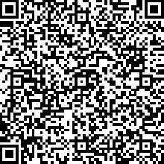  Video | This Video explains the concept of Social Media & Social Networking; and explains the difference between them.  https://www.youtube.com/watch?v=MU0ICy9ynH4&index=3&list=PLXN-JCVb8z8DS1umCwF2cvJoIgxSDRP4j

2.3 History of Social Networking

The idea of social networking is not new.Humans as a socialbeing always want to live in groups and want to communicate with each other. People invite their friends, organize social gatherings or just visit the people they want to see.

All the way through history, people came up with various ways of networking, but social networks, in the sense most people refer to them today, represent an improved, well-organized and more effective version of what previously occurred in the offline world. After the inception of the Internet, things have changed now with respect to the response time eliminating geographical barriers.
Throughout this unit the term ‘social networking’ is used to refer to the electronic form of social network popularised by Friendsetter, MySpace, Facebook, LinkedIn and all other social networking.
Activity 2.2 | In order to get an idea about the ancient methods of social networking, here is a small puzzle. (The Figure 2.1 will act as your guide, guess and write down the names)  Figure: 2.1(Ancient methods of Social Networking)  (CC BY 4.0, Graphic Era Hill University, Dehradun, India. 2016)  Answers:  - Cave Drawing. 2. Messengers. 3. Pigeons. 4. Roman Forum.  5. Cracker Barrel 6. Telegraph. 7. Telephone  Figure 2.2 given below depicts the major milestones of social media networking.  Figure : 2.2 Milestones of Social Media Networking  (CC BY 4.0, Graphic Era Hill University, Dehradun, India. 2016)
Activity 2.3 | SocialNetwork Crossword.
   |  | 3 |  |  |  |  |  | 4
  1
   |  |  |  |  |  |  | 2
Across
1.It is the first social networking site of 21st century.
2.This is known first actual social networking site
Down
3.Most popular social networking site is_____________.
4.In 1995_______ comes with allowing everyone to set up their own personal homepage.

Solutions:
- Classmates.com 2. Sixdegree3.Facebook4.Geocities

2.4 Network and Graph Theory
Technically, Social network can be defined as collection of nodes and edges. The term nodes and edges are related to the graph theory of mathematics. When you analyse social network visually it is analyzed in terms of complicated graphs (see figure 2.3).

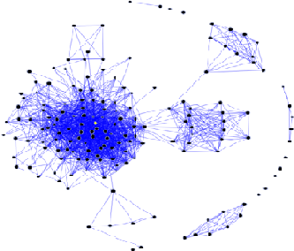
Figure 2.3 Social Network in terms of Graphs (Source: https://upload.wikimedia.org/wikipedia/commons/0/05/Sna_large.png)
In the figure 2.3 shown above, dots are the nodes and the lines are the edges. A social network can be analysed either visually or in terms of adjacency matrix.
You can formally represent social network as a “graph G (V, E, W)”: Where V is set of n number of profiles technically known as nodes such as Jay, Gina, Alex in Figure G1. Each node can have a no of attributes (characteristics) like login, password, demographic etc. E is the set of all edges or social link or relationships present on graph. Relationships can be of different types such as friendship, kinship, professional, influential etc.
As an example, you can consider the social network presented in Figure 2.4, It consists of eleven profiles which describe a collection of individuals (David, Jay, Gina, Alex, Jonty, Rohit, Simon, Josh, Sam, Eric, Lilian) along with their friendship links.

Figure 2.4: Graphical representation of small friendship Social Network
(CC BY 4.0, Graphic Era Hill University, Dehradun, India. 2016)
You can understand the concept of social networking and graph with the following example:
Example 2.1: Examine popular online social networking site Instagram. It is popular as a photo sharing website. Let graph G (V, E, W) represents Instagram user network, where
Nodes V:V is a set of all nodes present in graph and a single node vi ∈ V represents a single user
Edges E: An edge (i, j) ∈ E between two nodes vi, vj could represent
a range of potential. It can be a relationship such as friendship, sibling, partner etc, it can be a private message or a group message, or an social networking activity such as tagging in a photo; basically it could be a resulting link where vi, vj are connected if the corresponding users have co-viewed more than a certain number of photograph.

Node Labels Y: These are the characteristics of a node may include the user’s demographics (age, location, gender, occupation), interests (hobbies), a list of recommended videos extracted from the site, and so on.

Edge Weights W: The weight wij on an edge between nodes vi, vj can be used to point out the strength of the association and a weight on an edge could indicate the strength of the resemblance by recording the number of co-viewed photographs.

Activity 2.4 | You are friends of Sam, Bob, and Danny. Ronaldo is friends with Chris, Bob and Anne. Chris is friends with Max, Alex and Maria. Alex is friends with Marry, John and Bob and Rushty is friends with Neel and Danny. Graphically represent the social network.(Hint: Figure 2.4)

2.5 Classification of Social Network
Social networking is a combination of sociology, computer science and graph theory. Different sociologists have classified social groupsin different ways. The basis of classification can be purpose, capacity, stability or graph theory. This study material gives classification on the basis of graph theory which is based on edges which are also known as ties / links / relationship between nodes, thus social network can be classified into three types.
- One-mode network:Relations between a single set of actors: Here the term “mode” refers to nodes or usernames, known as “actors”. Whose members are connected to each other with some kind of a relationship or some kind of social or professional ties. It can be:
  - Acquaintance ties among a group of school children or friendship between college students.
  - Suggestion-giving ,instruction-giving relations within an organization
  - Marriage networks between people
  - Transaction between companies.

- Two-mode network:Relations between two set of actors: The Two-mode case comes in a picture when you try to collect affiliation between two set of units such as:
- Female employees of organization attended a events.
- Network among the magazines and readers.

- Ego network: Ego network is a set of ties connecting ego (focal node) and alters (nodes whom ego is directly associated or “actor” means to a person, organization that is engaged with some social relation or an actor is a node in a social network graph). An ego can be persons, groups, organizations, or whole societies (see figure 2.5). Ego network focuses on the individual actor and its immediate network neighbourhood. For example circles in Google+.
Figure 2.5: A simple Ego network.
(CC BY 4.0, Graphic Era Hill University, Dehradun, India. 2016)
Reading | Read more about Classification of Social Network.  http://toreopsahl.com/tnet/two-mode-networks/defining-two-mode-networks/

2.6 Social Network Analysis
Social Network Analysis (SNA) views social relationships in terms of network theory consisting of nodes and ties (alsocalled edges, links, or connections). All the social network is made of at least two basic types of elements: nodes, which are the building blocks, and edges which are the connections between the nodes.

The examples of nodes in social networking terms are organizations, individuals or specific areas of knowledge. Edges, on the other hand, are the relationships between those nodes. On the other hand examples of edges include a friendship, a family bond, or simply a recommendation on LinkedIn between a freelancer and a company.

SNA has become an instrument to understand complex relationships and changing demographics. By analyzing these relationships, many new aspects of social networking can be revealed. For example:
- Perhaps a network may be subjected to a particular individual , who becomes influential to new people as the network grows.(Twitter account of any famous actor/actress)
- A cosmetic company hoping to quickly advertise their new product throughout the network could do it most efficiently by starting with this particular individual.
- A politician may use it for his/her election campaign
SNA can be used for promoting new brands, finding changing needs of customers, hiring specific knowledge area workers, contagious disease control, in developing anti-terrorist activities, team building in an organization, analysing personal influence etc.

2.7 Advantages of Social Media
There are several positive aspects of using social media; some of them are listed as follows:
- Develop new contacts
- Diversity in contacts
- Strengthen interpersonal relationship
- Eliminate geographical boundaries
- Improve creativity
- Highly Interactive
- Helps in building communities.
Reflection 2.1 | Verify the importance of the above mentioned advantages. Observe yourself using social media in your day to day life for about a month and try to answer the following questions:  - How many new contacts did you develop in a month? List the name, age, place and occupation of all the new contacts.  - How often did you visit social networking sites for reconnecting with your family members or friends? Calculate the number of hours per day you spend with them online. (Example: chat in Facebook, or Skype, etc.)  - Make a list of the people in your address book who live overseas or away from the place of your residence.  - List the names of the sites you visited or came across while you were online for leisure activity. Were you refreshed and motivated?  - Are you part of any social community online? If not, look for sites that help you to come together in one platform to discuss matters of the society or topics of personal interest.  - List any other point that according to you can be considered as an advantage of social media networking.

2.8 Recent Trends and Issues
So, what is trending today?
Social media has captured the hearts of a million people. Whatever information you are hunting for is available at the click of a button. Mentioned below are the broad areas where social media is being widely used:
Entertainment& Shopping:Need updates about your favourite celebrity? Is there any new collection, new development, fashion tips from the brands of your choice? What are the TV Reality personalities doing on screen?
Science and Technology:Want to avail the unique opportunity to view a live flight demonstration by a NASA F-18? What is the secret of the Midnight terror cave? How do poison frog tadpoles beg for their dinner?
Sports:Looking for recent news on Summer Olympics? Eying for personal and professional relationship of sport stars? Hunting for IPL updates?
Politics: Want to know about Kohinoor? What is the Government’s new policy initiative to strengthen ties with neighbouring countries?
Trends apart, social media has a number of issues to handle as well. Some of these issues are privacy issues, legal issues and other social issues. You will learn about these issues in more detail in Unit III.

2.9 Categories of Social Networking Sites
Today there are a large number of social networking sites available on the internet. According to the typical working and the type of the target audience social networking sites are categorised in following manner:
 | S. No | Category
 | 1 | Social citation-sharing
 | 2 | Blogs
 | 3 | Microblogging
 | 4 | Wikis
 | 5 | Social bookmarking
 | 6 | Social network sites
 | 7 | Status-update services.
 | 8 | Professional Social networking sites
 | 9 | Researcher-specific social networking services
 | 10 | Media Sharing
 | 11 | Conferencing
 | Table 2.1: Categories of Social Networking Sites
Activity 2.5 | Given below are some of the social networking sites. Categorise each of these sites according to the categories given above.
CiteULike (www.citeulike.com) | Wikibooks
Mendeley (www.mendeley.com) | Wikiversity
Zotero (www.zotero.org) | Delicious (www.delicious.com)
Blogger (www.blogger.com) | Diigo(www.diigo.com)
Wordpress(www.wordpress.org) | BibSonomy (www.bibsonomy.org)
Posterous (www.posterous.com) | Facebook (www.facebook.com)
Twitter (www.twitter.com) | Twitter (www.twitter.com)
Tumblr (www.tumblr.com) | Facebook (www.facebook.com)
Plurk (www.plurk.com) | LinkedIn (www.linkedin.com)
Wikispaces (www.wikispaces.com) | Academici (www.academici.com)
Wikia (www.wikia.com) | LinkedIn (www.linkedin.com)
ResearchGate (www.researchgate.net) | Flicker (http://www.flickr.com)
Graduate Junction (www.graduatejunction.net) | Adobe Connect
MethodSpace (www.methodspace.com) | GoToMeeting (www.gotomeeting.com)
Nature Network (http://network.nature.com) | Skype (http://www.skype.com)
Instagram (www.instagram.com) | Youtube (www.youtube.com)

2.10 Hands on with popular Social Networking Sites
This section will provide hands on experience on some of the popular social media technologies available.

2.10.1 Blogging
Few decades back people used to write personal or private diaries. It has been replaced by digital diaries called blogs these days.
According to Wikipedia, "A blog (web log) is a personal journal published on the World Wide Web consisting of discrete entries ("posts") typically displayed in reverse chronological order so the most recent post appears first."
The most famous blog hosting sites are Wordpress.com, Blogger.dom/Blogspot.com,Twoday.net or Blog.de.

Steps to create a blog on blogger.com

1. In the address bar of the web browser type www.blogger.com
2. Sign in using your gmail account.
3. Enter the display name to be used in your blog posts and click on Continue.
4. Click on create a new blog.
5. Enter the title and address of your blog such as newddn2016.blogspot.com, choose a starter template (shown in Figure 2.6) that will be the basic design of your blog and click on create blog.
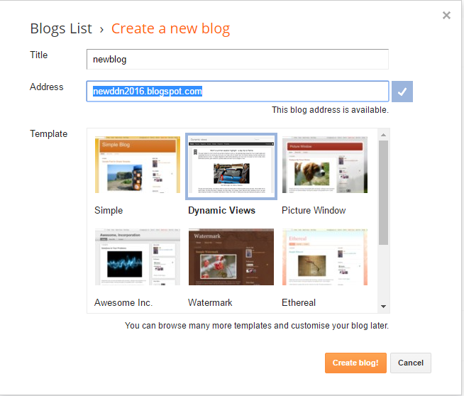Figure 2.6 Blog template
Screen Shot Source: blogger.com
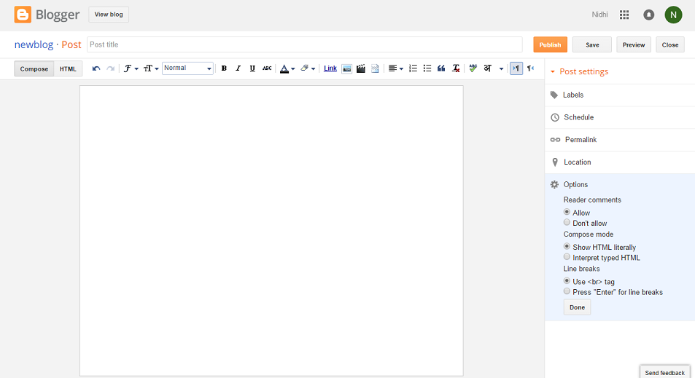
Figure 2.7 Compose a blog
Screen Shot Source: blogger.com
6.Enter the title so that you can enter or edit the blog posts .To compose a blog, type the text of your blog in the small text box(Figure 2.7).You can even change the font colour and size.
7. Click on to save your post. Click on to preview to see how your post looks before being published or click on to publish to publish your post.
8. You can adjust other settings such as who can view, contribute or comment to your blog go to the setting tab. For example, to allow new authors to contribute to and edit your blog go to settings-> permissions->add author.
Popular Blogging Terms:
Blogger or Blogging - The activity of writing a online diary (blog) is known as blogging and the person who is responsible for that is referred to as blogger.
Blogosphere - This refers to the global village of all blogs and bloggers on the web.
Blogroll - Ideally these includes the blogs that you really like and recommend to read and support.
Comments – These are the opinions, views regarding the particular content or you can say that these are reader’s response to your blog post. This is a useful way for collecting user’s feedback and to connect with your audience.
Header – The topmost part of your blog depicts tone or theme of your blog containing logos, taglines, navigation menus etc is termed as header.
Hyperlink – It is basically a link to another web page. Sometimes you want to include information from some other website in your content; this can be done with the help of hyper-linking.
Post – A post is consisting of context and content. It is user generated content or article with in a blog.
RSS - Short for Really Simple Syndication provides a easy subscribing for users and provide a fast platform to update and follow content in easy manner for other user.
Subscribe - Your blog should have multiple means through which users can subscribe to your blog content. These should include email and RSS.
Tag or Tagging – It is kind of labelling to your blog post. Tagging is also popular as a mechanism of defining and classifying the blog post.

2.10.2 Micro-blogging
Microblogs are a relatively new trend of social networking and are a special form of blogging. You can also say that it is the resent trend of social networking. The most famous microblog is Twitter, facebook, Tumblr, Google Buzz etc. The main idea behind a microblog is to restrict the size of a message to 140 characters.

2.10.2.1 Twitter
Twitter is the most established micro blogging platform and is used to broadcasting short, in-the-moment textual messages. Following are the steps to create a Twitter account
- You can choose any one option given below:
- If you’re using a desktop or laptop computer, go to www.twitter.com in your web browser.
- If you're using a mobile device, like a smart phone or tablet, download the Twitter app.
2. Whichever option you choose, you'll want to select Sign up and follow the instructions on the screen.
3. Type your name and email/phone number and password and select sign up.
4. If you want to tweet then click on tweet. Type your tweet (of maximum 140 characters) in the text box that appears on right side of the screen.
Common Twitter Terms:
@ Message: It is a way of addressing any individual twitter user publically by another twitter user.

Tweet: It can be any status update, or can be any other short message consisting of 140 characters-as a twitter user you broadcast to your contacts.

Hashtags (#s): It is popular way of making content based communities, denoted by a # symbol in front of a word .Ex: #GEHU #DCA #SocialNetwork #reading etc

Tweeple or Tweeps : Twitter users nicknames.

Retweet: A method of redirecting of another user’s tweet with your own followers

DM/Direct Message: A method to send private message to any individual twitter user or one to one messaging with the help of twitter.
Unfollow: “Typically, users unfollow other users when they no longer wish to see that person's Tweets in their home timeline. You can still view them on an as-needed basis by visiting their profile, unless their Tweets are protected”
(Source: https://support.twitter.com/articles/)
Favorite: You can create your most wanted, desired, preferred list with help of this option. In case you like a tweet you can “Favorite” it, and it will append to your “Favorite” lists on your profile and a notification is also sends to a person whose tweets you like or “Favorite”.

Lists/Listed: It is a kind of a directory of your account based on the different categories of your following accounts.

Trends: It is a kind of catalog containing top 10 phrases of twitter at any moment.
Microblogging: A way of performing many to many communications or an act of broadcasting short textual message.

Tip | REVIEW AND CONTROL PRIVACY SETTINGS.  - Go to twitter.com/settings/security and scroll down to the Privacy section.  - Chose who can tag you in Photo Tagging.  - Under Tweet privacy, lock down your posts so only approved followers can see them.  - Disable Tweet location to prevent Twitter from adding your location to your tweets. You can even delete location data from all previous tweets.  - You can set who can find you on Twitter- with an e-mail or phone number – in Discoverability.  - Disable Personalization to prevent Twitter from tracking your browsing history.  - Disable Prompted content to stop Twitter from displaying ads based on your personal information and interests.  - In Direct Messages, disable the option to “receive direct messages from anyone”.  REVOKE ACCESS TO APPS  - Go to twitter.com/settings/applications  - Click on the Revoke access button to stop infrequently used or untrusted apps and services that have access to your Twitter account.

Activity 2.6 | - Create a Twitter account.  - Find at least 10 people / accounts to follow.  - Post at least 4 tweets.
Tip | In order to explore more on micro blogging,you may also try identi.ca. It is a free open source social networking and micro-blogging service based on the pump.io software.Identi.ca is popular with the free software crowd because it is based on StatusNet, an Affero GPLv3 based micro blogging software like Twitter.

2.10.2.2 Facebook
Whenever you think about online social network the first website which comes in your mind is definitely facebook. This is the most popular website in social media. It does not allow children under theage of 13 to sign up else anyone with an email address can join. Facebook always comes with new technological updates in very simple manner, which is the main reason behind the popularity of facebook.

As a Facebook user you are able to:
- Create rich profiles including your demographics ,your relationship status , job history, interest ,favorites etc
- Locate your old classmates, friends and add new friends in your friend list.
- Find and follow companies, celebrities of different fields , politicians of your interest.
- Create photo albums for different occasions and share it with your friends
- Create a event and invite your friends.
- You can share content , videos and links to online articles etc.
- Along with broadcasting facebook also gives facility of instant messaging, chatting. You can send private or public both kinds of messages to your friends.
- Give contributions for charity.
- Can sign online petitions.
- Use different types of “apps” .Online gaming “apps” are very popular among facebook users.
- You can control what information is shared with whom by different filters such as public ,friends, friend of friend and custom.
- Create free professional pages for your group ,company, business, or community

Steps to create a Facebook account:
1. In the address bar of the web browser type facebook.com will get the page shown in figure 2.8. Facebook app can also be downloaded on smart phones.
2. Fill the details in the form provided and the click on the button that says Create my account.
3. An account for you is created if you are above 13 years of age.

Figure 2.8 Facebook page
Screen Shot Source: facebook.com

Tip | How to control who contacts you in facebook  - Click on Privacy shortcuts (shown in above figure)>Who can contact me?  - Click on drop down list under “who can send me friend requests?” and select an option viz. friend of friends.
How to control your personal information given to Ads
- Go to www.facebook.com/settings?tab=ads
- Here, you can opt out seeing ads based on your visits to websites and use of apps. However you’ll still see ads;they will less relevant to you.
- Choose if others can see how you interact with ads, such as liking a page .
- To manage your preferences for the advertisements that are shown to you click on Edit > Visit Ad preferences and remove the interest areas that facebook has collected.

2.10.2.3 Linkedin
LinkedIn is used for keeping track of and growing a professional network .It works in two manner: as a recruiter it helps in finding knowledge worker or specific domain type of candidates and as a job seeker LinkedIn helps in finding and applying for jobs, posting and viewing online résumés learning more about companies, tracking job trends, industry news and moves. There are premium (paid) accounts for jobseekers and recruiters, which give those who pay for the services more insights into the robust analytics.

As a Linkedin users you can:
- Find job trends, openings of your domain and also follow companies to receive essential updates about job openings, company news, and many more
- You can post your résumé online.
- Find and add your domain professionals to your contacts.
- Enhance professional networking by creating and joining online professional networking groups by industry, location, specialization, profession, age, educational background etc.
- You can directly apply for jobs.
- Give recommendations and also receive recommendations.
- Post professional status update similar to Facebook or Twitter, but these status updates are typically professional in nature.
- You can also send private messages.
- You can figure out many times your profile has been visited or seen.
- Create or post your digital portfolio.

Tip | Group of other social networking sites are known as circles in Linkedin. You directly import your contacts form your mail contacts also for example you can import contacts from your Gmail account.
Steps to create a Linkedin account:
1. In the address bar of the web browser type www.linkedin.com. You will get the page shown in Figure 2.9.

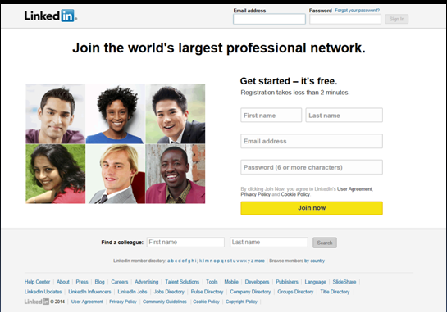
Figure 2.9 Linkedin homepage
Screen Shot Source: linkedin.com

2. Fill the details in the form provided and the click on the button that says join now.
3. An account for you is created shown in Figure 2.10.
Figure 2.10 Linkedin account
Screen Shot Source: linkedin.com

2.10.3 Content Sharing Social Network
Sharing your content is one of the most popular activity in social networking. You can share your content in variety of manners like writing a post on blog, uploading a video on youtube, uploading PowerPoint slides on slideshare and the list is very long. You can write any content on any context. Instagram, Flickr, Pinterest are examples of content sharing social network.

2.10.3.1 Instagram
Instagram is a popular photo social platform. It is available in 25languages.In comparison of other social networks like facebook and other instagram is specifically dedicated to sharing photographs. Reasons behind the popularity of instagram are:
1. Simplicity: Instead of focusing on a lot of different features, Instagram concentrating on only one core feature i.e. photographs. It makes very easy to share photos in effective manner and see photos from your friends. It also helps in building photo based communities.
2. Filters Uploading your photos after applying filters, quickly gives a exclusive look to your photos. It is a process of transforming an ordinary photo to special one or worth sharing.

Steps to create Instagram account:
1. Log on to www.instagram.com (see Figure 2.11)
2. Fill the details given in the home page
Figure 2.11 : Instagram Login
Screen Shot Source: instagram.com
3. Click on sign up.
4. Upload your profile photo.

Common Instagram Terms:
1. IG – Acronym for Instagram.
2. Feed - Where you’ll see all the posts shared by those you follow. Look for the house icon on the bottom navigation panel.
Hash tag -
- When you put a “#” symbol placed in front of a keyword or word or phrase it becomes an active ‘hash tag’ when– and will appear in blue.
- You apply Hash tags as a keywords or phrases relevant to the description of your Instagram post.
- Hash tags are searchable tags on Instagram used by marketing professionals, event organizers etc.
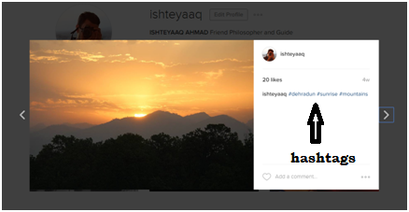
Figure 2.12 : Instagram Page
Screen Shot Source: instagram.com
4. Filters - The filter is perhaps Instagram’s trademark. It is an editing feature which can be applied to your post to enhance features and colours. Instagram provides 20 different filters which create a difference on the basis of exposure, colour balance, adding frames, rotation at a particular degree, contrast etc
5. Instameet – A gathering or meeting of local Instagramers to take Instagram photos.
6. IGers/ Instagramers – What you call people on Instagram also known as the Instagram community.
7. Tag – To add @ symbol in front of another Instagram users username. You can also add tags to in the photo by using Instagram’s tag feature by either adding tags after you’ve uploaded your post and are on the description page, or by clicking the 3 little dots lower right corner of your post.

Tip | How to control who sees your posts (Set your account private)  - Open your instagram account.  - Click on Profile button.  - Click on three vertical dots to view options and enable Private Account
Reading | To know more about Instagram read:  https://help.instagram.com

Activity 2.7 | 1. Create your Instagram account.  2. Organize an Instameet and upload pictures of Instameet on your Instagram account under social network hash tag.

2.10.3.2 Flickr
In the category of sharing photographs Flickr is a also a very popular site that enables you to upload, share pictures and provides a platform for connecting to other people who have similar interests. Flickr is especially well suited for professional photographers or people who like photography. Launched in 2004 and a year after in 2005 acquired by Yahoo. As a new user you can either log in with Yahoo or create a new flickr profile and post your own photos or download the photos of others. It gives 1000 GB free storage and also facility of uploading video of 30 seconds.
Along with sharing your pictures with friends, and other members of your friend list, you can also pinpoint pictures on geomaps such as from where you took the pictures. It also gives you facility to organize pictures in sets or groups based on locations and other interesting things.
Steps to create Flickr account:
1. In the address bar of the web browser type www.flickr.com
2.Click on sign up if you don’t have Yahoo account otherwise login with your Yahoo account(see Figure 2.13).
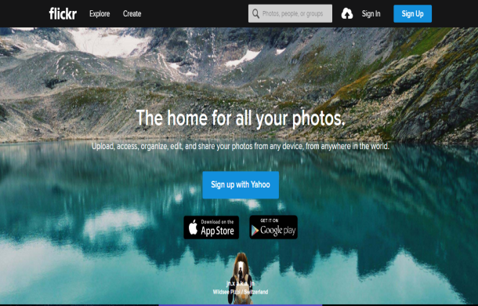
Figure 2.13 flickr homepage
Screen Shot Source: flickr.com
3. Fill the details, put the verification code and get started.
4. After uploading photo you can easily edit your photographs with help of wide variety of editing tools such as brightness, saturation etc as filters in instagram. (Figure 2.14)

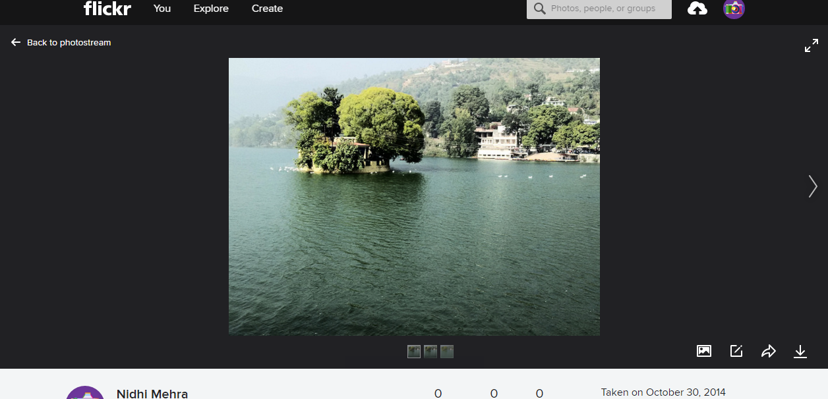
Click here to your edit photo
Click here to upload more photos
Figure 2.14 Photo editing
Screen Shot Source: flickr.com
5. You also add this photo to map see Figure 2.15.
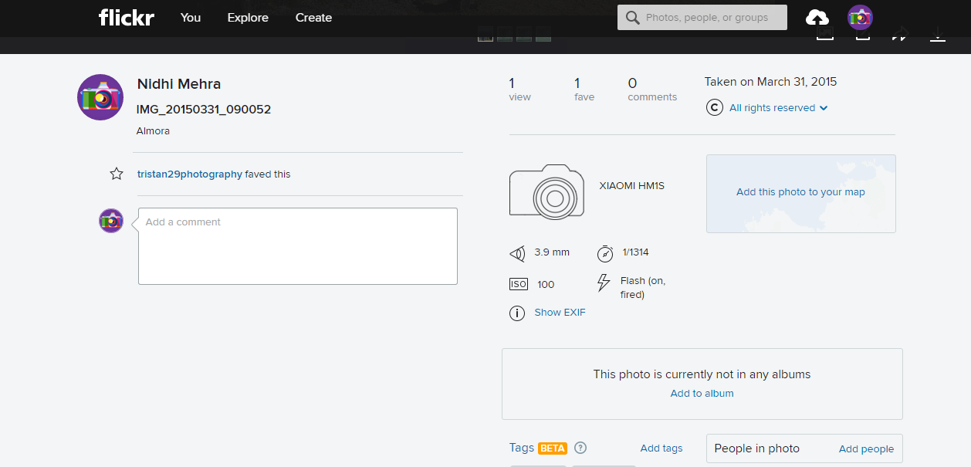
You can add photo to map from here
Figure 2.15
Screen Shot Source: flickr.com
Reading | Know more about flickr  https://www.flickr.com/help/guidelines

2.10.3.3Pinterest
Pinterest is a one of most popular content sharing “social network”. It is also popular as a visual book marking. Although other sites such as twitter, facebook focus on personal sharing, Pinterest targeting on collecting and sharing the things you find on the web.
Steps to create Pinterest account:
1. Log on to www.pinterest.com
2. Fill the details given in the home page. (see Figure 2.16)
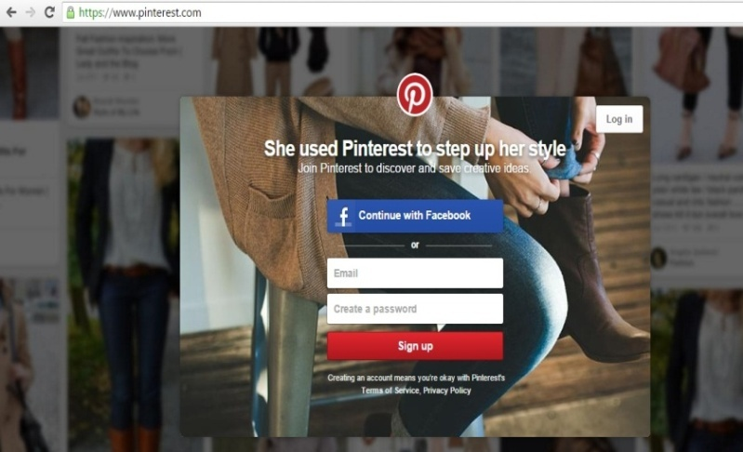
Figure 2.16 : Pinterest Homepage
Screen Shot Source: pinterest.com
3. Click on sign up. You can sign up for Pinterest with valid email address or with your Facebook account.
4. You get a screen as shown in figure 2.17.
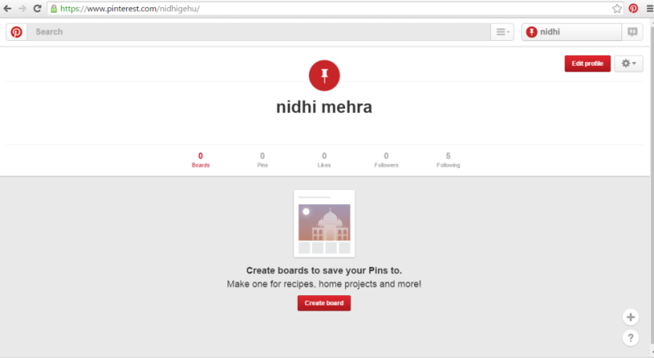
Figure 2.17 : Pinterest after Login
Screen Shot Source: pinterest.com
5. Creating a pinboard: It is similar to creating a notice board. To create a new pinboard:
- Go to your profile page
- select Create a board option
Common Pinterest Terms:
Pin-A pin is a visual bookmark that links from Pinterest to another website.
Re-pin-When you save a pin you discover on Pinterest to one of your own pinboards, it's called repinning.
Pinner-Users on Pinterest are commonly calledpinners. Whenever you find pinners you like, you can chooseto follow their pins—that way, whenever they share new pins, you'll see them on your homepage.
Pinboard-A pinboard is where you'll save related pins. For example, you could create a pinboard for the different tourist destination you find online.
Followers-Followers are other Pinterest users who have chosen to follow your pins. Whenever you add a new pin, it will appear on their homepage.
Activity 2.8 | 1.Create a pinterest account.  2.Create a board for social media. Pin at least 7 items to this board and add the social network tag.

2.10.3.4 YouTube

YouTube is one of most popular content sharing website .Users can follow channels, upload their own content, comment on and discuss videos, and follow other users content. With the ability to link directly to or embed videos, YouTube has become a primary source of video entertainment for users all over the web and it is popular as video sharing website. Its ability to monetize through ads—both for itself and its users—adds a layer of financial sustainability. Content is being uploaded and shared through YouTube at record rates.

Demographics and Key stats
- YouTube sees over one billion unique visits each month
- YouTube on mobile alone, reaches more 18-34 and 18-49 year-olds than any cable network
- Over 6 billion hours of video are watched each month
- 100 hours of video are uploaded every minute
- Mobile devices account for more than 1 billion views each day
- Thousands of YouTube channels are making six figures annually
Source: https://www.youtube.com/yt/press/statistics.html
The YouTube homepage
Once you've signed in, the YouTube homepage will come into view, and you'll see popular and trending videos, videos recommend for you, and more. You can also search videos of your choice, if present YouTube provides information as shown in figure 2.18
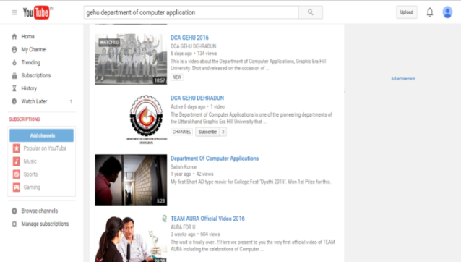
Figure 2.18: YouTube after search results
Screen Shot Source: youtube.com
If you see a video you want to watch, just click it to start playing. (See figure 2.19)
Figure 2.19: YouTube Video Play
Screen Shot Source: youtube.com
Sharing options
To share a video:
- Click on share button, given below the media player.
- Choose the desired sharing point such as (shown in figure 2.20)
  - Share a video with social network such as Facebook, Twitter etc.
  - Embed the video in a website.
  - Share it with email
  - Directly copy and paste link to video.

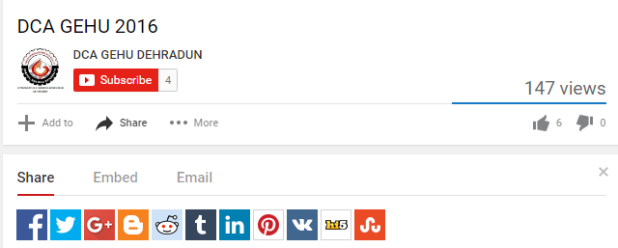
Figure 2.20: YouTube Video Share
Screen Shot Source: youtube.com
Liking and commenting
You can like or dislike videos, or leave a comment to share your thoughts.
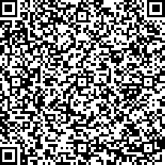  Video | This Video discusses the evolution of Social Networking & Social Media Technology. And brings forward the recent trends in it. The video also categorizes social networking sites.  https://www.youtube.com/watch?v=5QtUQiZdZac&index=4&list=PLXN-JCVb8z8DS1umCwF2cvJoIgxSDRP4j

Unit summary
Summary | In this unit you learned about the basic concept of social network and social media. From where these terms are started and how they are touching all the aspect of human life. You were also exposed to different categories of social networking sites, so that you can choose according to your specific need.

Assignment
Assignment | Q1. Social Networking Cites Crossword.  Across:  1. It is focussed on short messaging services and known as_______ blogging.  2. Most popular photo sharing site.  Down:  3. It is knows as professional social networking site.  4. Popular video sharing site  5. Free blogging site.  Answers:  1.Microblogging 2.Instagram 3.Linkedin 4.Youtube 5.Blogger.com
   |  |  |  |  |  |  | 5
   | 3 |  |  | 4
  1
  2.
Question 1.Write 5 terms related to Instagram.
1._____________________________________________
2._____________________________________________
3._____________________________________________
4._____________________________________________
5._____________________________________________
Hint: hashtag, filters, feed, IG , Instameet etc.
Question 2.What is the difference between # and @ in terms of Instagram?
___________________________________________________________
___________________________________________________________
___________________________________________________________
___________________________________________________________
___________________________________________________________
Answer. When you put a “#” symbol placed in front of a keyword or word or phrase it becomes an active ‘hashtag’ when– and will appear in blue. Hashtags are searchable tags on Instagram used by marketing professionals, event organizers etc.By applying hashtag you joining a community. A tag is a bit like a category in that it is another way of classifying blog post. It is a word or set of words that help define what the post is about ans in Instagram add a @ symbol in front of another users username. You can also add tags to in the photo by using Instagram’s tag feature by either adding tags after you’ve uploaded your post and are on the description page, or by clicking the 3 little dots lower right corner of your post.
Question3.Differentiate between Flickr and Instagram Also explain which one is better in your opinion and why?
________________________________________________________________________________________________________________________________________________________________________________________________________________________________________________________________________________________________________________________________________________________________________________________________________________________________________________________________________________________
Answer: Instagram is a community encouraging to likes and comments, whereas Flickr focuses more on displaying collections of photographs in photostreams, sets and galleries, organized by tags and maps. Instagram allows you to make artistic pictures even if you always thought you were the least creative person on earth ad it also makes you part of an international and multicultural community that is really into sharing. That is not the case on Flickr, where users have number of settings for changing photos to public, visible to friends, visible to family or completely private. Communities are more deliberate. Following is not an option, but joining is.
Question4.How whatsapp is different from twitter?
_______________________________________________________
______________________________________________________
______________________________________________________
______________________________________________________
Hint: A simple answer is that WhatsApp is a messaging service and Twitter is a microblog service. Messaging service is focused on private messages and microblog focused on public messages.
Question 5.Write down few popular terms related to Facebook along with their description.
____________________________________________________________________________________________________________________________________________________________________________________________________________________________________________________________________________________________________________________________________________________________________________________________________________________________________________________________________________
Hint: facebook wall, timeline, homepage, group, comment, likes, share etc

Assessment
Assessment | Question 1.Social media word search. Find out 11 social media words in the below riddle.
  M | I | C | R | O | B | L | O | G | D | O | T | D
  B | L | O | G | G | E | R | S | B | D | G | U | E
  A | B | C | I | N | S | T | A | G | R | A | M | F
  B | A | W | S | J | X | D | F | X | C | V | B | G
  F | I | L | T | E | R | S | A | R | N | M | L | T
  C | S | D | W | F | H | J | C | E | P | P | E | H
  S | O | C | I | A | L | N | E | T | W | O | R | K
  D | X | S | T | R | G | J | B | W | D | S | O | A
  E | K | L | T | F | G | H | O | E | E | T | H | C
  F | T | U | E | A | W | A | O | E | F | B | B | N
  G | D | R | R | S | E | S | K | T | G | C | F | M
  T | I | M | E | L | I | N | E | I | T | D | D | R
  H | F | T | R | C | F | G | R | L | H | G | H | T

1.______________________________________________
2.______________________________________________
3.______________________________________________
4.______________________________________________
5._____________________________________________
6._____________________________________________
7._____________________________________________
8._____________________________________________
9._____________________________________________
10.____________________________________________
11._____________________________________________

Question 2. Consider Facebook as a complex social network. Users of Facebook have a facility of entering a variety of demographic and personal information into their facebook profile. In addition two user of Facebook may interact by listing each other as friends ,posting a wall ,engaging in an Instant Messenger(IM) chat and so on .Create a graph representation of the Facebook social network in the form of G(V,E,W).
Where
V=Set of Vertices or Nodes of a graph
E= Set of Edges of a graph
W= Edge weight between two nodes vi and vj.
__________________________________________________________________________________________________________________________________________________________________________________________________________________________________________________________________________________________________________________________________________________________________

Question3. Look at each of the social media logo. State what they are and how they are used. Be sure to include the purpose for each social media site.

Question 4. How are different social media platforms appropriate and effective for different occasions or for different audiences?
___________________________________________________________
___________________________________________________________
___________________________________________________________
Question 5.Write a one paragraph reflection explaining why your identity is important to you, and how you think social media can be helpful or harmful to presenting your identity.
___________________________________________________________
___________________________________________________________
___________________________________________________________
___________________________________________________________
___________________________________________________________
___________________________________________________________
___________________________________________________________
___________________________________________________________
___________________________________________________________
___________________________________________________________
___________________________________________________________
___________________________________________________________

Unit 3

Critical Analysis of Social Media

3.1 Introduction
Respond to the following statement:
“Social media is destroying your communication skill.”
Your response must have been a ‘Yes’ or ‘No’. But responding with an affirmative or a negative statement is probably not the only answer you did like to give. You try to go beyond it. Did you ask yourself the following questions?
Who made this statement?
What is the truth behind this statement?
Why is my response in affirmative or in negative?
Do I have enough evidence to support my answer?
If I have sufficient evidence, what is the validity of my conclusion?
If you have tried to find the answers to the above questions (or more) that directed you to the final conclusion, you have ‘critically analyzed’ the given statement.
From the above example it must have been clear that any statement or opinion must be evaluated, analyzed and supported by logic/reasoning.
In the previous chapter, you were introduced to ‘Social Media Technology’. Technology undoubtedly is an engine for development. Development of technology on the other hand, leads to comfortable and sophisticated living styles. However, this is just the tip of a huge iceberg! Social Media Technology is a computer based technology that has taken the human civilization in its grip. If not attended, it can leave a man useless or strangle him to death.
This chapter will make a critical analysis of social media. It will further assist you in using the critical analysis skills, such as questioning, analyzing and evaluating any statement or opinion expressed in the social platform. So the next time you come across any question in your personal, professional or social life, your response will be backed by your capacity to reason out.
Have you been thinking that social media is all that “goody-goody stuff”? It is time you find out for yourself.Take back seat and just read on!

Outcomes | Upon completion of this unit you will be able to:  - Identifyvarious drawbacks of social media.  - Learn to use your mind to critically analyse any situation  - Differentiatebetween positive and normative aspects of social media

Terminology |  | Information Overload:: | Having more information than is necessary to make a decision.
 |  | Dubious: | Something that is unlikely to be true
 |  | Hoax: | Humorous or malicious deception
 |  | Privacy: | A state in which one is not observed or disturbed by other people
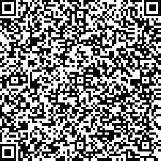  Video | This Video does a critical analysis of social media and explains the importance of using the critical analysis skills for before making a statement or forming an opinion on the social platform.  https://www.youtube.com/watch?v=ERB2ufCZ3FY&index=5&list=PLXN-JCVb8z8DS1umCwF2cvJoIgxSDRP4j

3.2 Information Overloads
Information technology has the capacity to produce information quickly and also pass on the information to a diverse population. Almost 82% of the world’s online population are reached by social networking sites representing 1.2 billion users around the world. (Source: comScore).
The irony is that information technology itself is responsible for information overload. “Google it” and the buck stops here!
For example, type the question “what is technology” the screen pops up with about 2,06,00,00,000 results! Do you really need this many information for the simple question asked?
The consequences:
- What could have taken just a minute by looking up the dictionary now keeps your eyes locked on the screen for hours.
- A large number of distractions on the screen divert the mind from the topic of concern.
- It becomes difficult to judge the correct and appropriate answer with different sources coming up with different definitions.
While knowledge is driven by information,too much information can be dangerous.Bombardment of excessive information may pollute the mind and as a result, quality of decisions making process gets affected.
How far do you agree?

3.3 Dubious Claims
Earlier information was available in magazines, television, radio and newspapers. Then suddenly the Internet popped up! And information was made available at your fingertips. Today, anybody can create a blog, have their own page on different social networking sites and post their opinions online. Thesocial media platform delivers the information throughout the globe.However, the picture is not as clear as crystal.
Traditional media had editors and other filters before it was published. But individual publications on the Internet have no filter. As a result an atmosphere full of unchecked information exists on the Internet and a large number of them fall under dubious claims.
Dubious is something that is unlikely to be true. Social networking is a platform where despite the profession you are in, you can fall prey to dubious claims. Did it occur to you ever that you are tempted to share something that is scandalous, surprising and outrageouswithout even trying to verify it? If you have been part of any such activity, you have helped spread propagandas.
Reading | You are advised to take further readings to understand dubious claims  Role of Dubious video clip for aggravating communal violence  http://www.thehindu.com/todays-paper/tp-national/fake-press-clippings-aggravated-communal-violence-says-up/article5110814.ece)  Patients using social media find dubious promotions  http://www.amednews.com/article/20101206/business/312069970/5/  Dubious statistics  http://digiday.com/agencies/dubious-mobile-stats-unpacked/  Dubious Internet Sensations  http://madisonherps.org/educationalarticle/forced-perspective-and-other-dubious-internet-sensations/  exercise self-censorship and verify news shared over social media news  http://www.themalaymailonline.com/malaysia/article/viruses-lurk-behind-dubious-social-media-feeds-you-share-communications-min
Tip | Never indulge in profanity, insults, hate speech, malicious links or fraudulent news; it is harder to get away with it. Be aware of what you say and do online because you are being watched and can get caught. Because for anything you post, it is assumed that you are responsible for it, even if you got it from somewhere else.

3.4 Hoax
What is a hoax? Can you fall prey to a hoax? Before answering these questions, test your current thinking ability. Have you seen picture of a snake on social media with three heads? Some of you might have seen picture of a snake with seven heads too. What was the first thought that came to your mind? Did that surprise you? (If you haven’t seen that case yet visit: http://wafflesatnoon.com/seven-headed-snake/)
A hoax is therefore a fiction that is erroneously believed to be the truth. But if analysed critically, it can be easily established as a rumour or urban legend.
Social media is an open platform and accessible to all around the globe. Sharing information in social media sites and grabbing numerous likes have become a symbol of status. While it has become easy to keep one up-to-date, it is important to verify the knowledge gained. In order not to fall an easy prey to rumours spread across the social media, it is necessary to keep your senses active and paint your mind with genuine information. Otherwise before you realise, everyday will be an April Fools’ Day!
Going back to the questions asked at the beginning of this section;
So, the next time you come across any story, rethink! Use your critical bent of mind to hunt for the truth and spread the information only when it is armoured with sufficient evidence and a genuine source.

3.5 Fact-Checking Sites
Garbage in, garbage out (GIGO), as is used in Computer Science or ICT (Information and Communications Technology), refers to the fact that computers automatically process unplanned or even senseless, input data ("garbage in") and produce unwanted, often irrational output ("garbage out"). This is the case sometimes even with human beings as well. Test yourself.
Enter “fact checking sites” itself in Google. You find about 3,140,000 results! What do you do? You start clicking on random sites? Or you follow your intuition?
Take another example. When you are using Facebook, you come across a large number of sponsored, recommended pages of celebrities, organizations, etc. What do you do in this case?
How do you know which sites, or pages will give you genuine information about the subject of your concern?
There are websites, books and agencies which have taken up the task of dissemination of awareness against anecdote and rumour by presenting evidence and hard facts.
Here are a few tips that you may find useful, always check official pages. An official page is an internet page controlled or endorsed by the owner. For example if there is talk of NASA, instead of collecting facts form here and there, visit the official page of NASA.
Activity 3.2 | Search the page of Mr. Roger Federer on Facebook. You will find numerous pages dedicated to him. Which among the three given below is the official page of Mr. Roger Federer?  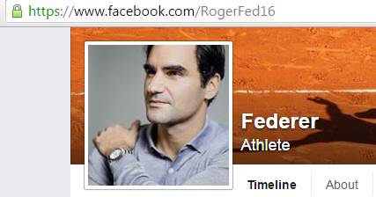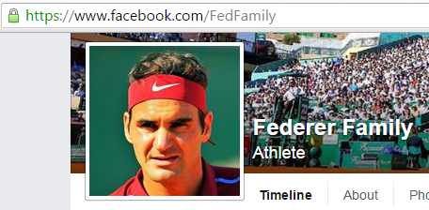  Solution: The one with blue tick. These blue ticks are used to identify verified high-profile people with large followings on Facebook and twitter. (Screen Shot Source: facebook.com)

3.6 Personal Privacy
Are you concerned about your privacy?
It is believed, “If it’s on Internet it’s not private”. This is because the main idea of Web 2.0 is the system that facilitates participatory information sharing and collaboration on the Internet and in social networking media websites.
Some of your personal information and information about your preferences and daily life can be used by marketers, for marketing purposes; it can be even used by identity thieves, scam artists, debt collectors and, stalkers. Certain basic information cannot be avoided; for instance your age, while you are creating your account in any social networking site. Much of the other information is optional.
Therefore, if you are concerned about your privacy and want to keep your personal life personal, be careful about the information you wish to share with people around the globe.
You will study more about privacy, security, ethics and laws in details in UNIT V.
Activity 3.3 | Google yourself. List at least three pages having your details about who you are, your hobbies or some of your activities. Describe whether you were expecting details on those pages.  - ___________________________________________________  ___________________________________________________  - ___________________________________________________  ___________________________________________________  - ___________________________________________________  ___________________________________________________

3.7 Social Isolation
How social are you? If you are devoting ample amount of your time surfing the net, can you consider yourself social?
Today’s society is the most connected society in human history. The credit goes to social media. What once may have seemed like a dream is now at your fingertips. Not only have you reconnected with your childhood friends, you have also connected with unknown people from different regions of the world. The irony is that more and more people are now finding means to hide themselves behind social networking sites.
Research shows that people who spend more time browsing the web also feel lonelier and less satisfied with life. Further, thislonelinessencourages them to spend more and more time online. This results in what is termed as ‘social isolation’.

Activity 3.4 | Starting from today, for seven days, calculate how much time you spend with friends online and how much time you spend with people in and around your immediate vicinity. Now, forego all online connections (not a difficult task if you believe it) and calculate the same for another week. Do you notice any major changes in your behaviour? Take a note of your behavioural pattern and analyse the changes.
Tip | In case you feel that you are socially isolated, and want to overcome it you can engage yourself in many community activities in real life in which you can work with people of other ages, viz. Hobby club, Continuing adult classes, community neighbour social groups, local cultural groups or sporting activities.

3.8 Cyber Infidelity
Social media has brought about numerous changes on the relationship front. An accepted fact of cyber interaction is “unknown”. You interact with strangers, the unknown. Even if you know someone, you are still unsure whether you are connecting with the person of your interest. Because of these reasons social media are the fastest-rising grounds of relationship breakdowns and divorce cases. It is said that Internet will soon become the most common form of infidelity. While there are stories of successful relationships, there are stories that are alarming. Therefore, the ball is in your court.
Stating this fact, do you think cyber infidelity can be considered infidelity? Who is to blame?

3.9 Virtual Life
With the advancement in the Internet, people can become more addictive to social networking. The idea of a clear separation between reality and virtual reality is becomingvague. Business Companies have started to work on mobile virtual reality social network, where user will use 3D avatars to talk with their friends online. Although in development phase, combination of social networking technologies and virtual environments can be incorporated anywhere, even in the classroom.
Reading | You are advised to take further readings to understand new developments in Social networking.  http://www.computerworld.com/article/2999819/social-media/why-virtual-reality-is-the-next-social-network.html  http://www.dailymail.co.uk/sciencetech/article-3388074/Forget-Facebook-World-s-mobile-VR-social-network-lets-meet-friends-virtual-reality.html

3.10 Cyber Criminals
The word cybercriminal means a person who is related to computer linked crime or a person who is responsible for cybercrime, where he/she makes use of the computer either as a device or as a target or as both.
Since the world is a global village with the wide acceptance of Internet, cyber crimes are a fast-growing area of crime (see figure 3.1). Social networking is no exception; Cybercriminals are using social media not only to commit crime online, but also for planning out real world crime due to over-sharing of personal information on the social platforms.

Figure 3.1: Different categories of cybercrimes
(CC BY 4.0, Graphic Era Hill University, Dehradun, India. 2016)

Reading | Following link gives you more information regarding the recent cybercrimes on social networking sites.  http://www.cyberoam.com/blog/why-social-networking-sites-are-a-favourite-with-cyber-criminals-today/  http://www.mcafee.com/in/security-awareness/articles/how-cybercriminals-target-social-media-accounts.aspx
You will study more about cyber laws in details in UNIT V.

3.11 Addiction
Social media is indeed an amazing and fabulous addition in our lives. It is a type of universal assembly, where people from all parts of the world come together. Undoubtedly, it has brought the world closer and made life easier. What then is the drawback?
Social media is fuelling “Internet addiction,” a psychiatric condition closely related with depression.Internet addiction can result in personal, family, academic, financial, and occupational problems. In more appropriate words, it is a ‘silent killer’. Just like any other addiction, internet addiction slowly kills a person, if not handled with caution.
Activity 3.5 | You are advised to take an online quiz at  http://psychcentral.com/quizzes/netaddiction.htm  This test is a screening measure to help you determine whether you might have an unhealthy relationship with the Internet.

3.12 Health Issues
This is the most crucial one. Where there is health, there is wealth. If you control the use of social media it can keep a check on your health. But if it controls you itcan burden your sanity and disrupt your thinking. It is generally not realised that social media can affect your health in a negative way, if not attended at the earliest. Here are few of them:
Stress:While you may argue that it is a stress reliever, you do not realise that it is in itself a carrier of stress. How?
Observe your immediate reaction over slow connectivity, electricity failure, some external disturbance like interference from a family member, etc. Is your behaviour as normal as it used to be when you are not online? If not, you are stressed out and need to keep a watch on your habit.
Cyber-bullying: The use of electronic communication to bully a person, particularly by sending messages of an intimidating or threatening nature is called cyber-bullying, The more time you spend on social media the more vulnerable you become to cyber-bullying, which can in turn lead to negative interactions and depression.
Depression: Exposure to social media may alsolead todepression. Depression on the other hand stimulates more use of social media. Though it may give momentary relief, it is an unhealthy practice to take shelter of social media to get rid of depression.
Sleeplessness: Excessive use of social media disturbs your sleeping habits. Though your body demands rest, you continue to keep awake that can affect your health and restrain you from delivering effective work at home or in the office.
(Source: http://www.sciencedirect.com/science/article/pii/S0091743516000025)
  Video | This Video continues the critical analysis of social media, and explain the terms viz. Information overloads, Dubious, Hoax, Social Isolation, Virtual Life, Addiction, Depression in context of Social Media. The video also discusses several health issues related with social media technology.  https://www.youtube.com/watch?v=lcDypk730vE&index=6&list=PLXN-JCVb8z8DS1umCwF2cvJoIgxSDRP4j

Unit summary
Summary | In this unit you learned about the issues and trends of social media technologies. Critical analysis of the different issues viz. information overloads, dubious claims, hoax, fact-checking sites, personal privacy, social isolation, cyber infidelity, virtual life, cyber criminals, addiction, health was done.

Assignment
Assignment | - Have you observed the green moon on April 20th2016? What was your reaction to the news on social media? Search Internet and use fact finding sites to know the truth.  - Thousands of people are caught out every year by deliberate hoaxsters and ignorant promoting unsubstantiated mistruths at the click of a button. Find out top ten hoax of the year.  - Check the points under health issues once again. Do you think that social media is affecting your health.

Assessment
Assessment | - List at list 10 websites that you can use to distinguish between the truth and rumours, the sites that give insight and gives logical explanation.  - After every Diwali (festival of lights in India), a colourful picture of India as seen from space from NASA satellite is circulated on social networks. Search Internet and use fact finding sites to know the truth.  - Discuss some of the possible motives that cause people to create and distribute hoaxes on social media.  - How would you handle negative comments about you on social media?

Unit 4

Social Media Analytics

4.1 Introduction
“Give a man a fish, and you feed him for a day. Teach a man to fish and you feed him for a lifetime.”
The previous three units fed you with the basic knowledge of two important concepts: critical thinking and social media. Now it is time you learn how to use these concepts effectively for successful and fruitful networking.
As a social media user when you share some post (e.g. Facebook), click on a link (e.g. Google), comment on some issues (e.g. Twitter), check any e-commerce site (e.g. Amazon); all these activities are potential data for business organizations. These create a bulk of data that has personal, socio-political and business implications. Extraction of meaningful information from such a huge volume of data is a challenge for researchers and business organizations.
How are these data processed so as to give valuable insights for rational decision making?
The answer to the above question is clearly Social Media Analytics. It is an emerging field that involves observation, monitoring and logic. There are numerous tools that help to make selections from all available data depending upon the level of business requirement. The aim of social media analytics is to extract business intelligence to achieve business goals, adding value in business decisions and to increase product reach by Ad-business.
Popular social networking sites generate the majority of data over the internet. Figure 4.1 shows some of the social media data generators.
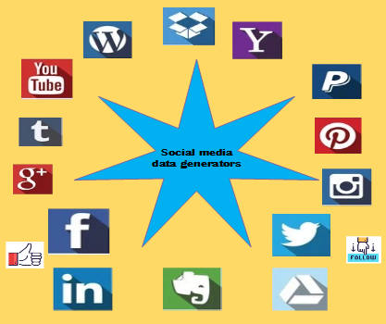
Figure 4.1: Social media data generators
(CC BY 4.0, Graphic Era Hill University, Dehradun, India. 2016)

This unit will focus on the basics of social media analytics and its popular tools. The different categories of data, and the need and challenges of social data analytics will also be covered.

Upon completion of this unit you will be able to:
Outcomes | - Understandwhat is social media analytics  - Define whatare social media data, Structured and unstructured data.  - Explain thekey reasons, why every organization wants to use social mediaanalytics.  - Explain how social networking sites make money.  - Define key performance indicators for analytics.  - Use the popular, open source social media analytic tools.

Terminology | KPI: | Key performance indicator is an indicator to check, how efficiently an organization achieves its business objectives.
 | Analytics: | Analytics is the discovery and communication of meaningful patterns in data.
 | ROI: | Return on investment is the return received by the investor after investing in some resource/business.
 | Data: | Data is translated into a form, information that is more convenient to understand or use.
 | Information: | Information is meaningful data in some context for its receiver.
 | Analysis: | Conversion of data into intelligence.
 | Venture capital : | Venture capital (VC) is money that is provided to seed early-stage, emerging and emerging growth companies.

4.2 Need and challenges
Social media is a great platform to interact with several users and to collect volume of data for analytics. Social media analytics is a three stage process: collect, analyse and deliver. A framework presented in this section, based on an approach given by Zeng et al is shown in the figure 4.2 :
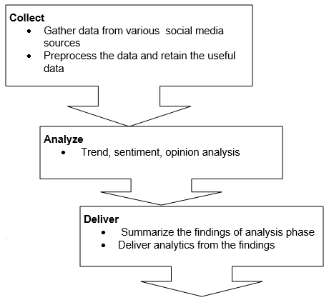
Figure 4.2: Social media analytics framework.
(CC BY 4.0, Graphic Era Hill University, Dehradun, India. 2016)

The collect stage involves obtaining relevant social media data by monitoring various social media sources, archiving relevant data and extracting relevant information. This process can either be done by a company itself or through a third-party vendor. Not all data that are captured will be useful.
Analyse stage selects relevant data for modelling, removes noisy, low quality data. In this stage various data analytics methods are used to analyse the data retained and gain insights from it.
The deliver stage deals with displaying findings from Stage 2 in a meaningful way.
Organizations are using this basic model in modified versions, which suites them best. This basic framework employs many challenges which are discussed in following sections.

4.2.1 Why Social media data analytics needed?
“How many friends do I have?”,” What is trending today?”, “Which brand is popular?” are the basic questions asked by a social media user. These Questions are needed to be answered by basic social media analytics. In addition to these questions, Social media analytics is needed for following purposes:

- To understand the customer sentiments to support business marketing activities. Every user generates a sentiment data when he shares an article, posts content, views video, tweets messages or supports a particular cause. This data is very valuable to understand the sentiment of customers.
- Companies use social media analytics to reduce customer service cost. Basic customer services can be provided at the social media platforms because most of the users are regularly visiting these sites.
- Getting feedback, positive or negative on products, policies, etc. is very easy and timely.
- To check Return on investment (ROI). Every organization wants to know if their current strategies are good enough for return on investment. Social media data is the best way to set the ROI metrics.
- Organizations are shifting towards digital marketing along with traditional marketing. So social analytics becomes a crucial tool for marketing.
- Governments can use it to know the views of the citizens and to plan new policies, regulations and acts.
- Researchers can gather bulk of data for content analysis, sentiment analysis.
- Real time analytics of social media data can help to take timely security measures in case of natural calamities. For example, The U.S. Geological Survey has its presence all over social network to analyse the social media data for real time analytics. (http://www.usgs.gov/socialmedia/ ) See case study 4.1 (How twitter data is being used to track earthquakes)
- Companies using social media analytics for efficient recruitment process.
- The uses are multidimensional. It can be used in healthcare, insurance, banking and every field in which customer data carries importance
Case study 4.1 | After Sichuan earthquake in 2008, it was found that many people turned to twitter to tweet about the earthquake. It was analysed that Twitter was faster at reporting the earthquake than the U.S. Geological Survey (USGS). Basically the USGS National Earthquake Information Centre (NEIC) processes about 2,000 real-time earthquake sensors, with the majority based in the United States. The limitation of these sensors is that they are not covering a majority of area but only probable areas for earthquakes. On the other hand, there are hundreds of millions of people using Twitter who can report earthquakes. At first, the USGS staff looked into it twitter data, they were surprised at the effectiveness of Twitter data for detection.  (https://en.wikipedia.org/wiki/2008_Sichuan_earthquake)

4.2.2 Key challenges in social media data analytics
Social media analytics can answer many socio-political, organizational issues which help in valuable decision making and prediction but there are many challenges in this process. Some of the main challenges are:
- Volume of data: The data generated by the social media activities is enormous. So it becomes a challenge to store the data for extraction information.
- Velocity of data: The speed at which data is being generated is also a challenge.
- Variety of data: Today the data shared through social media has many types; text, audio, video, animation, images, emoji’s etc. It presents challenge in storing and analysing.
- Data Analysis and analytics: As Facebook, Twitter and other social sites continue to release a stream of data, organizations need to not only turn the information generated into intelligence (Analysis), but also to critically analyse the business value and make prediction models (Analytics).
- Compromising Consumer Privacy: Organizations need to keep a balance between the privacy of social media users and analytics. Social media cyber laws cover these aspects of user privacy.
- Collect the right data: Billions of conversations happen on social media every day. Therefore, it’s extremely important to capture the important, relevant messages, and filter out the irrelevant data
- Unstructured data is challenging: Most social media data (IBM estimates 90%) is unstructured. For example it consists of words rather than numbers. Unstructured data challenges are explained in detail in late sections.
- Need for expertise: As the complexities grow, businesses have to look for experts who can effectively perform social mediaanalytics. At presentscenario,industries do not have many experts to handle social media analytics and will need more experts to earn more profitability.
- Language issues: It presents a challenge to integrate user-based location data facilitated by mobile technology and respond to social messages in real-time.
Reading | You are recommended to follow the links for further reading.  http://www.forbes.com/2009/02/19/facebook-myspace-twitter-linkedin-opinions-contributors_zuckerberg_internet .html  https://www.hausmanmarketingletter.com/challenges-real-time-social-media-analytics/  http://www.webanalyticsindia.com/2010-07-01/the-challenges-of-social-media-analytics/

4.3 How social networking sites make money
Facebook was launched in 2004, YouTube in 2005, Twitter in 2006.They already have millions of users and their valuation is in billions of US$. This is extraordinary growth in a very short time.The big question is how social networking sites make money to keep running with ever increasing demand and user base.
The major revenue collectors for social media sites are shown in the figure 4.3:
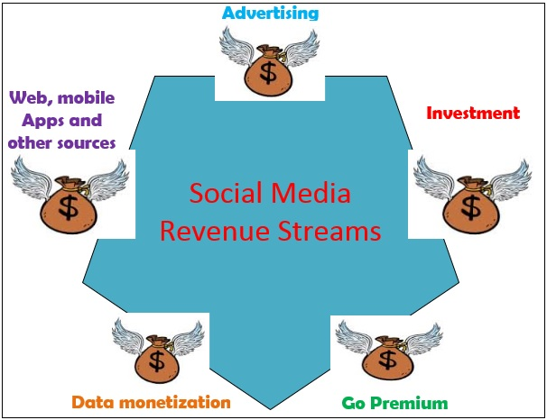
Figure 4.3: Social media revenue streams
(CC BY 4.0, Graphic Era Hill University, Dehradun, India. 2016)
Advertising: It is the best way to earn money and most of the social networking sites are using this method. Social sites allow other companies to advertise on their sites and in return the companies pay to them.
Note it! | Facebook needed a chief operating officer in 2007. When Mark Zuckerberg (Facebook Founder) ended his search, he did not select an engineer or technologist but a candidate with a background in advertising sales. The selected person Sheryl Sandberg was earlier vice president at Google and selling advertisements.
Investors: The basic idea of investment is to gain profit on the invested sum. Many social media websites were earlier an idea in which many investors have invested money so that the idea can become a reality. For example: The major open source, community based social network and news site Reddit, has secured $50 million of investments from multiple sources.

Go Premium: A social media application provides many features to the users and most of these sites are free to use. But there is a section of features which are provided to the premium users only. A premium user account has extra features support such as LinkedIn premium account where the job seekers have high probability to find a suitable job. Gmail plus or premium provides extra space for email service. The premium account is a paid account for monthly or yearly basis and the user is provided with extra features than the normal user account features.

Data Monetization:Data monetizing means selling data.The data collected by social network over the years is very valuable because it presents a relationship of the users to different entities like product, brands, contents, or other users. It also contains a user’s wants, needs, likes, dislikes and interests. This data is valuable for social sites and third parties as well. Third parties pay for this data collected over the years. It is important that this sold information doesn’t interfere with anyone’s privacy.

Tip | Generally if we are not paying for the services on Internet then most probably the service provider is using us as a product. Most of the social network websites are free and the reason is that they collect the user data, when the user uses the website and this data is very valuable for organizations.

Developer Fees: Developers can develop Web Apps, Mobile Apps and they can integrate their apps with social media sites such as Facebook, twitter. These sites take developer fee and provide the developers a platform to engage with target audience.

Others sources: Websites are finding new areas to increase their revenue and to engage the users. Facebook gifts were one such example which allowed users to send gifts to their friends that appear on the recipient profile. The gifts were virtual or physical.

4.4 Structured and unstructured data
According to Forbes “Data is just as likely to be as big as a piece of the business equation as advertising”.
Social networks are extremely rich in content, and they typically contain a tremendous amount of content and linkage data which can be used for analytics. The linkage data is essentially the graph structure of the social network and the communications between entities; whereas the content data contains the text, images and other multimedia data in the network. Broadly these different data type can be categorized as structured and unstructured.

Figure 4.4: Represents the key difference between structured and unstructured data; unstructured data has no predefined format, size and type.
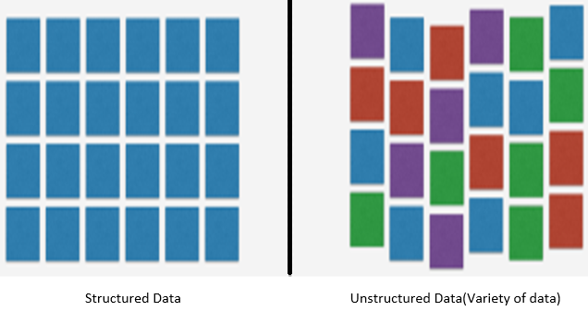
Figure 4.4: Structure v/s unstructured data
(CC BY 4.0, Graphic Era Hill University, Dehradun, India. 2016)

Structured Data:
Structured data is an improvement over strictly paper-based unstructured or manual systems.It is the data having a fixed structure and it resides within a record or file which can be stored, queried and analysed. This includes data contained in relational databases and spreadsheets. Structured data is accessed, deleted or updated using Structured Query Language (SQL) . SQL is a query programming language created for managing (deletion, updating, and insertion) and querying data in relational database management systems.
Activity 4.1 | Construct a spreadsheet in a structured format for nine students who appeared in an examination with total marks and division obtained.  ___________________________________________________________  ________________________________________________________  _______________________________________________________  _______________________________________________________  Solution:
Rollno | First name | Last name | Total marks | Division
1 | Abhishek | Kumar | 420 | First
2 | Akash | Negi | 360 | First
3 | Akhilesh | Joshi | 290 | Second
4 | Bablu | Kumar | 299 | Second
5 | Bhuwan | Rawat | 315 | First
6 | Chulbul | Pandey | 199 | Third
7 | Diksha | Modi | 435 | First
8 | Dipendra | Gandhi | 355 | First
9 | Karan | Grover | 133 | Fail

Unstructured Data:
Unstructured data are those that can not fit into a relational database. For examples: change: images, audio, video, emojies, blogs, text, web pages etc (see figure 4.5). Because of the higher percentage of unstructured data, most of the organizations are finding ways to analyse unstructured data.
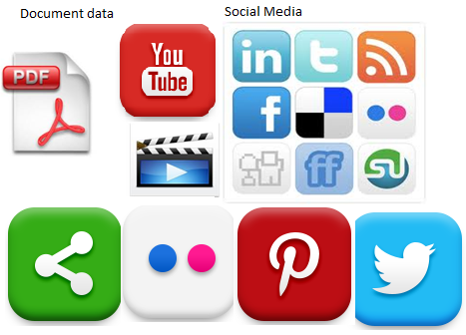
Figure 4.5 Unstructured Data Sources
(CC BY 4.0, Graphic Era Hill University, Dehradun, India. 2016)

4.5 Key performance indicators
Key performance indicator is an indicator to check, how efficiently an organization achieves its business objectives. Today, social media is the best medium to achieve business objectives by correlating social media strategies with key performance indicators (KPIs) and to keep a check on business objectives and on ROI. Counting the number of new followers on Twitter doesn’t provide significant insights, but relating this data and KPIs into something meaningful can deliver significant benefits .Different companies can have different KPI’s. Management can compare the KPI in timely basis to decide whether the company is going in positive direction or not. Also their social media efforts can be measured as well.
Following are some of the key indicators:
Distribution: Some of the KPI in this category are: Followers, Fans, Number of mentions, Reach, Inbound links, Blog subscribers
Interaction:Re-tweets, Forward to a friend, Social media sharing, Comments, Like or rate something, Reviews, Contributors and active contributors, Page views, Unique visitors, Traffic from social networking sites, Time spent on site, Response time
Influence: Share of conversation v/s competitors, Net Promoter, Satisfaction, Sentiment positive, neutral or negative
Action and ROI: Conversions (email subscriptions, downloads, install), Sales revenue, Registered users, Registered premium users, Number of leads (per day, week, month), Cost of lead, Cost of sale.
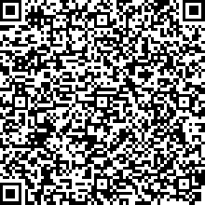  Video | This Video explains Social media analytics and it’s commonly used different approaches on business decisions, marketing, customer service, reputation management, sales and others.  https://www.youtube.com/watch?v=8yVM1tq_5FM&index=7&list=PLXN-JCVb8z8DS1umCwF2cvJoIgxSDRP4j

4.6 Popular tools for analytics
There are many free as well as licensed tools for social media analytics. These tools are used for tracking, measuring, and reporting on personal/community/business profile.
Most of the social media sites have free inbuilt analytics for users. Twitter ‘trend’, Facebook ‘top stories’, Facebook ‘friendship Recommender’, LinkedIn ‘circle’ are some examples.
Activity 4.3 | Log in to your social media account (Facebook, twitter, Instagram, LinkedIn etc.) and check the analytics provided such as top stories,  Trending and circle connections. Take a note of basic five analytics  provided.
The following sections will introduce you to some of the popular analytical tools.

4.6.1Google analytics:
Google Analytics is a very wide-ranging web analytics tool (https://www.google.co.in/analytics/ ). It is both free and paid. There are different categories of Google Analytics
- Google Analytics 360 Suite
- Google Analytics premium
- Adometry by Google
- Google Analytics
- Google tag manager.
Google Analytics HOW-TO
Step1: Go to Google analytics page.https://www.google.co.in/analytics/
Step 2: Sign in to Google analytics (free) or other accounts (If you have premium account).
Step 3: Add your website or resources which you want to analyse (optional). In most cases Google do it automatically if the resources are from the same login ID. Assuming you are logged into Google analytics the following steps are needed:
- Set your analytic goals – If you want to track conversions across social channels then set up a goal. For example, set goal for unique visitor traffic, so you can see the details , when someone new visitor visits your website,.
- Create custom Links using URL builder – Suppose, you want to track the traffic specific links, you can use Google URL Builder to create a custom link. After creating the custom links you can track activity of this link in Google Analytics.
Once you have created the links and are logged, the interaction is through the dashboard which shows the different features available with Google analytics; Active users, cohort analysis, Intelligence events etc. Dashboard is shown in the figure 4.6.
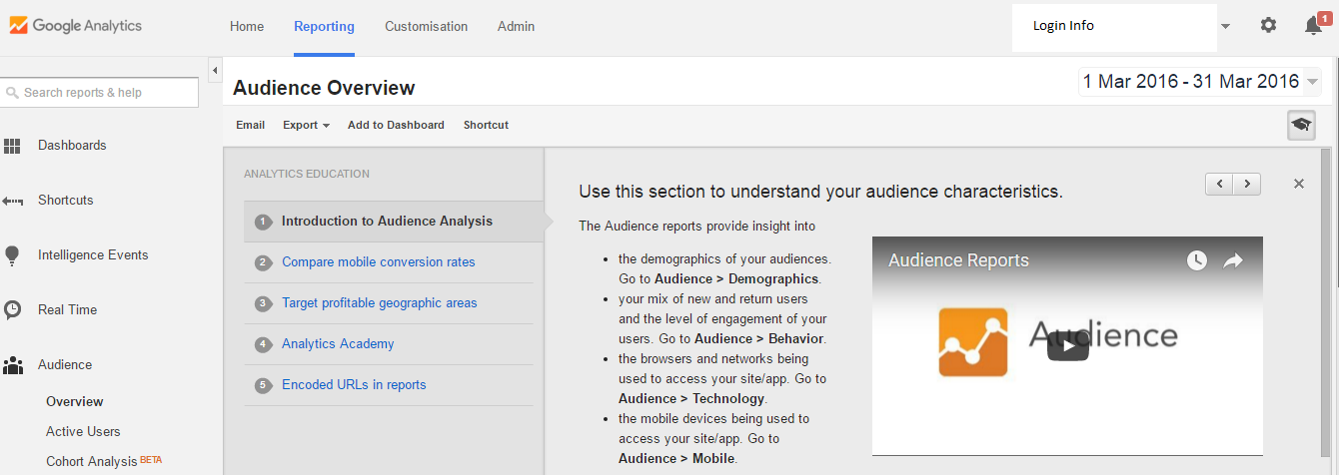
Figure 4.6: Google analytics dashboard
Screen Shot Source: google.com/analytics
Google analytics provides traffic analysis, user engagement, content analysis, active user report as seen in the figure 4.7.
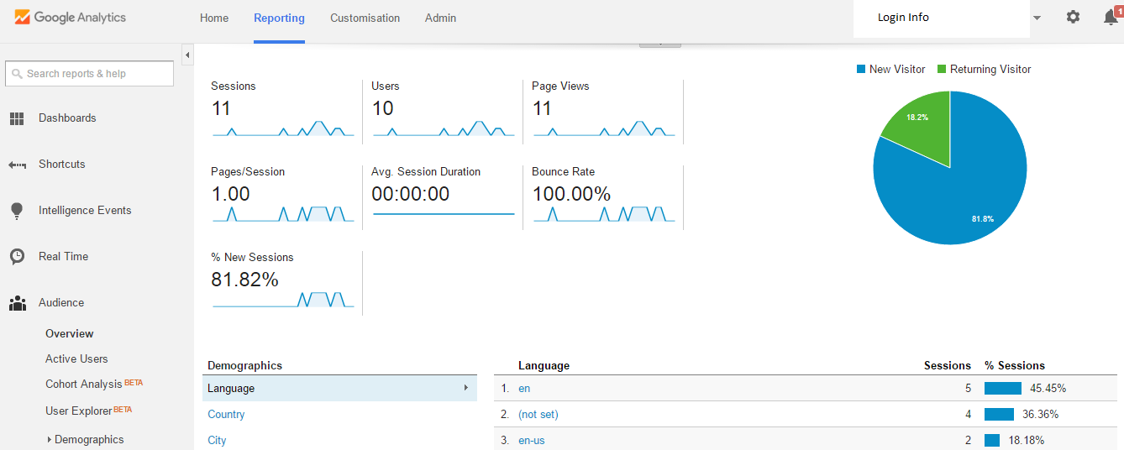
Figure 4.7: Traffic analysis
Screen Shot Source: google.com/analytics

Tip | 1. Under the Acquisition > channels section of Google Analytics, you’ll be able to see traffic from each social channel and conversion of thattraffic.  2. Under the Acquisition > Social section, there are other social mediaanalytics worth considering. For example, in the Data Hub section you can view the conversations related to your content that happened on various social channels. View conversations, which can be filtered by social network.
Activity 4.4 | Use Google sites to create a website. Login to Google analytics and add your resource (website) to it. Use Google analytics to analyse traffic, user engagement and other available features. For Google site follow the link https://www.google.com/sites/overview.html

4.6.2Twitter Analytics:
Twitter analytics answers the following questions:
- How many people see your tweets on their timeline?
- What is your follower count and potential reach?
- What is the reach for the hash tag you promote?
- Do you have a relevant audience?
Twitter provides a Twitter analytics dashboard within the platform (https://analytics.twitter.com/ ), which provides useful insights. You’ll get a selection of high-level stats, such as Follower growth, Profile of followers, Engagement rate, Link clicks.
When you login, you will see a dashboard screen, and this displays a visual of your performance as seen below in figure 4.8.
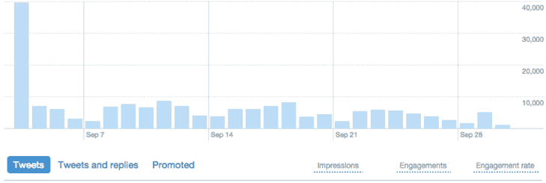
Figure 4.8: Twitter analytics dashboard
Screen Shot Source: analytics.twitter.com
The visual performance basically contains the tweets information in three categories.
- Impression: number of times user saw the tweet in twitter
- Engagements: number of times a user has interacted (click, retweet, hash tag) with the tweet
- Engagement rate: the number of engagement divided by the total number of impressions. The higher the engagement rate the more popular you are on twitter. (See reading)

Reading | Read more on Twitter Engagement  http://www.dasheroo.com/blog/whats-a-good-twitter-engagement-rate-for-your-tweets/
Activity 4.5 | Login to twitter and create a twitter application.  Visit https://spring.io/guides/gs/register-twitter-app/  This application will be needed in section 4.7; twitter data mining with R tool.

4.6.4 Facebook content analytics:
Facebook content analysisor reporting can be used to benchmark the progress of your Facebook marketing strategy, measure how your strategy working up to competitors and show whether a return on investment (ROI) is being made.
Facebook Analytics for Apps helps you better understand how people are using your iOS app, your Android app or your game on Facebook. It shows you data, trends and comes with many built-in graphs for the actions that people take in your app, such as the number of people launching your app, viewing content, searching or making purchases in your app, follow the links to use Facebook analytics:
https://developers.facebook.com/docs/analytics
https://www.facebook.com/help/search/?q=insights
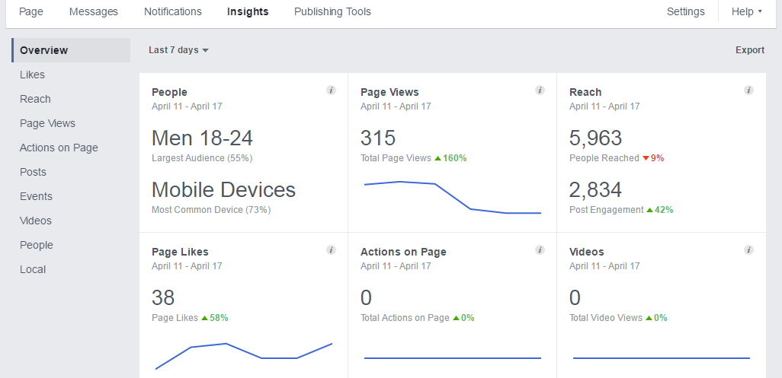
Figure 4.9: Facebook Insight of a Business Page
Screen Shot Source: facebook.com

4.6.5 Vine:
Vine enables users to record short video clips up to around six seconds long while recording through its in-app camera. The camera records only while the screen is being touched, enabling users to edit on the fly or create stop motion effects. Vine does not provide any inbuilt analytics but there are some tools which helps in vine data analytics, for eg. simplymeasured.com.
Simply measured makes it easy to analyse paid, owned, and earned activity from all of your social networks. Insights are delivered exactly how you need them, whether that's on the web, in dynamic Excel reports, or in PowerPoint. It provides analytics in two modes; free and paid. Almost all social media analytics tools are available at simplymeasured. In case of Vine, it provides vine analytics which helps in:
- How are your Vine Tweets engaging followers and which Vines are being shared the most?
- Analyse &compares your Vine content to other visual media on Instagram, Youtube and Twitter.
Reading | Read more about free social media tools and resources for analytics from simplymeasured.com at:  http://simplymeasured.com

4.6.3Klout:
Klout helps people to know how well they are at social media. Klout is a website and mobile app that uses social media analytics to rank its users according to online social influence using the "Klout Score", which is a numerical value between 1 and 100. Influence is the ability to drive action. When you share something on social media or in real life and people respond then it is influence. The more influential you are, the higher your Klout Score. Klout was launched in 2008 and it uses multiple social networks account login.
Klout HOW-TO
Follow the following steps to know your Klout score.
Step 1: Visit Klout. It's at: http://klout.com/.
Step 2: Sign up for new account or sign in using twitter, Facebook or other available social media account.
Step 3: Sign up. Simply start by clicking on the button that says "Sign In" using your Facebook and Twitter account only.

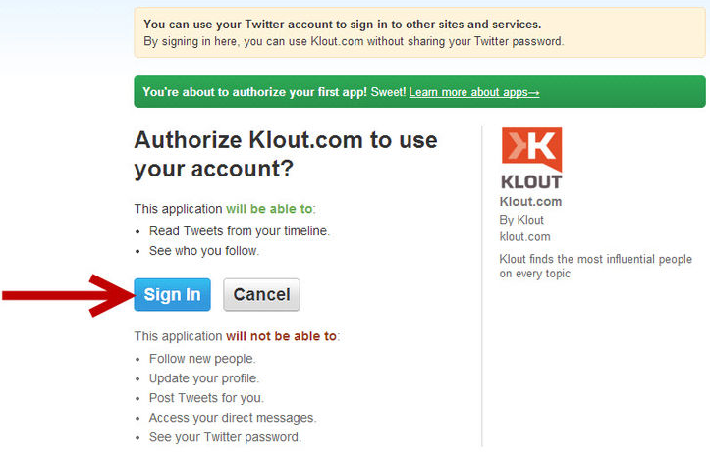
Figure 4.10 (a): Klout sign up window
Screen Shot Source: Klout.com
Step 4: Allow or deny access to your Twitter account. You will be taken to a page where it requests that you accept or deny the application to have access to your Twitter account. If you accept, click on Accept and you'll be redirected back to the Klout application.
Step 5:A standard box will appear and you'll need to fill in: First name, Last name, Email Id.
Step 6: Click on "Continue" once you've filled in the details. You'll be taken back to Klout and you'll see your own sphere of influence.
Klout takes around 24-48 hours to analyze your social media influence as it needs to configure you social media accounts and stream the data.
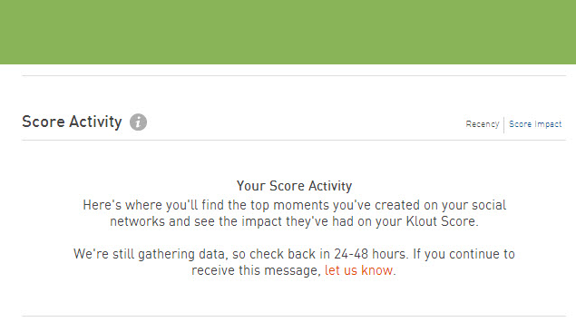
Figure 4.10 (b): Klout score processing
Screen Shot Source: Klout.com
Step 7: Have a look at the different measurements on your own Kloutpage. You'll find it after 24-48 hour, when your account is updated. A Klout score page looks like the following.
US president, Barack Obama has a Klout score of 99 which shows his popularity among people because he is active on Twitter , Facebook and Wikipedia page .
Klout scores are calculated with three specific measures, which Klout calls as:
- True reach: True reach is based on the size of a user's audience; who actively engage in the user's messages.
- Amplification: Amplification score relates to the likelihood that one's messages will generate actions, such as retweets, mentions, likes and comments.
Network impact: Network impact reflects the computed influence value of a person's engaged audience.
Activity 4.6 | Create a Klout account. Link it with your twitter, Facebook, Instagram, Google + etc accounts with it and know your Klout score.

4.6.7Gephi:
Gephi is an open-source software for visualizing and analysing large networks graphs. Gephi uses a 3D render engine to display graphs in real-time and speed up the exploration. You can use it to explore, analyse, specialize, filter, manipulate and export all types of graphs.Gephi can be used for following purposes.
- For network analysis and visualization
- To analyse a Facebook network
- To generate graphs of retweets and messages on Twitter
- For text network analysis
- To visualize keywords and landing pages from Google Analytics
Gephi is a powerful tool for social media analytics. It can be integrated with twitter, Facebook, Google and most of the social networks.

Reading | For installation and introductory lessons of Gephi follow the links:  https://gephi.org/users/  http://www.martingrandjean.ch/gephi-introduction/

4.7 Social media analytics with R tool:
R is an open source scripting language which is basically used for data mining and analysis purpose. R is a free software environment for statistical computing and graphics. It provides a wide variety of statistical and graphical techniques. It can be extended easily via packages. As on April 2016, there are more than 8000 packages available in the CRAN package repository. It is widely used in academia and research, as well as industrial applications.
In this section you will be introduced to the social media analytics (twitter data analytics) using R.
Help | The prerequisite of this section is that one must know the basics of programming and basic syntax of R language. For introduction and installation follow the given links.  http://www.r-project.org/  http://cran.r-project.org/  http://cran.r-project.org/doc/manuals/R-intro.pdf  http://cran.r-project.org/doc/manuals/R-lang.pdf

4.7.1 R installation:
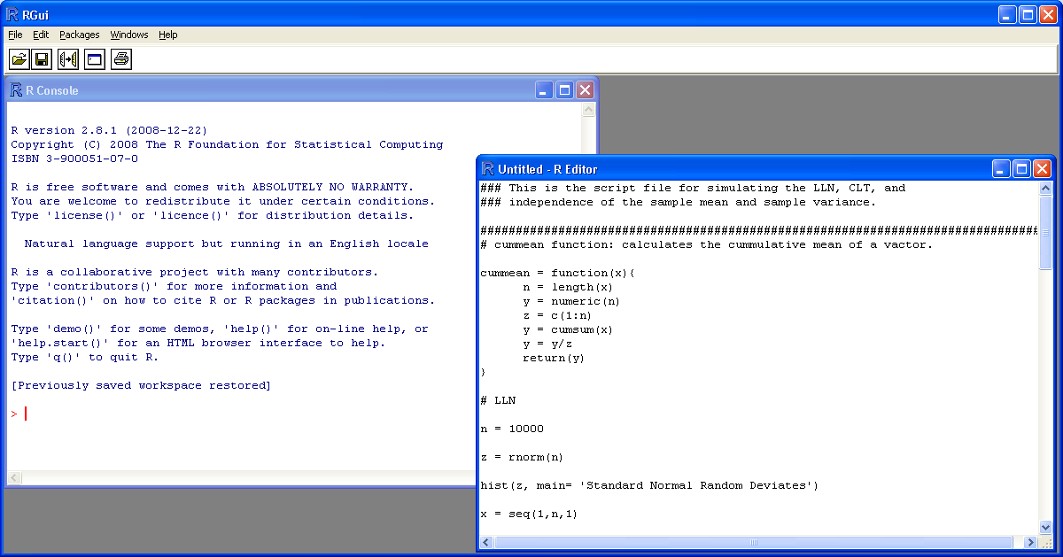
R is an open source tool and the tool can be downloaded from http://www.r-project.org/ by choosing the appropriate version of the R tool. Complete the installation process using the step given in the link http://cran.r-project.org/ . Once the installation is completed you will be shown the window as shown in figure 4.11.
Figure 4.11: R welcome window and terminal
Type 2+2 in R tool console. If it returns 4 without any error message installation is successful.

4.7.2 R packages:
There are many contributed packages that can be used to extend R. These libraries are created and maintained by the authors. You can install packages using command http://cran.r-project.org/doc/ manuals/R-intro.pdfor by using tool menu buttons.
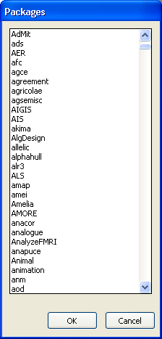
Figure 4.12: R packages
These two steps are mandatory. Step 1 to 4 are required to collect twitter data and analyse it.
- Make a Twitter application: Twitter allows developers to create applications to analyze the twitter data. You can create an application in twitter for which two prerequisites are; a valid twitter account, Account must have a verified phone number.
- Install package “twitteR”: twitteR is a package available in CRAN (Comprehensive R archive network) and it must be downloaded and installed in R tool.
- Configure R with twitter application: the next step is to connect the R tool with the twitter application. This is the most important part because it will ensure that you will get the online live tweeter data
- Twitter analytics: In this step you will capture the twitter data according to your defined parameters (keywords, groups, names etc) and can apply sentiment, content, keyword analytics on the obtained data.

4.7.3 Creation of Twitter application
- Go to https://dev.twitter.com/ and log in with
- App/twitter.com
- Login into your Twitter Account.
- Go to my application
- Create an application

Twitter application provides a medium to connect to twitter and collect tweets. User details are to be filled as shown in the figure below.
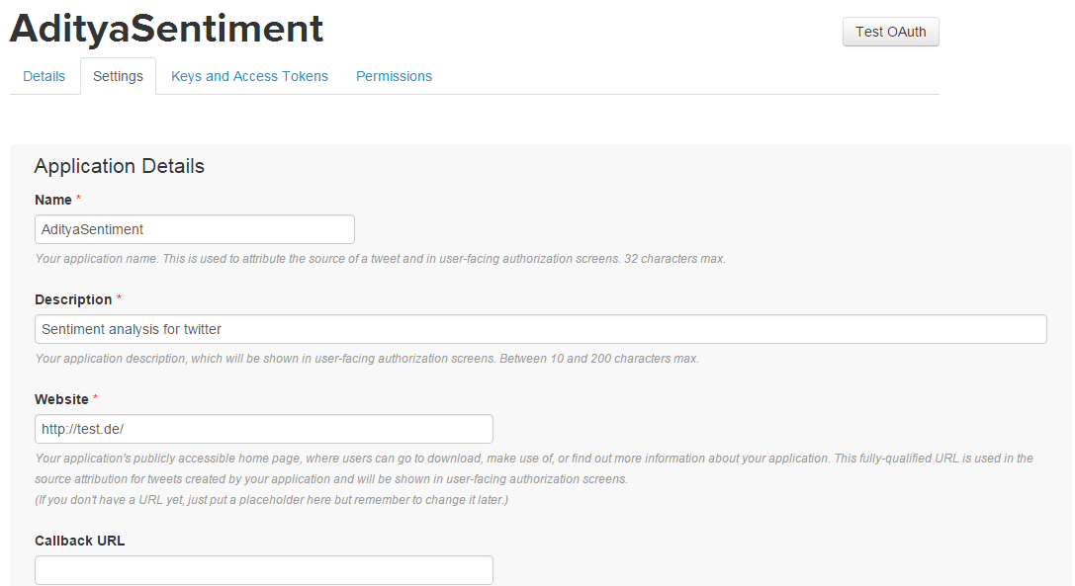
Figure 4.13 (a): twitter application details
Screen Shot Source: twitter.com
After filling details the application is created. You can check application details, settings by clicking on the links provided. For collecting tweets twitter needs authentication keys from the user. Figure 4.13 (b), (c) shows the generated keys by which you can authenticate your code to twitter.
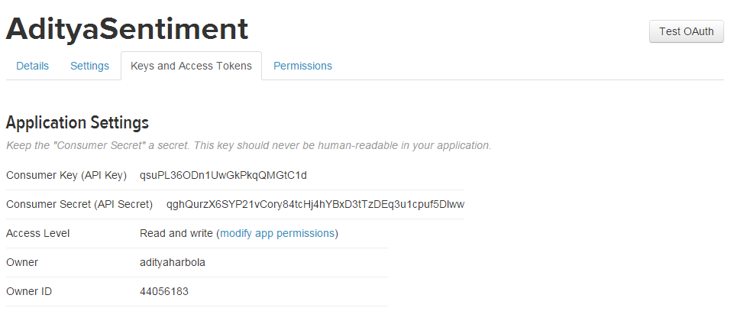
Figure 4.13 (b): twitter Keys and access tokens
Screen Shot Source: twitter.com

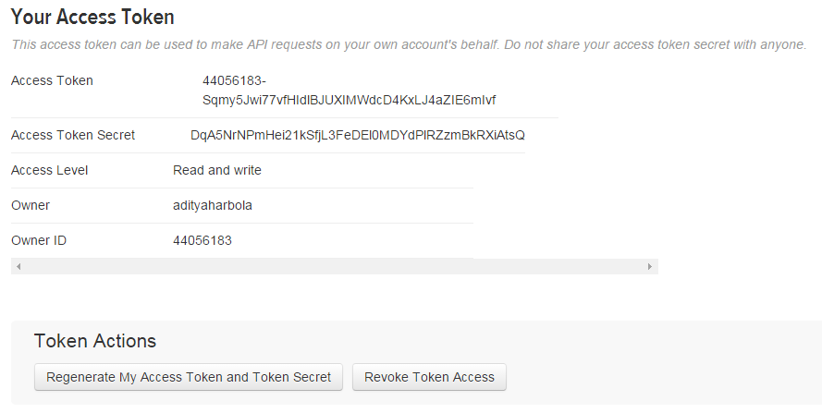
Figure 4.13 (c): twitter application access tokens
Screen Shot Source: twitter.com

Install packages: Run following commands in R terminal. You must be connected to the internet and these packages will be installed from the CRAN mirror.
- install.packages(c("devtools", "rjson", "bit64", "httr"))
- library(devtools)
- install_github("twitteR", username="xxxxx")
- library(twitteR)
After step 2 your R tool is configured with the required packages and the next step is to configure your twitter app with your local R tool.

Twitter Authentication with R: This step will link your R tool to your twitter app by authenticating you. The first four steps assigns the keys and the last step is to set twitter authentication by using all four variables.
- api_key<- "YOUR API KEY"
- api_secret<- "YOUR API SECRET"
- access_token<- "YOUR ACCESS TOKEN"
- access_token_secret<- "YOUR ACCESS TOKEN SECRET"
- setup_twitter_oauth(api_key,api_secret,access_token,access_token_secret)

Tweet analytics: The app which has just been created by the above said steps can be used to access the tweets from the twitter. There are many libraries available in R which can be used to analyse the data, but it will require R script knowledge at intermediate level which is beyond the scope of this study material. For more information regarding this you may visit http://www.r-project.org.
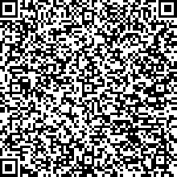  Video | The video tells about different free as well as licensed tools for social media analytics. These tools are used for tracking, measuring, and reporting on personal/ community/ business profile.  https://www.youtube.com/watch?v=hgOmcWSw2yY&index=8&list=PLXN-JCVb8z8DS1umCwF2cvJoIgxSDRP4j

Reading | For advanced topics of data analytics using R script basics visit:  http://www.thinktostart.com/forums/forum/questions-tutorials/twitter-authentication-r/  https://sites.google.com/site/miningtwitter/questions/sentiment/sentiment  https://sites.google.com/site/miningtwitter/questions/talking%ADabout/wordclouds/wordcloud1  https://sites.google.com/site/miningtwitter/basics/processing

Unit summary
Summary | Social media is a great source for data that can be used by organizations, researchers and governments to achieve business goals. It can predict the future and design policies for people. In this unit you have learned why social media analytics is needed and why every organization is adopting new ways for it even if it is a challenging task. You learned how to use analytical tools which gives you a good understanding of "How social media data can be used?"

Assignment
Assignment | - How whatsapp and Instagram make money?  - Log into Klout and add your social accounts in Klout. How can you improve your Klout score?  - Perform the steps for Gephi tool. Visualize your Facebook data.  - What impact unstructured data will make in coming ten years on social media analytics?  - Go to simplymeasured.com. Try free tools and analyse your social media accounts.

Assessment
Assessment | - Suppose you want to know the popularity of your website in past six months. What key performance indicators you will focus on?  - Collect 100 tweets from twitter per day over a month. Clean the tweets and do the frequency analysis of each word.  - What are possible ways to make money by social media website other than listed above?  - Create a twitter application. Extract 500 tweets for keyword “analytics”. Create a word cloud.  5: Which social network does not have ‘followers’?  - SoundCloud  - Google+  - Facebook  - Twitter  6: Which of the following are free analytical tools:  - Google Analytics  - Klout  - Followerwonk  - Sumall  - All of these
7: Raw, unorganized facts that need to be processed are called
- Information
- Data
- Knowledge
- None of these
8: Match the following KPI:
- Distribution | - Retweet
- Interaction | - Fan
- Influence | - Support cost
- ROI | - Sentiment

Unit 5

Ethical issues and social media cyber laws

Introduction
The 21st century is home to two worlds- Real and Virtual. While there seems to be a vast difference between the two, at the ground level it is just a matter of ‘tangible’ or ‘intangible’; all other things remaining the same.
When it comes to ethics, everything that is presented in the virtual world is actually a reflection of the real world. Whatever values you carry as a real person will be vomited in the virtual world.
Consider the following scenario.
“Mr. X posted negative comments on Facebook about the organization for which he works. The negative comments were focused on the policy for professional dress code as an employee. After the manager saw the comments, X was fired from the job.”
How do you analyse this incident? What must have pushed Mr X to post such comments on the social media that led him to lose his job? Could he have avoided this scenario?
However hard you try, your real personality, in some way or the other will be highlighted in the social media platform. It is therefore of utmost importance to know, “what to do” and “what not to do”, irrespective of which world you are living in.
While using social media, people generally do not pay much attention towards the ethical issues and the social issues. An ethical issue is “A problem or situation that requires a person or organization to choose between alternatives that must be evaluated as right (ethical) or wrong (unethical).” When an issue influence many people within a society, it is called a social issue.
However, with growing time, ethical and social issues are being raised by responsible social media sites and people worldwide. One must be aware about these issues while using social media. Also there are many frauds, crimes associated to social media usage. The section of laws dealing with these issues is called cyber laws.
Now, the question is: Are there any social media ethics or laws by which social media users abide? If any, what are the issues one must think before commenting, sharing, or promoting content over social media?

Upon completion of this unit you will be able to:
 | Outcomes |  | - Define social media ethical issues.  - Distinguish between ethical and unethical use of social media.  - Determine Ethical use of social media.  - Explain Social media laws and regulations.  - Defining basic privacy policies for your websites.  - Explain copyright issues with digital/social media.
Terminology |  | Intellectual Property: |  | Creation of someone's mind such as, song, design, innovation etc are called intellectual property.
 |  | Trademark: |  | Unique identification such as, sign, design of a service or a product.
 |  | Patent: |  | The rights granted by the government to the owner or the inventor for a limited period, for disclosing his invention.
 |  | NLRB |  | National labor Relations Board
 |  | COPPA |  | Child online privacy protection act
 |  | FINRA |  | Financial Industry Regulatory Authority

5.1 Defining Ethical and Influence Factors
Ethics are moral and personal values of an individual in a society which defines an individual as 'good' or 'bad' person. Social media ethics are conduct of an individual which is governed by the social ethics. It is cumbersome to regulate social media. Some of the reasons are as follows:
- Social media space has no respect for jurisdictional boundaries.
- It has intangible dimension that is impossible to govern using conventional laws.
- Cyber space is open to participation of all.
- Cyber space offers enormous potential for anonymity to its members.
Therefore, it is the responsibility of every individual to follow the ethical path while spreading knowledge over social media so that the posts shared do not violate social media ethics, do not hurt other users’ sentiments or create social unrest.
There are many factors which affect a person's ethical behavior; the most important being morals and personality.
Morals: Moral values are 'What a person obtains from his childhood, education and culture'.
Activity 5.1 | What are the different aspects you would consider before publishing a post, image or article? Do these points in any way show your concern for the society in general? Do they convey a positive or negative message?
Personality: All those activities that describe you as a person frame your personality. For example, if you wear shabby clothes in public, you will most likely be judged as a person with untidy thoughts as well. Your behavior towards other people will tell you the type of person you are. Similarly, the way you communicate in social media will hint others about your intentions.
Note it! | While 74% of employees surveyed by Deloitte Touche LLP agreed that “it is easy to damage a company’s reputation on social media, only 22% of companies surveyed were found to have a formal social media policy.”

5.2 Connection between Ethics and Social Media
Social media ethics are mainly categorized as:
- Ethics for social media users: As a social media user you must follow the following rules as ethical practices:
- Confirm the facts before posting or reposting topics over social media. Social media data remains forever and there are no roll backs for your actions.
- Never reveal your private information on social media platforms.
- Never express negative sentiments against organization/community/person over social media.
- Before using digital material check the term of use and copyright issues. This may create legal issues if copyright violation is found.
- Always check the privacy policies of the social media sites as they differ site to site.
- Ethics for social media regulators or organizations:
- Organization should keep social media user’s personal information private and secure.
- Financial organization should record user conversations, provide online support to the users.
- Copyright issues should be addressed in "term of service" and notified to the user.
- Organization should have specific policy for children.
- Medical organization should have health policy which keeps patients information private and secure.
All these ethics are covered in various cyber laws which are described in section 5.4 onwards.
Activity 5.2 | True or False:  - As a user can you defame someone over social media?  - Do you need to provide a privacy policy for your website?  - As a medical practitioner , do you abide by social media ethics?  - Are you allowed to download the songs from your CD to your MP3 player in America?  *Answers are given at assignment section with explanation.

5.3 Ethical Issues
There are many ethical issues over social media which must be followed by the user as well as organizations. These issues can affect a user, organization, society or customer.
Figure 5.1: Recently unethical use of social media has shown that it can be used as a weapon for spreading fake information, influencing people by terrorist organizations / political parties, retrieving private information of social media users etc.
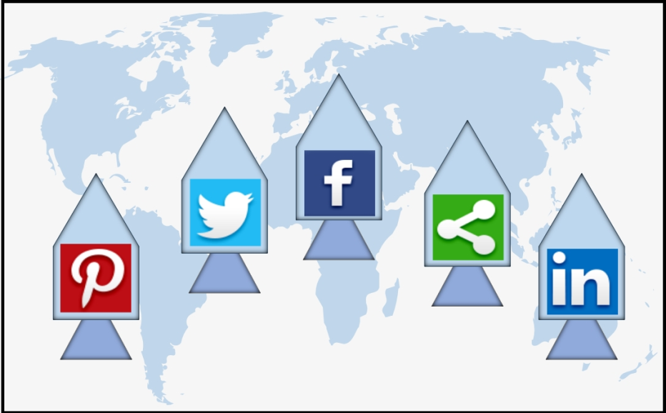
Figure 5.1: Use of social media as a weapon
(CC BY 4.0, Graphic Era Hill University, Dehradun, India. 2016)
Different ethical issues are defined as follows:
Confidentiality
The confidentiality of the social user is of prime importance and the social media companies or other organization must keep this information private. It has been seen over the time that the organizations are failing in keeping the user information, knowingly or unknowingly. For example, many organization are doing data monetization, by which they sell the user data to other organizations. This may harm the confidentiality of user data.
Unintended retainer
In certain case it has been observed that doctors/teachers/brokers have a link to the client over social media. They should take precautionary steps and must avoid involuntary relationship with client. For example, if a teachers is friend with a student 'X' over social media and he answers some specific queries of the student 'X', friends of X may see the answers and teacher becomes liable for the unintended advice to other students.
Defamation
Defamation means degrading the image, value of any organization, personality or an individual over social media. Social media platforms are being used to defamation purposes by some users. Defamation law apply to messages, post or stories made on social media channels.
Employees’ use of social media
With time it has been observed that employee use of social media must come under ethical conduct. If an organization allows the employees, they must follow the policies and rules defined by the organization. many organizations are deciding their social media policies to educate the employee, "How to use social media at workplace?"
Reflection | Most of the companies have developed internal social media systems where employees can discuss their issues rather than discussing it over open public domain. Also according to NLRB all social media comments cannot be used against the employee. If the comments or post represents a group or union of employees, employers cannot fire the employees.
Integrity risk
Integrity of an organization is the one of the main issue of social media ethics. When a representative of the organization behaves in an unethical or irresponsible manner using social media accounts, It causes integrity risk for the organizations. Every organization has a social media team of employees and they must keep the integrity of the organization in a good light.
Reading | [1] http://www.forbes.com/sites/adrianagardella/2015/05/21/can-your-employees-trash-you-on-social-media/#5df63f9436b6  [2]http://www.nolo.com/legal-encyclopedia/social-media-online-defamation.html  [3] http://maximizesocialbusiness.com/can-social-media-confidentiality-co-exist-workplace-12834/  [4] http://www.hsj.co.uk/topics/technology-and-innovation/social-media-protecting-patient-confidentiality/5061216.fullarticle
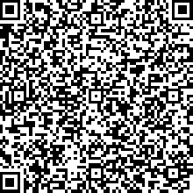  Video | The video discusses about Social media ethics, moral principles and values that generally govern the conduct of an individual over social media technology.  https://www.youtube.com/watch?v=SfFZR9qEZT8&index=9&list=PLXN-JCVb8z8DS1umCwF2cvJoIgxSDRP4j

5.4 Social Media Laws and Regulations
With the advancement of social media user base it is important to follow regulations, laws and guidelines which govern social media industry. You will read few major regulations and cyber laws in following sections.

Figure 5.2: Social media Laws and regulations
(CC BY 4.0, Graphic Era Hill University, Dehradun, India. 2016)
Note it! | Social media do not have boundaries and all over the world many regulations, laws are in force for cyber laws. For the sake of uniformity and simplicity you will explore United State social media cyber laws. It is also known that almost all social media sites are US based so they must be abide by US cyber laws.
Social media laws are always changing or updating according to the incidents and demographic needs. Some of major laws/regulations are:
- Financial Industry Regulatory Authority Act
- Health insurance Portability and accountability Act
- Federal Trade Commission
- US copyright Act
- National Labor Relation Board
- Genetic Information Non-Discrimination Act
- Children’s Online Privacy Protection Act
- Computer Fraud and Abuse Act

5.5 Financial Industry Regulatory Authority
The Financial Industry Regulatory Authority, Inc. (FINRA) is a financial corporation in United states and it regulates the financial industry activities. It is a self-regulatory organization and has specific sections for social media. With the ever increasing use of social media, people are also using it for business and organizational communications. It provides easy and timely medium for communication. But the communication must be secured and secret. FINRA provides guidelines to the companies for communication with the public.
A social networking task force came into action in 2009 when FINRA staff and organizational persons discussed the use of social media among the companies registered staff and the customer. it was also discussed that how should be used by financial industries that ensures the customers privacy and protection. Then in 2010 FINRA has published the notices and guidelines which include recordkeeping, supervision of the social media activities of the registered staff and customers. The FINRA notice ensures that the customers do not get false or fake information. It also insures that the websites which provides fake information must be blocked so that the investors do not access false information.
(Read: http://www.forbes.com/sites/joannabelbey/2014/10/16/finra-and-the-future-of-social-media-in-financial-services/#faec1df1b229)
FINRA helps in:
- Recordkeeping: It ensures that the customer and broker communication must be recorded and it must be kept for at least three years period so that in case of any fraud it can help.
- Supervision: An online system must be maintained which must look in to the social media activities and communication of the engaged parties in financial/insurance activities. It ensures that the customer is not being given false information or the broker is not doing fraud with the customer.
- Links to Third-Party Sites: The financial organization website must not contain red flag links. A red flag link is a link which may have misleading or false information. So the companies must look for such links and should avoid the use of these inks in any way.
- Data Feeds: There are many social media sites, so a system must be designed to manage the data feeds of several social media sites in to the website of the organization. In some situations the companies are getting the data feeds which are inaccurate. So the companies must process the data feeds and validate them. After processing the data the data can be shown on the company’s website.

5.6 Health Insurance Portability and Authority Act
The Health Insurance Portability and Accountability Act (HIPAA) is a federal law that says that a patient has control of his or her own protected health information. The HIPAA Privacy Rule protects “all individually identifiable health information held or transmitted by a covered entity or its business associate, in any form or media, whether electronic, paper or oral.” Without the permission of the patient the health information cannot be used by anyone else.
If you work in healthcare, including a hospital, doctor’s office, or clinic, it’s important to keep customer information private.
Read: https://www.ncsbn.org/NCSBN_SocialMedia.pdf
You should
- Keep your patient's social media accounts separate from your professional accounts. It is highly recommended to avoid your patients from your social media accounts.
- HIPAA lists 18 personal identifiers including photos, social security number, birthdates and vehicle identifiers. All of these must stay private. Do not mention any of these identifiers in social media posts.
- Don’t accidentally share any patient information, like photo that includes a patient, or a tweet that could identify someone that he visited your clinic.
- Don’t invite customers to post personal information on social media portals.
- Don’t acknowledge(retweet/like/repost) anything that a patient discloses, or defend a negative post when a patient posts something online.
- Train your staff in social media policies and procedures.

5.7 Children Online Privacy Protection Act
The Children's Online Privacy Protection Act (COPPA), effective April 21, 2000, applies to the onlinecollection of personal information from children under 13. The new rules spell out what a Website operator must include in a privacy policy, when and how to seek verifiable consent from aparent and what responsibilities an operator has to protect children's privacy and safety online.
Read: https://en.wikipedia.org/wiki/Children%27s_Online_Privacy_
Protection_Act
It must be followed in following cases:
- If the website allows the access of the website to the child users aged below thirteen years.
- If the website collects the personal information of the child user, by any means.
What does it mean by personal information of child:
The Children's Online Privacy Protection Act and Rule apply to personal information of a child which may be collected by online websites or through cookies or other types of tracking mechanisms. The information may be such as:
- full name
- home address
- email address
- contact number
- friends information
- interests
An operator must insure that the following provisions are being followed.
- Notice to parents: The parent of the child must be notified about the usage of the website by the child user. Also if the website operator want to collect some information of the child user , the parent must be notified by the operator. The operator must design a method to notify the parent which can be such as email, telephone or by sending mails.
- Verifiable Parental Consent: Before collecting and using the child information the operator must take a verifiable consent from the parent. He must verify the consent also.
- Privacy Notice: The operator must provide a privacy notice and the term of usage. The link on the website for the privacy notice must be clearly visible to the users.
- Content usage: The operator must reveal that how the use of the personal information of the child will be done. It means the potential use of the information must be known to the child and parent. Whether the data is being used by the operator only or it will be used by the third parties. the operator must reveal that for what kind of business the data will be used. In any cases the privacy and confidentiality of the child user can not be compromised.

5.8 United States Copyright Act
This law is an integral part of United states code. In tile 17 of the united states code, copyright law is mentioned in chapter 8 and 10 to 12. This law came into existence in 1976 and it provides the base for the current law.
This federal law protects the authorship of the original works. Original work of authorship means if someone has originated the idea or has authored the content; it includes drama, art, song, books, stories or other type of original works. The owner can do:
- Make copies of his work, called reproduction.
- Show his work in public.
- Update or use his work in other works.
Copyright law protects "original works of authorship,". I n the age of social media website such as Facebook, twitter there are many types of contents which can violate the copyright, such as photographs, poems, blog contents etc. now a day's millions of digital content is shared over the internet without the care and knowledge of the ownership of the content. It is not ethical to share others copyrighted material without license or the permission of the owner. Either get the license or permission of the material or insure that the use comes under the fair use policy.
Note it! | Fair use is any use of copyrighted material so that the owner’s interests are not hurt or the use is for limited period. Ex: quoting a few lines from a Michael Jackson song in a music review. Such uses can be done without permission from the copyright owner.
With time this law has seen many amendments. Some of the notable amendments are:
- Digital Millennium Copyright Act
- Preservation of Orphan Works Act
- Artists’ Rights and Theft Prevention Act of 2005
- Fraudulent Online Identity Sanctions Act 2004
- Prioritizing Resources and Organization for Intellectual Property Act of 2008
Note it! | - UK.Gov passes Instagram Act: Now all your pictures belong to everyone now.  - In US Facebook comments could be used as a reason to fire an employee from job if the comments are not as per rules defined in National Labor Relations Board (NLRB)
What are responsibilities of a social user:
A social media user must always consider taking the following steps:
- Check the information on the websites about the copyright policy, how the content may be used. The social media website provide the notice link at the bottom-middle section of the home page.
- If want to re-post any content over social media you must first check the social media (Facebook) network's terms and conditions to re-post the content. In some social media platforms the copyright of the digital material over that site is provided to all the users. But it is not applicable to all social media sites. For example Pinterest provides all other users a license to use the content of Pinterest.
- Always acknowledge the author or owner by posting a link of the original source or content.

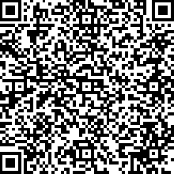  Video | The video discusses few regulations, laws and guidelines which govern social media industry.  https://www.youtube.com/watch?v=mr2tf9EtNS4&index=10&list=PLXN-JCVb8z8DS1umCwF2cvJoIgxSDRP4j

Unit summary
Summary | In this unit you learned the ethical use of social media. You also learned how social media unethical uses are covered by different regulations/act/laws. Social media is very diversified and fast but one wrong step could get you in to trouble. You must check the "term of use" or "privacy policy" of social media sites before using it. You must know that social media is for connecting people but not to land you in trouble. Further you were told about various acts and how they restrict the unethical use of social media. You are advised to dive deep into social media laws in your region and make a note of ethical and unethical actions.

Assignment
Assignment | - What are major data protection and privacy laws over social media?  - What are various categories of copyright act? Explain with example.  - Define privacy policies. Design a privacy policy for child related website?  - Take a note of Wikipedia term of use? Does Wikipedia allows posting copyright contents?  - Can Posting on Facebook, Twitter, or Pinterest Really Violate Copyright Law?

Activity Answers | True or False: Answers are at assignment section  - As a user can you defame someone over social media? You can defame someone over social media but you must have true facts and reasoning behind your actions. for example: a person may claim that he was fired for fraud. The individual may have been fired but not for fraud. The court may find defamation still existed despite some truth to the statement.  - Do you need to provide a privacy policy for your website? Yes. Every website must have a privacy policy so that the user must have know what information is being collected and for what purpose. for free privacy policy design check the following link  http://www.freeprivacypolicy.com/  - As a medical practitioner , do you abide by social media ethics? Yes. medical field requires patience and trustworthiness. Patient information is very private and as a medical practitioner you must follow the ethics defined in HIPAA section 5.6.  - Are you allowed to download the songs from your CD to your MP3 player?No. In UK (73%) of the UK population did not know that it was illegal to convert from CD to MP3. It basically depends upon the laws of a state. Commercial use is ban in almost all over the world.

Assessment
Assessment | - What are privacy policies of twitter? Does a tweet come under copyright law?  - You live in the India and hack into a social media account in France. Whose laws apply?  - Does Using a popular song for musical review is violation of copyright law?  - Take a note of national labor relations board (NLRB) guidelines for social media usage.

Feed Back Form
*Required
- Did the course cover the content you were expecting? Why or why not? *

- Rate your understanding of course expectations and assignments *
Very Good Good Average
- What topics were you expecting, or would have liked addressed, that were not covered? *

- Was the content arranged in a clear and logical way? *
Yes No
- Did you utilize any links to external web sites? *
Yes No
- Did the use of case studies/examples help you gain a clearer understanding of the content? *
Yes No
- What additional material would you like to see in the course? *

- What was the (average) amount of time you spent on this course? *
Weekly in hours
- Rate the amount of multimedia (audio, video, and animation) used in the course *
Very Good Good Average
- List three important concepts or ideas that you learned in this course *

- Would you prefer to take this course online or in the classroom?*
Online Classroom
- What are the strengths and weaknesses of this course? *

The Feedback Form can also be filled online at
https://docs.google.com/forms/d/1MBTCuypFPkyR77cxrQn00cJjmmC8JxzOPSTotdV8gmo/viewform?c=0&w=1

